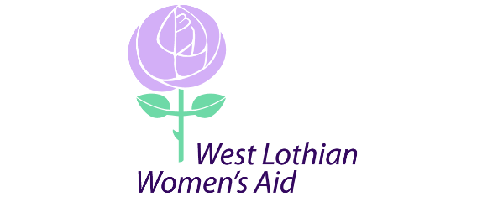
West Lothian Women’s Aid
92 Ivanhoe Rise, Dedridge
Livingston
EH54 6HZ
01506 461938
info@wlwa.org.uk

May 2020

Dear Applicant

Re: Children and Young Person’s Worker

Please find enclosed the application pack for this post.

This comprises of the following;

- Application form
- Job description and person specification

Please complete your application and return marked for my attention either to the address above or to ilena@wlwa.org.uk by Thursday June 4th at 9am. We are unable to consider CV’s as part of the application process.

Please note that we are unable to respond to every applicant but should you not have heard back from the organisation by the end of June 2020 you can assume that on this occasion you have not been successful in being shortlisted for interview.

Yours faithfully

Ilena Brown
Manager

