APPLICATION PACK

MARKETING OFFICER (Maternity Cover, Fixed-Term Contract)

Thank you for requesting an application pack for the position of Marketing Officer (Maternity Cover, Fixed-Term contract) at the Royal Society of Edinburgh.

Application Pack:

- A Job Description including key responsibilities, competencies, skills & experience needed to do the job, salary & hours
- An Application Form
- Information about the Royal Society of Edinburgh
- An Equal Opportunities Monitoring Form
- A note summarising RSE non-pay benefits

Job Application Form

Please complete the job application form as fully as possible demonstrating how you meet the competencies and skills required for the post and the relevant experience you bring to the role. If you have any questions about filling in the form, do not hesitate to contact me.

Diversity

Completion of the Equal Opportunities Monitoring Form is optional.

How to apply

Your completed job application and your Equal Opportunities Monitoring Form should be returned to the RSE HR Office by 5pm on Monday 06 July 2020 to vacancies@theRSE.org.uk

Interviews

If you are invited for interview, due to the current situation of COVID 19, this will take place online possibly using Microsoft Teams on a date and at a time to be confirmed.

Eligibility

In accordance with the Immigration, Asylum and Nationality Act 2006 The RSE, as an employer, has a legal responsibility to prevent illegal working and therefore must check that all employees are entitled to work in the United Kingdom. To do so we require to see original documents evidencing right to work in the UK before commencement of employment and this will be carried out at the interview stage. Details will be provided to candidates invited for interview.

Feedback on your application

Please note that feedback will only be provided to candidates after interview.

Finally, I would like to thank you for your interest in the Royal Society of Edinburgh.

Yours faithfully,

Ms Christel Baudère
Senior HR Advisor

Job Title | MARKETING OFFICER (Maternity Cover)
Grade  Salary  Hours | Grade 2.  £25,000 pa  Monday to Friday (35 hours per week). There is flexibility to work 35 hours between 0830 and 1930 across the contracted days. There will be occasional work required out-with the flexi periods.
Starting Date | Tuesday 01 September 2020 to Friday 30 July 2021
Role | To develop and lead on the marketing for the RSE programmes relating to Enterprise Fellowships (60%), Research Awards and Public Engagement activities (40%).
Key responsibilities | - Plan and deliver marketing activities for the Enterprise Fellowship programmes, public engagement events (online and physical) and research awards activities  - Engage with internal and external stakeholders and contractors to raise RSE profile  - Maintain communication planning systems to manage trafficking and delivery  - Produce reports for marketing and other activity  - Prepare copy for range of internal and external publications
Key Competencies /Skills | ESSENTIAL  - Experienced in leading and managing high quality marketing campaigns across digital and print platforms  - Ability to plan and work under pressure and manage multiple projects simultaneously and within budget  - Experience with engaging with range of internal and external stakeholders  - Experience of working within/or for a similar environment and maintaining networks  - Excellent written, communication and visual storytelling skills, including briefings and report writing  Experience in working with designers and printers  - Excellent organisation skills | DESIRABLE
Key IT Skills | Word/Outlook/Website | Excel
 | Intermediate | Intermediate
 | Adobe Acrobat | PowerPoint
 | Intermediate | Intermediate
 | CRM Database (currently Integra, training will be given) | Others
 | General Procedures
Staff Management  Responsibilities | None
Responsible to | Head of Communications
Key Customer Groups | External: General public, government and other public organisations, other academic organisations, Enterprise Fellowships funders, service providers, designers, printers, marketing colleagues  Internal: All RSE staff, Enterprise, Awards and PE teams, Fellows

Job Specification

Plan and deliver marketing activities for the Enterprise Fellowship programme
- Twice yearly campaign to encourage applications
- Ongoing cohort engagement – case studies, showcase videos,
- Training period – interactions with the cohort
- Updates and copy for partners, stakeholders, RSE corporate publications
- Monitor and evaluate the marketing plan as it is implemented and make adaptations to improve effectiveness
- Capture and record impact information during the year

Develop and lead on marketing campaigns for Public Engagement and Research Awards activities
- Prepare fully formed marketing plans for projects including Curious 2021, RSE Investigates, partnership events including RBGE 350th anniversary event and RSE/SCF lecture and other events agreed with the Public Engagement Team
- Evaluate marketing campaign for effectiveness
- Prepared a marketing plan to underpin the Awards strategy that supports marketing of awards, prizes and medals to relevant audience including preparation of copy, digital marketing and liaison with external providers and lead on implementing activities as agreed with the Research Awards Team

Co-ordinate and deliver designed materials for marketing campaigns
- Produce online digital campaigns that work across all RSE digital platforms as appropriate and also with other external platforms such as Eventbrite and conference platforms
- Prepare specifications and identify and appoint designers, printers and manufacturers to work on producing marketing collateral for projects
- Liaise with staff and external contractors to deliver marketing materials within time and budget
- Occasionally design minor pieces of collateral for campaigns

Engage with internal and external stakeholders to deliver key projects and raise RSE profile
- Identify synchronicity between projects and events both internally and externally to maximise marketing effort by the RSE
- Identify and contact key stakeholders throughout the city and the country who can help amplify the RSE message and promote and support the RSE’s mission
- Appoint and manage content producers including photographers, videographers and others to help in the development of running marketing campaigns

Maintain communication planning systems to manage trafficking and delivery
- Develop and maintain a work planning system for marketing that allows for simple tracking of activity

Produce reports for campaigns and other projects
- Prepare reports to a high standard for SMT and other teams following delivery of marketing campaigns detailing objectives, methodology and evaluation with good use of visuals and explanations to illustrate the campaign
- Work closely with Digital Comms Officer in preparing evaluations

Corporate Expectations
- Apply RSE’s key behaviours and skills (See “Our Expectations” enclosed).
- Adhere to the RSE vision, mission and values
- Ensure all processes comply with data protection legislation and are in accordance with RSE record management policy and processes
- Observe all health and safety requirements
- Work within and promote policies in relation to the RSE Diversity Policy
- To undertake any training as required by the job description, in line with the business needs or required by your team leader
- To undertake other reasonable tasks as required by RSE

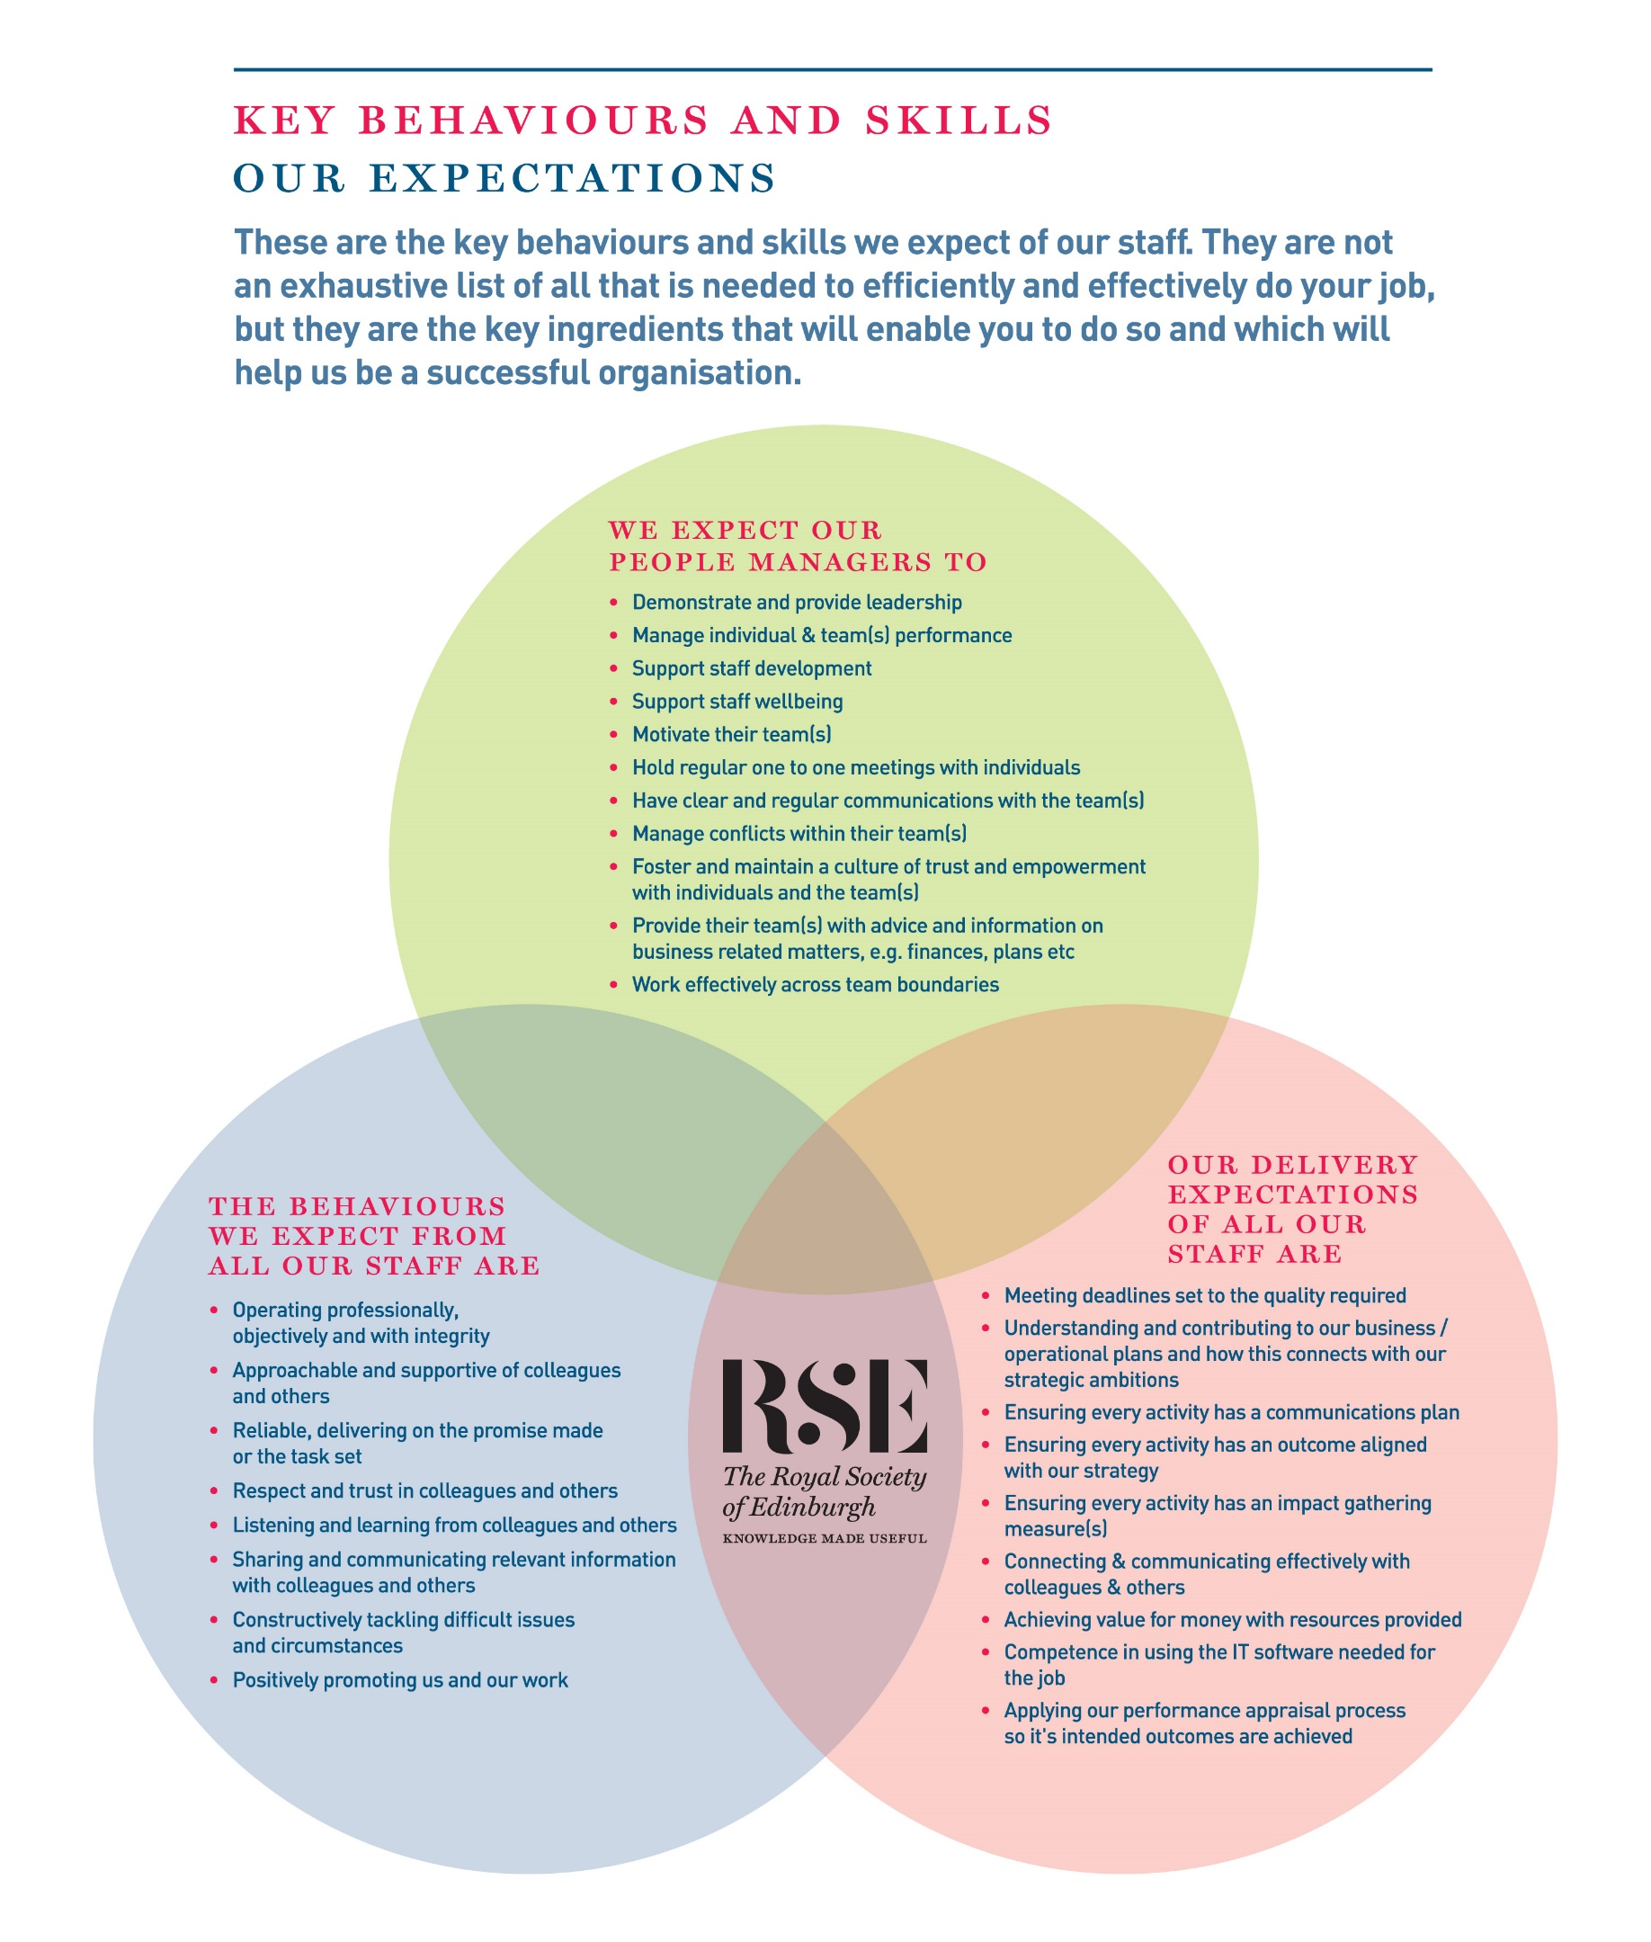

About the RSE
The Royal Society of Edinburgh, Scotland’s National Academy, is an educational charity that provides public benefit throughout Scotland through a diverse range of activity including awarding research funding, informing public policy and delivering events across Scotland to inspire knowledge and learning.
The RSE’s mission, set out in its Royal Charter of 1783, is “the advancement of learning and useful knowledge”. Its contemporary purpose remains the same – the deployment of knowledge for public good: knowledge that contributes to the social and economic well-being of Scotland and its people and the nation’s wider contribution to the global community.
The RSE draws upon a body of elected fellows who are leaders and experts in their fields. The breadth of expertise and experience within the Fellowship ranges from life sciences, physical sciences and technology, to arts, humanities, social science, business, public service and civil society. The multidisciplinary breadth of the RSE – reaching well beyond the academic world – is a distinctive strength and unique within UK national academies.
Our staff group, is responsible for executing our programmes of activities and ensuring due governance is followed.

Our Strategic Framework
Published in 2016, our Strategic Framework 2016-2021 sets out the Royal Society of Edinburgh’s vision and strategic objectives to 2021. It identifies the distinctive impact the RSE aims to make nationally and internationally, and the benefits that a vibrant multidisciplinary national academy can bring to Scotland.
The Framework sets out four strategic objectives to:
- Inspire and support Scotland’s most promising young talent across the research, business and public sectors, to create value for the economy and society;
- Engage on key contemporary issues by providing an impartial forum for public debate and discussion;
- Provide expertise to ensure that Scotland’s policy makers and influencers have access to the best national, and indeed global expertise;
- Promote Scotland’s interests and reputation on the global stage.
Alongside these strategic objectives, the Framework identifies four development aims:
- To create an active and more diverse Fellowship;
- To secure increased funding from a diverse range of sources;
- To enhance and widen the RSE’s outreach and impact;
- To redevelop our premises.
In line with the ambitions set out in the Strategic Framework the RSE is embarking on a major programme of change, building on existing strengths, to further enhance the Society’s visibility, reach and impact.

APPLICATION FORM

Please provide the information requested below outlining your experience and skills. You should then email your job application form to the RSE HR Office as soon as possible.

1. Post Applied For: Marketing Officer (Maternity Cover ,Fixed-term contract)

2. Application No: (for RSE use only)

3. Your Details:

Title
Forename
Surname
Address
Postcode
Telephone Number
Mobile Number
E-mail Address

4. Do you need a work permit to take up this post? (please tick)

Yes No

Application Number (for RSE use only)

5. Present Post

Job Title:

Employer’s details:

Date of employment (From – To):

Reason for leaving (if applicable):

Notice period required:

Role Purpose / Summary of responsibilities:

Application Number (for RSE use only)
6. Employment history
Starting from the most recent first and working down the page. (Please, use a separate sheet if needed).

Job Title | Employer | Responsibilities | Dates from | Dates to

Application Number (for RSE use only)

7. Education or relevant courses

Subject(s) | Qualification achieved | Date obtained

8. Membership of Professional Bodies

Full name of Organisation | Registration Number | Date obtained

Application Number (for RSE use only)

9. Statement of Application
Please demonstrate how you meet the competencies and skills required for the post and the relevant experience you bring to the role with reference to the key responsibilities set out in the job description. You may also wish to provide other information that may be relevant to your application such as your reasons for applying for this position, major achievements to date, personal qualities, interests or other skills and attributes.

Application Number (for RSE use only)

- References: Please give the names of two referees who can provide references on your suitability for the post, and who you are content the RSE approaches if required (do not enclose references with this application).

Note that references will only be taken up for successful candidates following the interview.

I am content that the RSE approaches the referees below
(Please tick the box above accordingly)

REFEREE 1
Title
Forename
Surname
Mobile Number
E-mail Address

REFEREE 2
Title
Forename
Surname
Mobile Number
E-mail Address

Application Number (for RSE use only)

11. Where did you see the advertisement for this post (please tick accordingly)?

Good Moves / Third Force News website
RSE Website
Indeed
LinkedIn
Twitter
WOM
Other

Data Protection

The Data Protection legislation regulates the use of personal data (“information”) about an individual and requires the RSE to receive your consent to use the information you give in this form and in any attachments to it, to assess your suitability for the post you have applied for. By signing this application form, you will be consenting to the RSE processing information for this purpose.

If you are unsuccessful, this form will only be kept in the RSE files for 3 months and will only be viewed by staff involved in the recruitment process. If you are successful, this form will be kept for the length of your employment with the RSE.

Date:

Name:

Signature:

POLICY ON CRIMINAL RECORD DISCLOSURE

In line with its overall recruitment policy, the RSE seeks criminal record information before making an offer of employment to a successful job applicant. The note below describes the process that will be followed and what happens to any information received. Please read it carefully.
The post for which you have applied requires the applicant who is successful at the interview stage to complete a personal disclosure of any unspent convictions, details of any cautions, reprimands and final warnings administered, and details of any charged offences. There will, also, be open and measured discussion about disclosure information at the interview stage. If an applicant fails to disclose relevant information at interview, it may lead to the withdrawal of an offer of employment, or following appointment, disciplinary action being taken, which may include the termination of employment.
If an interview, or subsequent personal disclosure, provide information about a conviction, cautions, reprimands, final warnings administered and charged offences, RSE will assess the relevance of the information by considering:
- The seriousness of the offence and whether it is relevant to the protection and safety of RSE staff, others and RSE property.
- The length of time since the offence took place
- Whether there is a pattern of offending behaviour
- Whether an individual’s circumstances have changed since the offending took place, making re-offending less likely.
- Relevant information offered by an individual about the circumstances which led to the offence being committed
- The country in which the offence was committed; some activities are offences in Scotland and not in England and Wales, and vice versa.
- If the offence has since been decriminalised by Parliament.
- The degree of remorse, or otherwise, expressed by an individual and their motivation to change.
Personal disclosure information provided will only be used for recruitment purposes and will only be shared with those authorised to see it during their duties. No image or photocopy of the information will be made. The Personnel Office will keep all information disclosed in a secure and confidential file for 6 months after the start of employment.

RSE EQUAL OPPORTUNITIES MONITORING FORM

As an equal opportunity employer, the RSE welcomes applications from all suitably qualified people and aims to employ a diverse workforce. To help us meet that aim we would be grateful if you could complete this form and return it to us. The form is completed on an anonymous basis, will not be used in the short-listing process for the post, and cannot be reconciled with your application.

The information you provide may, however, be stored on a computer system for the purposes of personnel administration and statistical analysis. It will be treated as strictly confidential and only be used for Equal Opportunities purposes.

Post Applied for | Marketing Officer (Maternity Cover fixed-term contract
Where did you see this vacancy advertised?
What is your age? | Please tick accordingly below
 | 17-25
 | 26-44
 | 45-64
 | 65+
 | Prefer not to say
What is your gender? | Male
 | Female
Ethnic / Racial Origin – Please indicate how you would describe your ethnic / racial origin from the selection (Ethnic Origin is not about nationality, place of birth or citizenship, but about colour and broad ethnic group) | Bangladeshi
 | Black African
 | Black Caribbean
 | Black other
 | Chinese
 | Indian
 | Pakistani
 | White
 | Other
The Equality Act 2010 defines disability as a “physical or mental impairment which has a substantial and adverse effect on a person’s ability to carry out normal day to day activities”  Do you consider yourself to have a disability? | Yes
 | No

Thank you for your co-operation in completing the form

In addition to the basic salary paid, the RSE offers staff a generous package of rewards. The package includes:

Salary | - Subject to what we can afford, you may receive an annual pay award to maintain the real terms value of your pay. There is also discretionary scope for additional consolidated or non-consolidated pay awards
Contributory Pension Scheme | - You can join the RSE AVIVA Group Pension Plan. You contribute 3%. On your behalf, we pay a further contribution of 6% of your annual salary. Further information about the scheme is available here http://www.aviva.co.uk  - There is scope for you to pay a higher employee contribution. If you decide to do so, the RSE will pay double the employee contribution rate up to a maximum employer contribution limit of 12%.  - AVIVA may accept transfers from other schemes so please check with them prior to applying for a transfer.
Annual leave | All employees employed after 1 August 2018 receive the following annual allowances (pro-rata for part time staff):  - 25 days up until completion of 3 years employment  - 27 days following completion of 3 years employment (+ 2 days)  - 30 days following completion of 5 years employment (+ 3 days)
Public Holidays | - You get 9 days public holiday (pro-rata for part time staff). This is built into your total holiday allowance (annual leave + public holidays) each year
Sick Absence | - You receive sick absence pay once you have satisfactorily completed your probation period. The period of paid absence increases progressively according to your length of service and reaches, after 4 years of service, full pay for 26 weeks absence and half pay for a further 26 weeks absence
Family Leave | - We recognise and fully comply with your legal rights in relation to paid (Adoption, Maternity & Paternity leave, Shared Parental Leave) and unpaid time off, and flexible working. Where your contracted salary is greater than the statutory minimum for paid time off, during, or for part of the absence, you will be paid your contracted salary. In addition to these legal rights, you can also, depending on the circumstances, receive paid “Family Responsibility Leave” to cover unforeseen family circumstances.
Performance Management | - We care about your performance and development and assess, manage and support it through our performance review system.
Flexibility with medical appointments | - We are flexible in how we deal with dental and medical appointments. We expect these to be arranged out-with your normal hours of work, but we recognise that for many reasons this might not always be possible. Where that is the case we exercise discretion and provide reasonable time off during your normal working hours to attend your appointment.
Healthy Working Lives | - We are part of the Healthy Working Lives Award Programme. We obtained our Bronze Award in 2005 and have obtained our Silver Award in July 2011 and since then maintained both Awards. A group of staff volunteers organise events focussing on health promotion, occupational health and safety, health and the environment, raising awareness about mental health and well-being and we are working towards the Gold Award.  - Types of Events: RSE Wellness Day - Health Checks for staff (diabetes, cholesterol, BMI, Blood Pressure), Big & Healthy breakfast, Running Club at lunchtime (Jog Scotland), Pedometer Competitions, Walking group, Lunchtime Yoga classes, social cycle rides at the weekend, training on First Aid for baby and child for all new parents, event of information on Nutrition, Cancer, Salt Intake, Legal Highs, etc.
Support with VDU | - As part of the Health and Safety at Work legislation, employers are required to designate which staff members are classed as regular users of computers. We have designated that all staff fall into this category.  - Employers also have an obligation to provide eye tests, or a facility, which will allow staff to have their eyes tested so that their ability to see the screen properly can be assessed. We are committed to complying with this obligation by paying for eye tests related to computer usage only.  - Additionally, if a member of staff requires glasses for computer use only, we will contribute to the cost for an amount of up £45  - We organise online DSE checks for all staff and monitor these as part of our wellbeing programme
Occupational Health | - To help support the health & well-being of staff in the workplace, we are registered with the Lothian Health Occupational Health & Safety (LHOHS), which is an arm of NHS Lothian’s Primary and Community Care Division  - LHOHS provides a range of occupational health services if they are needed. These services include guidance and advice on legal; requirements, support and advice on health-related issues, promotion of health in the workplace, and counselling.  - The service is available to all staff, individually and collectively. Anyone wishing to draw on it should speak to the HR Office, which has the contact details and can advise on appropriate courses of action (Physiotherapy, Counselling, helping with Mental Health issues, etc…)
Learning & Development | - We support your learning and development and have a budget dedicated to these activities as well as an annual Learning & Development programme. You can also apply for up to a 50% contribution towards the costs of maintaining or achieving a professional membership or qualification.
Travel Loans | - You can apply for an interest free loan to cover the cost of a public transport season ticket.
Overtime | - You will get time off in lieu (TOIL) to compensate for overtime worked out-with normal hours at our request, which is not already compensated through your annual leave entitlement.
Give as you earn | - We are committed to supporting you should you wish to donate to charities directly from your monthly salary. The Direct Donation allows you to personally nominate your own favourite charity or charities to benefit from regular donations straight from your pay. Giving through your pay is tax free and flexible. You can make donations to any charitable or voluntary organisation in the UK. This can include places of worship, schools, scout groups and many other organisations. We pay the administration fee to the scheme and all your donation will therefore go to your nominated charity.
Staff Away Day | - We arrange and pay for a staff away day each year. The purpose of this is to give you an enjoyable, informal day away from your normal work-place, where you can get to know your colleagues better. Due to COVID 19, this event has been postponed

