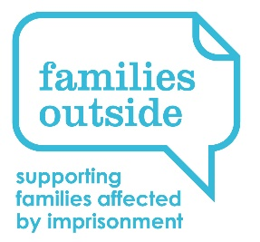
Regional Family Support Coordinator
Supplementary Information

Stirling & Clacks

Responsible to: Regional Manager (North)

Location: This post is currently based in Stirling but with flexibility for travel and some home working.

Hours: 15 hours per week

Primary responsibility for:
HMP & YOI Cornton Vale, linking with the wider Women’s Estate.
Support to families of prisoners in HMP & YOI Cornton Vale and/or other families of prisoners who live in that vicinity/north east Central belt.
Community Planning Partnerships (CPPs) feeding in to the vicinity of HMP & YOI Cornton Vale.
Links with other organisations working in those areas, with particular reference to Circle and the SHINE partnership.
Collaborative working with the Stirling Interfaith Community Justice Group at the Cornton Vale Family Help Hub.

