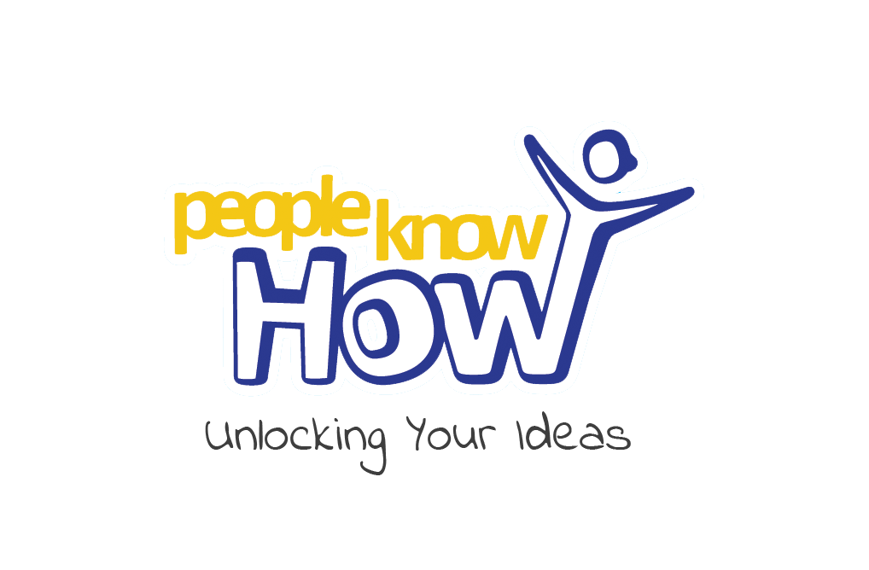 | People Know How  525 Ferry Road  Edinburgh, EH5 2FF  www.peopleknowhow.org

Operations Officer

Salary: | Grade E  £23,787 to £26,690 (with increments over three years)
 | Pension – 5% employee, 3% employer contributions
 | Life Assurance – 4 times salary
Duration: | Permanent
Holidays: | 28 days annual leave plus public holidays
Location: | Home working and 525 Ferry Road, Edinburgh
Start Date: | 1 August 2020

The organisation
People Know How is an Edinburgh based social innovation charity (SCIO), operating since 2013. We combine an international reach, receiving volunteers and interns from all around the world; with a focus on engaging with local people and local issues.
We are committed to addressing marginalisation and have an ethos driven to make a positive difference. We have developed innovative methods to engage and empower people to improve their lives. We believe that together we can create and deliver the most productive and impactful differences for communities.

Our mission
To empower individuals to be socially innovative in their communities, by helping them transform their ideas into action. We do this by providing the skills, tools, resources and framework they need to deliver positive social change.

Our vision
Communities where people have the opportunity to reach their full potential using their strengths and assets.

Our values
- We value people’s potential;
- ​We invest in creative and dynamic processes;
- ​We commit to meaningful action;
- ​We strive for innovative solutions;
- We collaborate with purpose.

Our process
We are people-led, placing huge value on people’s lived experiences, whilst also developing evidence-based approaches through reviewing best practice and research. We call this process ‘social innovation’ and every project we run is rooted in this approach. We have developed a model which we have used to deliver on a number of successful projects. Each of our projects moves through a cycle of 4 key phases:

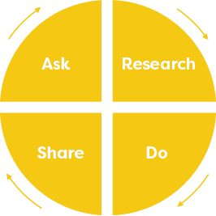
- Ask
We begin every project by asking people to share their ideas, needs, strengths and assets. We believe “People Know How” to identify their needs and the solutions that will help them fulfil their potential and solve social issues.
- Research
We review literature and best practice guidance to inform people’s ideas and ensure there is an evidence base before proceeding with a project.
- Do
We run projects and deliver activities, putting ideas into practice. We have developed a number of monitoring and evaluation tools which are built into our activities so that we are constantly gathering data to assess our progress and performance.
- Share
We share the approaches and impact of our work to recognise and celebrate the positive outcomes, whilst identifying where improvements can be made. We then ask for feedback on what we have shared, creating a cycle driving continuous improvement.

Our key projects:

Social Innovation Programme
In line with our new Strategic Plan to 2025 the programme aims to support and empower communities including people, community groups, new/established charities and to engage in systems change with the public, third, business and academic sectors.

Positive Transitions
Established in 2015 to support disadvantaged and vulnerable children, young people and families. The overarching aim is that children and young people grow up to be healthy, confident and resilient so they can fulfil their potential.

Reconnect
Reconnect was established in 2017 to help people use digital skills to make better social connections and improve wellbeing. It has since grown into a full service supporting adults across Edinburgh, promoting social inclusion and wellbeing.

The role
We have a unique opportunity for an Operations Officer to join our team, during an exciting period of growth. The postholder will be lined managed by the Operations Manager and have responsibility for supporting and line-managing a team of social work and arts therapies students; who will in turn develop their practice with children, young people families and adults. You will have extensive experience in providing support services to children, young people, families and adults.

Key tasks
- To line-manage, support and develop a team of social work students as link tutor working with a Practice Educator;
- To line-manage, support and develop a team of art therapies (art / music / drama) students;
- To line-manage, VIPs (volunteers, interns and placement students) as required.
- To work as part of the team to ensure services are delivered effectively; and to work in partnership with service users, relevant professionals and other stakeholders to ensure the services / projects remits are carried out with regard to statutory commitments and best practice;
This may include:
  - Designing, organising and facilitating group activities including Science Club, Outdoor Journeys and social outings;
  - Engaging with children and young people and empowering them to share their ideas and work together to shape group activities;
- To support the development of work in line with policies, procedures and management systems;
- To fulfil agency requirements in relation to receiving training and practice development, and to develop individual and team skills;
- Support the delivery of the Strategic Plan and its ambitious objectives
- Support the developing of relationships and networks based on shared values;
- Collaborating with the team supporting the design and refining delivery models for new and existing work;
- Collaborating with the team supporting the design and refining monitoring and evaluation frameworks and tools which gather evidence of outcomes;
- Support the collection of monitoring and evaluation data;
- Carry out any other duties as required.

Person specification: essential
- Extensive experience in providing support services to children, young people, families and adults;
- Excellent link worker, support and supervision skills
- Excellent communication skills (written and verbal)
- Skilled in using Microsoft Office applications;
- Strong planning, organisational and administrative skills with the ability to manage multiple projects with overlapping deadlines;
- Practical experience of monitoring, evaluation and reporting;
- Creative, with the ability to share ideas and work collaboratively;
- Highly motivated and able to work independently;
- A positive, professional ‘can do’ attitude;
- Flexible and able to adapt to change to meet the needs of the organisation;
- Ability to work well with others as part of a team;
- Supportive, and able to encourage others to contribute/share ideas;
- Friendly, and able to manage relationships with partner organisations;
- Driven to make a real difference with a shared vision and commitment to what we do.

Person specification: desirable
- A driving licence and access to a car.

