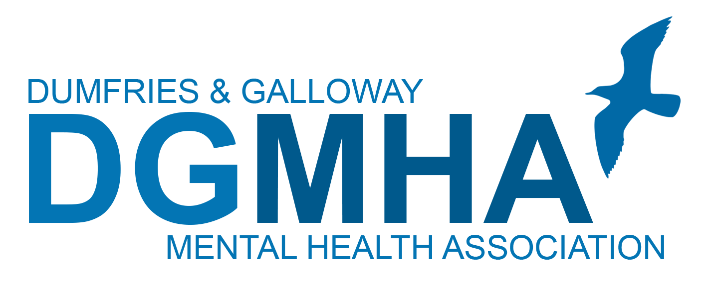

**ROLE DESCRIPTION / PERSON SPECIFICATION**

**Post: Finance Manager**

**Hours: Part Time or Full Time**

**Reporting to: Chief Executive Officer**

**Department: Finance Location: Head Office**

**Purpose of the job**

The Finance Manager is responsible for the financial management and formal reporting for DGMHA, ensuring ongoing viability and a secure financial future in line with the organisation’s charitable status, mission and values.

This role is part of the Senior Management team and will report directly to the Chief Executive Officer and work closely alongside the Head of Care and Support and the HR Manager to ensure the introduction of the transformational change required to future proof the organisation, maintain and improve our place in the social care market place of Dumfries and Galloway and meet our organisational action plans.

**Key Responsibilities**

* Provide an accurate and timely financial service including the development, monitoring and management of budgets, forecasts, cash flow analysis, as well as management and financial accounts
* Develop and implement the appropriate financial policies, procedures, checks and controls to appropriately support the Association and to minimise risk of fraud ensuring that all staff act in accordance with DGMHA requirements
* Manage, review and report on the financial position of the Association on a monthly basis and communicate /review results with CEO as well as Board of Trustee Directors
* Responsible for all statutory reporting, compliance, annual accounts, including Companies House, SORP, and Charity regulations (OSCR)
* Work closely with the CEO/Head of Care & Support to effectively manage our Local Authority service provision contracts including the regular review thereof.
* Work with the Partners Foundation Ltd to deliver effective management of tenancies within DGMHA properties.
* Ensure appropriate financial controls and processes are in place to ensure payroll, procurement, invoicing and credit control operate effectively.
* Develop internal auditing processes for the financial areas of responsibility and manage the annual audit process in conjunction with the appointed auditors to ensure statutory accounts are produced within the required deadlines
* Manage and support the Finance / General Admin Staff (2) to ensure their activities are focussed towards the achievement of the DGMHA business objectives.

**General responsibilities**

* Staff Management: This will include but is not limited to:

- provide professional support and guidance as and when required

- identify staff training & development needs

- set appropriate objectives & review personal performance

- absence management

- effectively address any issues raised by staff

- communicate regularly and effectively with staff members including development of Team meetings and timely staff supervision sessions

* Contribute to a clear focus on driving improvements in quality, impact and performance
* Commit to the Mission, Vision and Values, and be an ambassador for DGMHA in all activities

**Responsibilities common to all staff**

**Data Protection / GDPR**

All employees with responsibility for using personal data must follow the principles in Data Protection legislation/GDPR, ensuring the information to which they have access is used appropriately:

**Health and Safety**

DGMHA places paramount importance on the health, safety and welfare of its employees at work. We aim to exceed the minimum statutory obligations for health and safety.

Under the Health & Safety at Work Act (1974), the employee is responsible for taking care of his / her own health and safety, and that of others who may be affected by his/her acts at work.

**Flexibility**

The employee is expected to adopt a flexible approach to representing DGMHA at varying times and be able to meet the ever-changing challenges and opportunities of working within DGMHA. This role should actively promote and encourage a similar professional disposition throughout the Association.

**Person Specification**

**Experience**: Will ideally have held a similar financial management role although not necessarily in the Care Sector and will be able to demonstrate leadership and financial management experience within a business environment. Must have practical experience across all areas of financial management including payroll, management/cost accounting, budget preparation, Statutory and local reporting, audit procedures and finance policy & procedural design and implementation.

**Education, Qualifications and Training**: Will preferably be professionally qualified in a financial discipline but will as a minimum, have a considerable level of practical experience within a comparable financial role. A thorough working knowledge of MS Office Applications is essential and experience of working with XERO would be a distinct advantage

**Value base:** A belief in inclusion, fairness and equality evidenced through work practice or personal experience. A desire to ensure people are at the heart of decision making and an ability to balance this with the needs of the Association. Commitment to the principles and practices of continuous improvement.

**Skills, Abilities and Knowledge:** Excellent organisational skills and an ability to effectively problem solve within a financial environment. Must be self-motivated, able to work on own initiative, prioritise workload, multi-task, meet deadlines and be able to work under pressure. Will have excellent communication skills (written and verbal) and be able to communicate effectively with all stakeholders. Incumbent should lead by example in terms of behaviour and conduct in relation to everything they do within their role

**Note**: This role description is not exhaustive and is a reflection of current requirements. The employee is expected to view it as a guide rather than an exact description of duties and responsibilities. It may be subject to variation from time to time in accordance with the evolving organisational requirements. .