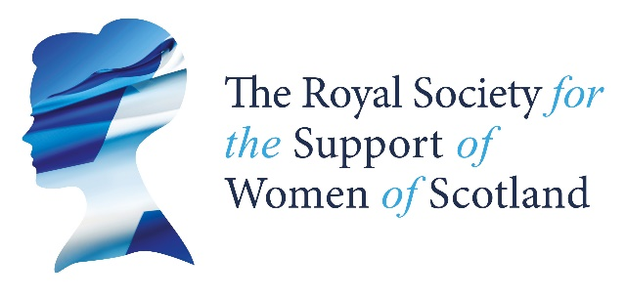
Thank you for taking an interest in The Royal Society for the Support of Women of Scotland (RSSWS). The following information is to help you decide if you are eligible and willing to become a Member and Trustee of the Society.

Background and Finances
The Society is a Royal Charter company. It was founded in 1847 as the Society for the Relief of Indigent Gentlewomen of Scotland and received its first Royal Charter in 1930. However, the Society has kept pace with the times including winning awards for our use of IT. These changes were codified in an updated Royal Charter in 2015 which, amongst other things, changed the Society’s name to The Royal Society for the Support of Women of Scotland. The Society is also a Registered Charity, no. SC016095.
The Society is extremely fortunate to be able to undertake its work with the income it derives from a significant investment portfolio, now under discretionary management with investment managers. The Society does not actively fundraise but welcomes legacies and donations.

Objectives and Activities
The Society operates throughout Scotland with the purpose of providing financial support to single women over the age of 50 who struggle with financial hardship. A small staff team operates from offices in 14 Rutland Square in Edinburgh (a building which was gifted to the Society in 1909) alongside part time Caseworkers based around Scotland who visit both applicants and existing beneficiaries regularly. The Society places significant emphasis on promoting a sense of personal connection and engagement with the Society’s work amongst its beneficiaries and we have overwhelmingly positive feedback from them. However, the core of our support is through the provision of direct financial aid to beneficiaries, principally in the form of a monthly grant (currently £110pcm). In the twelve months to 31st March 2020, a total of £1.3 million was distributed among 1023 beneficiaries.
Further information about the work of the Society, including The Trustees most recent Annual Report and Financial Statements, can be found at http://rssws.org.uk/

Organisational Structure and Trustee Meetings
Under our Royal Charter, the members of General Committee of Management (“the General Committee”) are the Members of the Society and comprise its charitable Trustees. There are between 10 and 17 Trustees with, as far as possible, a balance between Trustees living or working in the East and West of Scotland. Trustees are appointed to serve for an initial term of 3 to 4 years, with the opportunity to be re-appointed, up to a maximum tenure of 12 years. They are not remunerated, but travel expenses are reimbursed.
The General Committee meets 4 times each year (currently on Friday mornings), usually alternately at venues in Edinburgh and Glasgow. One of these meetings is also the Annual General Meeting. As with all organisations, during the Coronavirus lockdown we have adopted remote attendance at meetings and it is probable that we will extend the option to trustees to attend remotely in the future. We hope this may encourage applications from candidates out with the central belt.
The Society also has two sub-committees which meet periodically and which focus on over sight of (a) the management of our investments and (b) our policies and procedures for making grants to beneficiaries. There will be opportunities for successful candidates to become further involved in the work of these sub committees as appropriate and should they wish.

Current Trustee Vacancies:
Following the retirement of several long-serving Committee members this year, the Society invites applications from individuals interested in its work and willing to commit to the role of Member and Trustee. As established by our recent Trustee Skills Audit, we would be particularly interested to hear from individuals with experience and expertise in:
- Welfare delivery and / or grant making to individuals
- Knowledge of welfare policy and /or the effects of poverty
- Accountancy
- Background in general legal practice
However, we would also be interested to hear from individuals with other relevant skills who would be interested in contributing to the future work and direction of the Society.
RSSWS supports women from all around Scotland, and we would like to welcome new trustees from a similarly diverse geographical background. We would be particularly interested to hear from individuals based in the Glasgow area, or in the West or North of Scotland.

Trustee Person Specification
Essential Criteria:
- Commitment to the work of the organisation.
- Good communication skills and the ability to work as part of a group to further the Society’s work.
- Able to exercise independent judgement and take reasonable care, skill and diligence in their role on the Committee.
- Willing to give the time to attend Committee and sub-committee meetings (at least 75% of meetings) and undertake preparatory work.
Desirable Criteria:
- Experience of strategic decision making.
- Previous experience on a Board of Trustees, or an understanding of the charitable sector.
- Competent computer user and able to communicate regularly by email.

Additionally, all Trustees must meet the “Fit and Proper Persons” criteria for being a Charity Trustee. You can find guidance on the duties of Trustees on the Office of the Scottish Charity Regulator’s website.

Recruitment process
To apply please send your CV and a covering letter explaining why you would like to be involved and what skills and experience you have to offer. Please also provide details of TWO referees. Please send your application by email to the Chief Executive at ceo@rssws.org.
Applications close on Monday 24th August 2020. Short-listed candidates will be asked to meet a Selection Panel for interview by Zoom on 7th September 2020 and recommendations made thereafter to the General Committee. References will only be taken up following the interview.
Our Chief Executive would be happy to have an informal discussion about becoming a Trustee or matters relating to the role specification. Due to our current home working arrangements, please email him in the first instance giving a note of your contact details and he will arrange a suitable time to call you back.

Data Protection
All information provided in your application, or from your referees, will be used to process your application and to monitor the recruitment process in accordance with the GDPR. Personal information on unsuccessful applicants will be held for up to 6 months and thereafter destroyed unless permission has been given for records being retained for possible future opportunities.

