**GDPR Privacy Statement for Job Applicants**

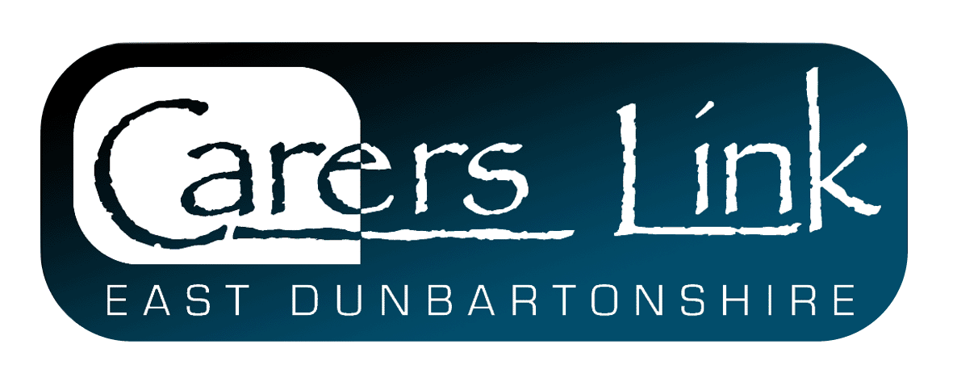

**Welcome**

We appreciate that when you apply for a position at Carers Link, you trust us with not only your contact details but also with a lot of personal and sensitive information. We use this information to process your application but we want you to understand what data we collect, why we collect it and what we do with it. We are committed to not only being transparent but also to meeting our data protection obligations under UK and EU Law.

This notice therefore sets out the basis on which we collect, use and disclose the personal data of our job applicants, as well as your rights in respect of such personal data.

**What information does Carers Link collect and how?**

Carers Link collects a range of information about prospective candidates. This includes:



* Your name, address and contact details, including email address and telephone number
* Details of your qualifications, skills, experience and employment history
* Information from interviews you may have
* Information about your entitlement to work in the UK
* Equal opportunities monitoring information, including information about your ethnic origin, sexual orientation, health and religion or belief.

We may collect this information in a variety of ways. For example, data might be contained in application forms, obtained from your passport or other identity documents, or collected through interviews or other methods of assessment.

We may also collect personal data about you from third parties, such as references supplied by former employers. We will usually seek information from third parties only once a job offer has been made to you. If we require to do this beforehand, we will always check with you first.

Data will be stored in a range of different places, including on your application record, on our server (in a restricted access folder) and within our email system.

**Why does Carers Link process personal data for Job Applicants?**

The table/image above details the lawful basis under EU law for processing your data. We have a legitimate interest in processing personal data during the recruitment process and for keeping records of the process. Processing data from job applicants allows us to manage the recruitment process, assess and confirm a candidate's suitability for employment and decide to whom to offer a job. We may also need to process data from job applicants to respond to and defend against legal claims.

In some cases, we need to process data to ensure that we are complying with our legal obligations. For example, we are required to check a successful applicant's eligibility to work in the UK before employment starts.

Carers Link may process information about whether or not applicants are disabled so we can make reasonable adjustments for candidates who have a disability. Where we process other special categories of data, such as information about ethnic origin, sexual orientation, health or religion or belief, this is for equal opportunities monitoring purposes.

We will not use your data for any purpose other than the recruitment process of which you are a part.

**Who has access to applicant data?**

Your information may be shared internally within Carers Link for the purposes of the recruitment process but is normally restricted to the Management Team, namely the CEO, Operational Manager, Office Manager and Support Manager. Other staff or board members or third parties will only be involved if they have a line-management responsibility for the vacant post and/or are involved in the interviewing stage.

We will not share your data with other third parties, unless your application for employment is successful and an offer of employment is made. We will then share some specific data with former employers in order to obtain references. We will also be required to share your data with Disclosure Scotland for the purposes of PVG membership.

**How does Carers Link protect applicant data?**

Carers Link takes the security of your data seriously. We have internal policies and controls in place to ensure that your data is not lost, accidentally destroyed, misused or disclosed, and is not accessed except by staff in the proper performance of their duties.

**For how long does Carers Link keep applicant data?**

If your application for employment is unsuccessful, we will hold your data on file for 6 months. At the end of that period, your data is deleted or destroyed (unless we need to retain it for longer to exercise or defend any legal claims).

If your application for employment is successful, personal data gathered during the recruitment process will be transferred to your personnel file and retained during your employment. The periods for which employee data is held will be provided to you in a separate privacy notice.

**Your rights**

As a data subject, you have a number of rights under data protection law. You can:

* Access and obtain a copy of your data on request;
* Require Carers Link to change incorrect or incomplete data;
* Require Carers Link to delete or stop processing your data
* Object to the processing of your data where Carers Link is relying only on our legitimate interests as the legal ground for processing; or
* ask us to transfer your data to another organisation.

If you would like to exercise any of these rights or if you have any questions about this notice or our processing of your data more generally, please contact the CEO on [jennifer@carerslink/.org.uk](mailto:jennifer@carerslink/.org.uk). If you believe that we have not complied with your data protection rights, you can complain to the Information Commissioner's Office (<https://ico.org.uk/>).

**What if you do not provide your personal data?**

You are under no statutory or contractual obligation to provide data to Carers Link during the recruitment process. However, if you do not provide the information, we may not be able to fully process your application.