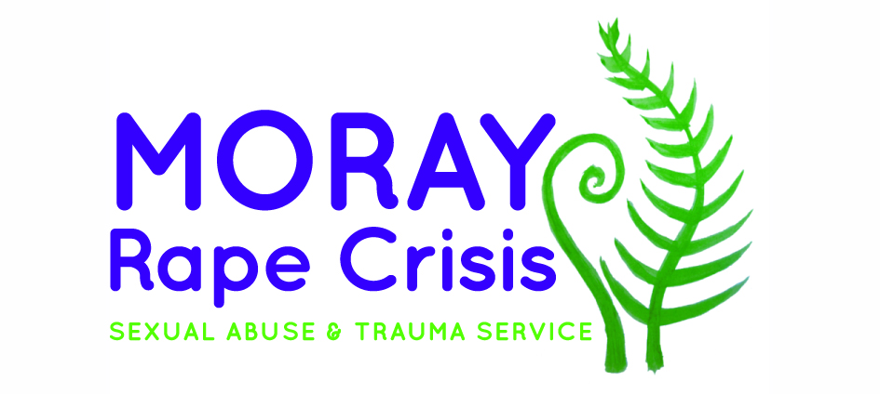

Dear Applicant,
Vacancy: Sexual Violence Prevention Worker
Thank you very much for your interest in working with Moray Rape Crisis.
I am enclosing:
- Background information
- Job description
- Person specification
- Application form
- Equal opportunities monitoring form online link
Further information about Moray Rape Crisis is available at www.morayrapecrisis.scot and about Rape Crisis Scotland and the work of Member Centres at www.rapecrisisscotland.org.uk
Please note that the deadline for completed applications is midnight on Sunday 27th September. Interviews will be held on Wednesday 7th October online via Zoom. Due to limited resources, we will only contact you if you have been shortlisted for interview. All shortlisted candidates will be contacted by email by Thursday 1st October.
If invited to interview we will ask you to prepare a 10 minute presentation related to the prevention worker role and to present this at the start of your interview. We will confirm the presentation topic when contacting candidates shortlisted for interview and can be flexible about the presentation format.
Please note that we do not accept CVs. The full application form should be completed and emailed to recruitment@rapecrisisscotland.org.uk. The completed equal opportunities monitoring form should be completed online at https://www.surveymonkey.co.uk/r/CPCCVYB
Please note only women need apply under Schedule 9, Part 1 of the Equality Act 2010.
We look forward to receiving your application. In the meantime, if you have any queries please contact me at isla.guild@rapecrisisscotland.org.uk or via 0141 331 4180.
Yours faithfully,

Isla Guild

Prevention Programme Manager

Rape Crisis Scotland

Background Information: Moray Rape Crisis

Moray Rape Crisis is currently a project being overseen by Rape Crisis Scotland, with the first worker having come into post in 2018, with a formal launch in September 2018. It is the newest Centre in the national network of 17 Rape Crisis Centres, all of whom are members of Rape Crisis Scotland and adhere to the Rape Crisis Scotland National Service Standards. Currently there is a shadow board in place preparing for the SCIO application, to become an independent charity, and all staff will TUPE over from Rape Crisis Scotland to Moray Rape Crisis later in 2020.

You can find out more about what Rape Crisis support involves in our short film Making Recovery a Reality https://www.youtube.com/watch?v=D7MSqIok0zw.

Moray Rape Crisis currently:

Provides trauma informed therapeutic 1:1 & group support to survivors of all genders and all forms of sexual violence aged 11+ as well as their friends, family, partners and workers

Provides advocacy support to those considering, or engaging with the criminal justice process. We are not currently part of the National Advocacy Project, but are working towards having a dedicated advocacy worker.

Works in partnership with other key stakeholders to improve understanding of gender based violence and trauma informed responses to survivors of sexual violence

With the addition of this post we will deliver prevention work with young people as part of the Rape Crisis Scotland National Prevention Programme. https://www.rapecrisisscotland.org.uk/national-sv-prevention-programme/

Sexual Violence Prevention Worker post
There is increasing awareness of issues of sexual violence affecting young people (such as sexual bullying, pressures and expectations around “sexting”, and violence within teenage relationships) and of the impact of increasing sexualisation in the media. This post is part of a national programme involving prevention workers based at Rape Crisis centres around Scotland, coordinated by Rape Crisis Scotland, using a shared resource pack and evaluation framework. Regular training opportunities and a practitioners’ forum are provided as part of the programme. More information and the report from an external evaluation can be found https://www.rapecrisisscotland.org.uk/national-sv-prevention-programme/
The post is funded by the Scottish Government Violence against Women and Girls Fund until the 30th September 2022.

Job description

Job Title: Prevention Worker
Salary: £27, 714 pro rata
Hours: 21 hours per week
Annual leave: 30 days, plus 12 days Public Holidays (pro rata)
Pension Entitlement: 8%
Responsible To: Manager

Purpose of Post | The overall aim of this post is to deliver interventions to young people around healthy sexual relationships using the Rape Crisis Scotland sexual violence prevention pack, and to develop local strategic approaches to sexual violence prevention.
Main Responsibilities and Activities | 1.Delivery of prevention education  - Deliver educational programmes in schools and other education and community settings using the Rape Crisis Scotland sexual violence prevention pack.  - Develop partnerships with schools and other education providers to plan education programmes and to support the development of policy and practice in relation to sexual violence, in accordance with existing priorities such as Curriculum for Excellence, Getting it Right for Every Child and child protection.  - Deliver information sessions to school staff and parents/carers as required.  2.Strategic development  - Liaise with statutory and voluntary sector agencies (such as local education authority, youth and children’s services) and participate in multi-agency partnerships to develop strategic approaches to sexual violence prevention.  - Liaise with Rape Crisis Scotland to increase connections and consistency between local and national approaches to prevention sexual violence.  - Participate in practitioners’ forums with network of Rape Crisis prevention workers  - Seek and develop opportunities for young people to be involved in shaping prevention interventions.  3. Support  - Respond sensitively to disclosures and facilitate young people’s access to support services as appropriate  - Act on any child protection or wellbeing concerns identified during seminars according to centre’s child protection policies and procedures. Where appropriate, participate in multi-agency initiatives to promote the young person’s safety and wellbeing.  4. Monitoring and Evaluation  - Gather evaluation data from young people and link professionals using the materials in the Rape Crisis Scotland sexual violence prevention pack. Pass data to Rape Crisis Scotland to inform revision of materials and funding reports.  - Contribute to any agreed evaluation procedures including external evaluations.  5. Equalities  - Promote anti-discriminatory values and non-violence in all aspects of practice.  6. Accountability, supervision and professional development  - Attend regular support and supervision with line manager.  - Undertake training and development as required.  - Adhere to centre’s policies and procedures.  7. Team working and communication  - Work as a team with other centre employees  - Attend regular team meetings  8. Other  - Additional duties as required

Person Specification
CRITERIA |  | ESSENTIAL |  | DESIRABLE
Knowledge | E1  E2  E3 | Understanding of feminist analysis of violence against women  Thorough knowledge of issues relating to sexual violence  Understanding of the impact of sexualisation of young people in the media and links with violence against women | D1  D2 | Knowledge of approaches to sexual violence prevention  Knowledge of current legislation, policy and strategy relating to education and to the violence against women agenda
Skills and Abilities | E4  E5  E6  E7  E8 | Ability to engage with young people in a range of settings  Ability to work effectively with a wide range of partners in voluntary and statutory agencies  Good communication skills both written and oral  Ability to organize and prioritise workload  Competence in use of IT, for example Word and Excel programmes, email and internet and delivery of Powerpoint presentations
Experience | E9  E10 | Experience of delivering workshops/groupwork to young people  Experience of responding to disclosures | D3  D4  D5  D6 | Experience of developing educational materials or groupwork programmes  Experience of working with people affected by gender-based violence  Experience of evaluating interventions aimed at young people  Experience of working independently in an outreach capacity
Qualifications |  |  | D7 | Qualification in Social Care, Community Education, Youth Work or similar discipline
Other | E11  E12  E13 | Access to vehicle and able to travel to various locations in the local area  Able to work flexibly and to undertake some evening and weekend work  Commitment to anti-discriminatory practice

Application to Rape Crisis Scotland
for the post of Sexual Violence Prevention Worker – Moray Rape Crisis

To be returned to: recruitment@rapecrisisscotland.org.uk
by: Midnight on Sunday 27th September

Section 1: Personal details
Surname: | First name:
Address: | Tel (home):
 | Tel (mobile):
Tel (work):
May we contact you at work? yes/no
Postcode: | Email address:

Section 2: Qualifications and training
(only enter those qualifications and/or training necessary or relevant to the job)
Qualification and/or training |  |  | Subject |  | Date
Section 3: Present employer
Name & address of employer: |  |  |  | Date commenced employment:
Job title: |  |  |  | Notice required: |  | Current salary:
Brief description of your main duties and responsibilities, with an emphasis, where possible, on those areas most relevant to the job applied for:

Section 4: Previous employment (list in order, with most recent employer first)
Please list all your previous employment, detailing any gaps between employments with reasons (continue on a separate sheet if necessary).
Dates |  | Name and address of employer |  | Job title and nature of work |  | Reason for leaving
From  DD/MM/YY | To  DD/MM/YY

Section 5: Relevant skills, experience and abilities
With reference to the job description and person specification, please outline how your work experience (including unpaid work) training, skills and abilities would enable you to carry out the duties of this post. Please include any information which you feel is relevant, paying specific attention to the Essential and Desirable points in the person specification as scoring and shortlisting will be based on your answering each point. Shortlisting will be based on the information given in this application so please be explicit and give specific examples from your own practice where helpful. Do not include a CV as this will not be considered.
Section 6: References
Moray Rape Crisis requires a minimum of 2 employment references to cover a three year period – if necessary, please provide further referees covering the last 3 years. Your referees should be your line manager / former line manager. If this is not possible please explain why.
Reference 1: Current / most recent employer
Name: | Position: |  | Tel no:
Company name: |  | Address:
May we, with discretion, contact your employer to discuss this reference:
Yes/no
Reference 2: Previous employer / supervisor
Name: | Position: |  | Tel no:
Company name: |  | Address:
May we, with discretion, contact your previous employer to discuss this reference:
Yes/no
Reference 3: Previous employer / supervisor
Name: | Position: |  | Tel no:
Company name: |  | Address:
May we, with discretion, contact your previous employer to discuss this reference:
Yes/no

Section 7: Declaration
I certify that all the information contained in this form and any attachments is true and correct to the best of my knowledge. Offers of employment will be subject to satisfactory references, a PVG check and compliance with UK working restrictions. I realise that false information or omissions may lead to dismissal without notice.
Signature: (Electronic will suffice)
Date:
For more information on how we use and store your data please refer to our privacy policy https://www.rapecrisisscotland.org.uk/privacy/ Applications will be retained for a 6 month period following the deadline and the successful applicant’s data will be dealt with in line with our GDPR & HR policies.

