

**Ardenglen Housing Association**

**Pantry Co-ordinator**

**Recruitment Pack**

**September 2020**

**Contents**

|  |  |
| --- | --- |
| CEO Welcome | 3 |
| About us | 4 |
| Strategic map 2019-21 | 5 |
| Organisational structure | 6 |
| Job profile | 7 |
| Person specification | 11 |
| Summary of terms | 13 |
| The selection process | 14 |
| Fair Processing Notice | 15 |

**CEO Welcome**

Dear applicant

**Pantry Co-ordinator Vacancy**

Thank you for your interest in the above post. This is an exciting time to be joining Ardenglen and its partners as we launch the ***Castlemilk Community Food Pantry***.

During the COVID-19 pandemic, the delivery of emergency food provision became a critical element in terms of supporting our community through a difficult time. As we ease very gradually out of lock-down the opening of the Castlemilk Community Food Pantry could not be timed any better. The numbers supported during the crisis clearly demonstrate there is demand for good quality food and as a partnership of organisations, we wish to move towards a more dignified, affordable and sustainable way of supporting our community.

Please find enclosed an application pack including details of the role, a personal specification to assist you with completing and tailoring your application, application form and equal opportunities monitoring form.

Please note that applications will only be considered if all the documentation is complete. Please send your application, preferably in MS Word format by email to: **recruitment@ardenglen.org.uk** or by post to Recruitment, Ardenglen Housing Association, 355 Tormusk Road, Castlemilk, Glasgow G45 0HF

**Applications must be received by 12noon** **Monday 12th October 2020.**

This is a great opportunity for the right applicant to come and join us to develop and shape this new venture and we look forward to receiving your application.

Yours sincerely



Audrey Simpson

**Chief Executive Officer**

Encs

**About us**

Ardenglen is a not-for-profit charity registered with the Scottish Housing Regulator and the Register of Friendly Societies.

The association was formed in 1990 thanks to the dedicated efforts of local tenants who were determined to bring change to their area and to be involved with the improvement and management of their home.

In addition to being a landlord, we also provide a factoring service to approximately eighteen owners, we let six commercial shop units and through our subsidiary, Ardenglen Developments Limited, we let office space to a community based charity.

Our new strategic map was developed through consultation with our full staff team and Board. It sets out the organisations vision, values and strategic objectives. Our values set the organisational culture and underpin everything we do.

As previous recipients of the CIH “Team of the Year” and shortlisted for Housing Association of the Year awards 2020, we are a people focussed organisation and recognise that staff training and development, are crucial to helping us achieve our strategic objectives.

The association is managed by a vastly experienced Board whom are responsible for deciding strategic direction and monitoring the performance of the association.

We are looking for someone to join us as Pantry Co-ordinator who:-

* has a real interest and commitment to the strategic direction of the

Association

* can contribute to the wider regeneration of our local community
* has the highest standards of personal integrity
* is diligent and precise in their work
* has the potential to be a valued member of our staff team

**Strategic Map 2019-21**

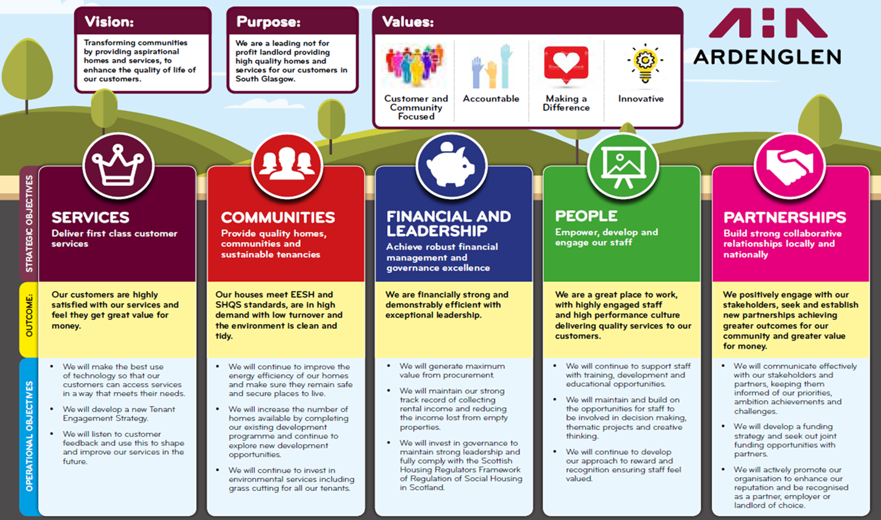

**Organisational Structure**

**Job profile**

|  |  |  |  |  |  |  |  |  |
| --- | --- | --- | --- | --- | --- | --- | --- | --- |
| ----------------------------------*--**-**-we-*+  **Ardenglen Housing Association**  **Job Profile** | | | | | | headed paper logo | | |
| **Job Details** | | | | | | | | |
| **Job Title:** | Castlemilk Pantry  Co-ordinator | | | **Location:** | | | Castlemilk | |
| **Service Area:** | Operations | | | **Responsible to:** | | | Regeneration Officer | |
| **Grade:** | EVH Grade 6 (pro rata)  £28,538-£31,198 | | | **Responsible for:** | | | Pantry Volunteers | |
| **Date Reviewed:** | New | | |  | | |  | |
| **Job Summary** | | | | | | | | |
| The Pantry Co-ordinator will have responsibility for setting up and successfully managing and leading on the operations of Castlemilk Pantry. Our Pantry Co-ordinator must be customer and community focussed with great organisational and leadership skills and able to work in a fast-paced environment. The Pantry Co-ordinator will lead and develop a team of volunteers to support the operations of the Pantry. | | | | | | | | |
| **Job Outputs** | | | | | | | | |
| The job holder will carry the formal responsibility for delivering the following key tasks. They will be achieved through effective working relationships with those in the identified key relationships. However, this job description does not limit or define the scope of this role. It should be stressed that this is a varied role and the post holder will require to be ‘hands-on’ within the day to day running of the Pantry. | | | | | | | | |
| **Key Tasks** | | | **Includes the requirement to:** | | | | | |
| Leadership and Management | | | * Providing day to day leadership for the Castlemilk Pantry, ensuring clarity of vision, values and objectives for customers, staff, volunteers and other stakeholders. * Develop Pantry objectives and ensure systems in place to achieve those objectives. * Assess Pantry requirements to determine number and range of volunteers required. * Manage volunteer recruitment process and maintain volunteer database. * Provide appropriate support and training for volunteers. * Organise and manage volunteer rotas. * Engage positively with partner organisations and stakeholders, seek out, and explore new partnership opportunities. | | | | | |
| Finance, Operations and Reporting | | | * Run all operational activity in the Pantry, including stacking shelves, stock taking, customer services. * Establish cash handling systems. * Liaise with Fare Share and manage partnership. * Manage cash handling process and monitor and manage budgets. * Ensure all standards including customer services, health and safety and food and hygiene are maintained. * Develop, implement and review suite of policies and procedures to support the effective operations. * Ensure principles of sustainability are embedded across the activities of the Food Pantry from food production to disposal. * Ensure adequate audits and stock taking systems. * Co-ordinate food delivery with partner organisations. * Ensure foods are stored in line with food standards requirements and that fresh fruit and vegetables are ‘turned over’. * Develop and implement membership system. * Prepare monthly statistics in line with Pantry Key Performance Indicators. * Prepare reports to partners, stakeholders, Pantry Management Committee, Ardenglen Board and CEO as required. | | | | | |
| Communication and Customer Services | | | * Ensure high quality customer services that reflect the values of Ardenglen Housing Association. * Establish effective community engagement tools and processes to seek regular feedback from customers. * Consider and act on customer feedback where appropriate, to ensure the successful operations of the Pantry. * Process complaints in line with Ardenglen Complaints Policy and actively learn from complaints to drive service improvements. * Prepare communications and briefings as required. * Develop marketing strategy to maximise membership up take. | | | | | |
| Maintaining Operational and Organisational Standards | | | * Always act in the best interests of Ardenglen Housing Association. * Support Ardenglen Housing Association’s objectives and values. * Encourage and drive quality and continuous improvement of processes used across the team. * Follow all policies and procedures. * Adapt to legislative, regulatory, and organisational changes in the work environment. * Supervision, management and operational lead for the Food Pantry. * Preparation of monthly statistics, reporting and sharing of information. * Monitoring of budget. * Ensure that the Health & Safety requirements are always met. | | | | | |
| Ardenglen Housing Association will develop as an organisation to deliver its long terms aims. The developing direction and priorities of the Association will require flexibility and post holders will be required to respond to these within the scope of their job role. | | | | | | | | |
| **Key Relationships** | | | | | | | | |
| * Liaise and manage Fare Share partnership. * Liaison with other partners. * Communicate positively with membership. * Report to Pantry Committee. | | | | | | | | |
| **Special Conditions** | | | | | | | | |
| * You may occasionally be expected to undertake activities out with working hours e.g. training or critical incidents/emergency situations that may arise. * To undertake training as necessary to maintain high standards in the quality of work as outlined in the Job Outline and Key Competencies and as identified in the personnel development process. * Ensure you adhere to and are fully conversant with any Health & Safety regulations provided by the Association. * To actively promote the Equality and Diversity Policy in all aspects of the job role as it relates to colleagues, tenants, service users, contractors, consultants and external agencies. * The post holder must work in accordance with the Association’s performance standards, core values and any instructions and/or training received. * The Job Outline is indicative of the nature and level of responsibility associate with the post. It is not exhaustive, and the post holder may be required from time to time to undertake such other reasonable duties as may be required by the Chief Executive or Board of Management. | | | | | | | | |
| **Review** | | | | | | | | |
| The Job Outputs will be reviewed as and when required in accordance with the Association’s review mechanisms. | | | | | | | | |
| **Job Description Agreement** | | | | | | | | |
| Job holder: | |  | | | Date: | | |  |
| Line Manager: | |  | | | Date: | | |  |

**Person specification**

|  |  |  |
| --- | --- | --- |
| **Education and professional membership** | **Essential** | **Desirable** |
| Community Development qualification or equivalent experience | x |  |
| REHIS Food Hygiene qualification or equivalent experience | x |  |
| Evidence of continued professional development in related areas |  | x |
| **Skills, knowledge and ability** | **Essential** | **Desirable** |
| Knowledge of food safety regulations and legislation that would be applicable to the Pantry. | x |  |
| Knowledge of the needs and experiences of volunteers and service users from a diverse range of backgrounds | x |  |
| Sound knowledge of volunteer management good practice and the ability to establish and maintain appropriate systems for the management and accurate recording of volunteer programmes |  | x |
| Strong communication and interpersonal skills with the ability to deal with people at all levels in order to build successful, productive business relationships, both internal and external | x |  |
| Enthusiastic and self-motivated with excellent team-working skills | x |  |
| Ability to use own initiative, working independently with good time management and ability to manage workload, set priorities and meet deadlines | x |  |
| Strong presentation skills to promote the Castlemilk Community Pantry as a destination for volunteering along with sound IT literacy in particular using Microsoft applications (outlook, word, excel & power point) | x |  |
| **Experience** | **Essential** | **Desirable** |
| Experience of successful project development within the social enterprise sector | x |  |
| Developing and delivering successful volunteer recruitment, training and engagement programmes |  | x |
| Experience of working with volunteers/adults with additional support needs and ability to lead and mentor them to unleash their potential | x |  |
| Experience of line-managing others in a work-based setting, including developing and empowering staff | x |  |
| Ability to manage a volunteer team and workload, delivering and delegating where appropriate | x |  |
| Building relationships with external organisations and associations to create and promote volunteering programmes | x |  |
| Managing projects and associated budgets | x |  |
| Experience of delivering effective marketing and communications campaigns | x |  |
| Experience of working in a food/shop related environment | x |  |
| Ability to develop creative solutions to complex problems | x |  |
| **Personal Qualities** | **Essential** | **Desirable** |
| Takes ownership and is solution focused | x |  |
| Highly organised but flexible and comfortable working with a wide range of partners | x |  |
| Strive for continuous improvement of best value, quality service provision and your own personal development | x |  |
| Excellent interpersonal skills with the personal credibility and integrity required to engage effectively | x |  |
| Personal resilience, self-awareness and willingness to learn and adapt | x |  |
| **Other Requirements** | **Essential** | **Desirable** |
| Full Driving License and daily access to a car | x |  |
| Committed, flexible and adaptable approach to work requirements | x |  |
| Commitment to the principles of customer care, equal opportunities and the core values of Ardenglen Housing Association | x |  |

**Summary of Terms**

Ardenglen Housing Association is a full member of Employers in Voluntary Housing (EVH) and the terms and conditions for this post follow the EVH terms. A summary of the principal areas are as follows:

|  |  |
| --- | --- |
| **Salary** | **Employers in Voluntary Housing Grade 6**  **£28,538-£31,198** |
| **Salary Payment** | Salary will be paid on the 27th of the month |
| **Contract status** | Fixed Term until end March 2022 (extension may be possible but subject to funding) |
| **Hours** | 30-35 hours per week – scope to have some flexibility on the contracted hours of work. |
| **Primary place of work** | Castlemilk Community Food Pantry  c/o Castlemilk Community Centre  121 Castlemilk Drive  Castlemilk  GLASGOW  G45 9UG  The Community Centre has onsite staff car parking |
| **Holiday entitlement** | 25 annual leave days per annum  15 public holidays per annum pro rata |
| **Pension** | The Association offers SHAPS Defined Contribution pension scheme including the option for salary sacrifice. |
| **Notice period** | Four weeks |
| **Learning & Development** | Ardenglen are Investors in People (IIP) accredited and committed to providing staff with learning and development opportunities to ensure that individuals and departments are able to contribute fully to the achievement of department and organisation objectives |

*This summary is for general guidance of applicants and will not form part of the contract of employment. Any offer of employment will be subject to the receipt of satisfactory references.*

**The selection process**

|  |  |
| --- | --- |
| **Closing date for applications** | **Monday 12th October 2020 at 12noon** |
| **Interviews:** | **Friday 23rd October 2020** |

Candidates will be required to carry out a 10-minute presentation. The presentation topic will be included within the interview notification letter to allow suitable preparation time. A display screen and laptop will be available for presentations.

Following on from the presentation will be questions based on your application form to determine suitability for the post.

It is our intention to conduct interviews within our offices; however this is subject to review in response to Scottish Government advice.

Ardenglen Housing Association   
355 Tormusk Road  
Glasgow  
G45 0HF

**Fair Processing Notice**

This notice explains what information we collect, when we collect it and how we use this. During the course of our activities, we will process personal data (which may be held on paper, electronically, or otherwise) about you and we recognise the need to treat it in an appropriate and lawful manner. The purpose of this notice is to make you aware of how we will handle your information.

**How we use your information**

The information we collect from you will in the main be basic personal and contact details, which we require to carry out our functions as a Registered Social Landlord. There are occasions however where we are required to collect data of a more sensitive nature which we will always treat with the utmost confidentiality.

We will only hold your personal data for as long as is necessary for the relevant activity, or as required by law (we may be legally required to hold some types of information), or as set out in any relevant contract we have with you.

We may collect the following personal information about you:

* Name
* Address
* Date of birth.
* Telephone number(s)
* Email address;
* Employment history
* Educational achievements;
* Professional memberships,
* Current remuneration;
* Declaration of interest in relation to Ardenglen Housing Association’s Board or employees
* Gender
* Ethnicity
* Disability
* Medical details
* Signature.
* Right to work in the UK
* Criminal record declaration.
* Driving license status
* References to support your application

We will also collect additional information when we make an applicant an offer of employment. This could include requesting and holding a copy of your passport, national insurance number and in some circumstances a valid driving licence, insurance and MOT documents.

We will not collect any personal data for you that we do not need.

**How your information will be used**

We need your information and will use your information to:

* Meet our legal obligations including information we must provide to regulators and statutory authorities;
* Ensure that an applicant has the legal right to work in the UK.
* Make reasonable adjustments for a candidate who is disabled
* Produce and monitor recruitment and selection statistics.
* Check criminal convictions information to ensure we meet legal obligations in relation to certain positions
* Process your data before entering into a contract with you, if your application for employment is successful.
* Process data during the recruitment and selection process to help us manage the process, and to assess an applicant or candidate’s suitability for employment.
* Respond to and defend against any possible legal claims.

**Consent**

Where we collect special category data such as information about your ethnicity, sexual orientation, health or religion we do so for our monitoring purposes and only with your explicit consent.

We also need and use your information for all other purposes consistent with the proper performance of our operations and business.

**Sharing of Your Information**

The information you provide to us will be treated by us as confidential and will be processed only by our employees within the UK/EEA. We occasionally need to share personal information with other organisations, however where this is necessary, we are required to comply with all aspects of GDPR. Even when this is required, we only share data within the European Union. Unless required to do so by law, we will not otherwise share, sell or distribute any of the information you provide to us without your consent.

Your information may be shared internally with staff involved in the recruitment process.

We may also seek information from the following third parties when an offer of employment has been made and may disclose your information to appropriate third parties who act for us including the following:

* Referees;
* Disclosure Scotland PVG scheme for certain positions;
* Relevant bodies to validate your qualifications or professional memberships; and
* Lawyers or solicitors where legal advice may be sought in relation the processing of an application and the recruitment process

The following organisations may be given controlled access to our electronic network for reason of security, maintenance, or any specific purposes outlined in their third party agreement:

* IT support contractors.
* Specialist housing software providers.
* Electronic file system software provider.

We are also required to share information with statutory bodies which govern finances or housing for auditing or inspection purposes. However, this will be restricted to the actual information required from the Association and will usually be viewed within the Association, with strict permission set on our electronic file system to ensure use is controlled. We will also encrypt and limit the content of any files that require to be sent either electronically or otherwise.

**Your Rights**

You have the right at any time to:

* ask for a copy of the information about you held by us in our records
* require us to correct any inaccuracies in your information

If you would like to exercise any of your rights above, please contact us at [dataprotection@ardenglen.org.uk](mailto:dataprotection@ardenglen.org.uk) or tel: 0141 634 8016

You also have the right to complain to the Information Commissioner’s Office in relation to our use of your information. The Information Commissioner’s contact details are noted below:

The Information Commissioner’s Office – Scotland  
45 Melville Street  
Edinburgh  
EH3 7HL  
  
Telephone: 0131 244 9001  
Email: [Scotland@ico.org.uk](mailto:Scotland@ico.org.uk)

The accuracy of your information is important to us; please help us keep our records updated by informing us of any changes to your details