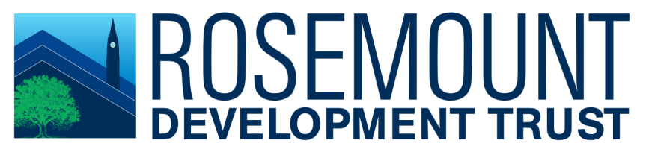

Rosemount Development Trust Information Pack

Community Development Officer

October 2020

CONTENTS

Page

Covering Letter 1

About Us 2

Guidance Notes 3

13 October 2020

Dear Applicant

Post of Community Development Officer

Thank you for expressing interest in coming to work with us Rosemount Development Trust.

The following documents with this information pack include:

- Application Form
- Equal Opportunities Monitoring Form
- Job Description and Person Specification.

Once you have completed your application and equal opportunities monitoring form please email to: admin@rosemounttrust.co.uk or post to Rosemount Development Trust, Unit W16, Rosemount Business Park, 141 Charles Street, Glasgow, G21 2QA (Mark on envelope CDO Post P&C) no later than Friday 30th October 2020 at 12noon.

Only those applicants short listed for interview will be contacted and this will be by Monday 16th November 2020.

Interviews will be held week commencing 30th November 2020.

Yours sincerely

Maureen Flynn
Managing Director

ABOUT US

Rosemount Development Trust Limited, Rosemount (Workspace) Limited and Roystonhill Spire and Park Limited form the Rosemount group of companies.

Rosemount Development Trust is a social enterprise, formed in 1989 as a company limited by guarantee, with a voluntary board of directors. Members of the Board are elected from RDT’s membership, which is open to residents within Royston and surrounding areas. The Board is responsible for setting policy and strategic management of the company. Management of the day to day operation is delegated to the Managing Director, Maureen Flynn.
The Trust is a longstanding local community development body, working in the field of workspace provision, employment, and community development in Royston, in the north of Glasgow. It has played a lead role in creating and sustaining employment at its Charles Street and Millburn Centre premises, as well as preserving and enhancing the A-listed structure known as Roystonhill Spire for the community.

As a community led and managed organisation operating in Royston for the past 30 years, we are proud to acknowledge and publicise our contribution to the regeneration of the Royston community over the years.
Rosemount has directly and indirectly, through provision of locally managed workspaces, enabled many community organisations to locate in affordable business premises, to not only deliver essential services to residents of Royston and surrounding areas, but also to run businesses and create much needed employment and training opportunities within the community.

Our Charitable Objectives are:

- To prevent and/or relieve poverty, particularly among residents of the community.
- To relieve unemployment in such ways as may be thought fit, particularly among the residents of the community.
- To advance citizenship and community development, particularly with the community.
- To relive those in need by reason of age, ill-health, disability, financial hardship, or other disadvantage, particularly among residents of the community.
- To support such other similar charitable purposes for the benefit of the community as the directors may consider appropriate from time to time.

All the above to be consistent with sustainable development.

Brief History

1989 - Rosemount Development Trust Limited (RDT), a company limited by guarantee with charitable status, was formed by a group of residents who were concerned about the high level of unemployment and poverty in Royston.

1997 - RDT set up its first wholly owned subsidiary company Rosemount (Workspace) Limited (RWL).

2000 - RDT set up its second wholly owned subsidiary Roystonhill Spire and Park Limited to maintain and preserve, the A listed structure in Royston known as the Spire and its surrounding park.

2014 - Local organisations came together to form the Royston Strategy Group (RSG) to deliver a regeneration strategy for the Royston area, oversee the process for its implementation. Kevin Murray Associates were engaged to deliver a community led vision and strategy for Royston.

To date a number of initiatives, identified in the strategy document, have been achieved but there are still much more difficult milestones to achieve.

Partners include: Blochairn, Copperworks and Spire View Housing Associations, GHA, Rosemount Lifelong Learning, Royston Youth Action, North Glasgow Community Initiative, Glasgow City Council elected members, MSP and MP.

A copy of the Royston Vision and Strategy Document is available on request from:

admin@rosemounttrust.co.uk

Guidance Notes

Please read these notes carefully – they are to help you make the best of your application.

- Please do not send your Curriculum Vitae.

- One of your references should be your present or most recent employer.

- The person specification lists the essential and desirable requirements for this post. When short listing for interview, the selection panel will consider the information contained in your application form and assess this against the person specification.

- It is not the responsibility of the selection panel to make assumptions about the nature of the work you have done from a list of job titles. It is therefore, important that you use the space provided to detail your experience and skills. Neither is it enough for you just to state that you meet the requirements; you must demonstrate this to the panel.

- If you are short listed for interview, the selection panel will wish to discuss the areas covered in the person specification in more detail.

In particular, the panel will assess your commitment to and understanding of diversity and equal opportunities.

Rosemount Development Trust
Unit W6/W16
Rosemount Business Park
141 Charles Street
Glasgow
G21 2QA

Telephone: 0141 552 1199
Email: admin@rosemounttrust.co.uk

www.rosemounttrust.co.uk

