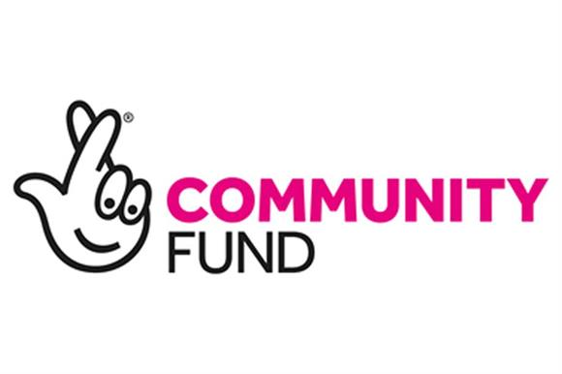

Title: Project Manager

Salary: £29,120 per annum
This post has been funded by the National Lottery Community Fund and William Grant Foundation until June 2022, however we are hopeful to secure funding to extend the post beyond this date.

Hours: 35 hours per week (£16 per hour)

Responsible to: The Board of Trustees

The Project Manager will be responsible for assisting the Board of Trustees to support the delivery of the organisations’ services as a Lanarkshire wide charity. This will be achieved through retaining current services and helping to develop new projects. The post holder will manage the day to day running of the charity and will liaise with the Board of Trustees as and when required to ensure the charity is continuing to develop and expand. The post holder will Line Manage all staff within the charity.

Aims of Post:

• To manage the day to day delivery of all services.
• To line manage, support and motivate staff to ensure the smooth delivery of services
• To ensure that services are consistently high quality and that services are provided effectively and efficiently according to funding and contractual requirements
• To ensure that our services meet the evolving needs of service users
• To demonstrate commitment to the values of REACH Lanarkshire Autism and ensure this is distilled in the delivery of services

Duties:

1. Working with the Board of Trustees to ensure that highest quality and strong outcomes are achieved for those who access the services.
2. To ensure the services provided are consistently user-led, accessible and responsive, that they maintain the accurate representation of views and interests of service users and uphold their legal and human rights, in line with REACH Lanarkshire Autism’s policies and procedures.
3. To proactively seek ways to raise the profile and credibility of REACH Lanarkshire Autism with all those associated with it externally, supporting a team of paid staff and unpaid volunteers to do the same.
4. To build constructive and collaborative relationships with other professionals, whilst maintaining the accurate representation of the views of service users and the independence of REACH Lanarkshire Autism services.
5. To handle complaints and comments in line with organisational policy.
6. To identify and resolve any operational issues that arise within the services.
7. To ensure recording and monitoring systems are in place, to track and record activity so that reporting requirements can be satisfied.
8. To ensure that data is accurately entered and managed within the organisation databases
9. To collate information and produce reports for REACH Lanarkshire Autism’s Trustee meetings.
10. To coordinate the gathering of information (budgets, materials, evaluation reports, etc.) in line with REACH Lanarkshire Autism’s policies and procedures.
11. Ensuring all project policies including GDPR are up to date and rigidly adhered to
12. To ensure that records are up to date, accurate and complete, and that confidentiality and data protection is being observed.
13. To work independently and as part of the staff team.
14. Understand and adhere to REACH Lanarkshire Autism’s Policies and Procedures, offering practical input to their development and updates, promoting their use to all staff
15. To perform all other duties as necessary or assigned.

Person Specification – Project Manager

Essential Requirements:

Experience of working in the field of social care and/or the voluntary sector.
Good networking skills
A proven record of working towards and achieving improved outcomes.
Experience of managing, supporting and motivating staff.
Experience of maintaining records and database systems.
Experience of writing reports and producing project data.
Experience of service promotion through talks and information sessions
The successful applicant will be required to register with the Protection of Vulnerable Groups scheme through Disclosure Scotland.

Desirable Requirements:

Direct experience of working with vulnerable people.
Forward thinking, with ability to think outside the box and problem solve.
Ability to work accurately to strict deadlines.
Experience of quality monitoring.
Experience of providing information in accessible formats.
It will be considered an advantage if you hold a relevant Project Management qualification, such as Prince 2 or Agile or have equivalent, proven, practical experience.

Please email completed Application forms to our Chair, Mandy Clark mandyclark@reachautism.org.uk

The closing date to receive applications will be Friday, 4th December 2020 and those shortlisted for interview will be contacted after the closing date.

