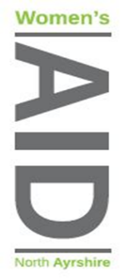

Date as post mark

Dear Applicant

Thank you for your interest in working with North Ayrshire Women’s Aid.

Please find enclosed:

1. An Application Form
2. Job Description
3. Summary of Terms and Conditions
4. Equal Opportunities Monitoring Form
5. Equal Opportunities Policy

Please email (preferably) your application by the closing date of midnight on Monday 16th November 2020

[admin@nawomensaid.co.uk](mailto:admin@nawomensaid.co.uk) or post to arrive prior to closing date

‘FAO RECRUITMENT’ to

NAWA,

17 Vernon Street, Saltcoats, KA21 5HE

Please note that we are unable to acknowledge receipt of your application.

Interviews will be held week commencing Monday 23rd November 2020

We will only contact those applicants who are to be invited to interview and thank you again for your interest in our work.

Yours Sincerely

Mary Beglan

Chief Officer