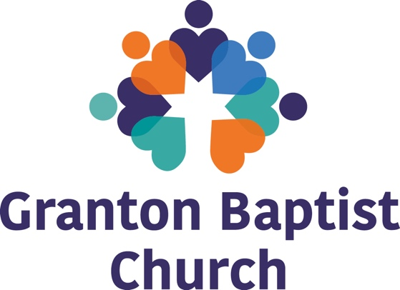

Job Title: Children and Youth Worker

Responsible to: Church Leadership

Working with: The Pastor, Church Leadership, Youth and Children’s workers (approximately 15 volunteers) Working with parents, other agencies and organisations; including schools and 3rd Sector providers.

Job Purpose: To work with Granton Baptist Church in the development of their Children and Young People’s work and their development and work with children and Young People within the church and in the community. A church that is rooted in Christian faith and values and works with young people in the West & East Pilton and Muirhouse areas of Edinburgh. The church’s aims are to have input into the lives of children and young people with the aim that; they are valued and supported; they live lives characterised by positive, healthy and responsible choices; and promote an active involvement with the church.

Job Requirements: The children and Youth Worker will have experience of working with Children and Young people in the charity sector, whether in a paid or unpaid capacity. An enthusiasm to see children and young people fulfil their potential, should be tempered with pastoral sensitivity in supporting children, young people, their families and volunteers. An excellent communicator, they will help build connections with Schools, 3rd Sector providers and Community. They will have the ability to run current groups and develop new initiatives in collaboration with the Pastor, Leaders, volunteers and other agencies.

Main Duties:
Church Based Work
- Contribute, develop and Lead the program and development of the Churches Children and Youth Ministries.
- Lead, co-ordinate and provide Pastoral Support to the volunteer team and encourage and recruit new volunteers.
- Build healthy and supportive relationships with young people and their families.
- Participate in and help lead activities.
- Participate in and help lead social activities, outings and special events for groups.
- Prepare, facilitate and evaluate small group work to address the social, emotional and behavioural needs of those within all current Children and Youth ministries.
- Provide support to enable the young people to deal with difficult life situations.
- Keep up-to-date development records of all work with relevant groups.
- Effectively communicate with church, families and agencies as appropriate.
- Support children and young people in their spiritual development.

Community Based Work

Network with other organisations and stakeholders in the community helping build strong partnering relationships. Work alongside the local community, agencies, young people and families.
- Lead and develop small groups which may include:
  - Scripture Union groups
  - Special interest groups

Training

- Actively seek and attend relevant professional training in order to maintain their Continuing Professional Development requirements
- Encourage and support other team members and volunteers to attend training. Depending on skills and experience may help deliver and facilitate training for volunteers

Other

- Undertake personal development through active participation in annual reviews, supervision and identified training needs as required.
- Take part in other Church activities where appropriate.
- Promote the work of Granton Baptist Church by active engagement in building partnerships, for prayer, finance and volunteering within church.
- Maintain record of expenses for the project and of groupwork and individual work.
- Any other task required for the contingency of this service as directed by the designated line manager.

Genuine Occupational Requirement
This post requires the occupant to have a personal faith in Jesus Christ as Saviour and Lord and to believe the Bible to be fully trustworthy and the highest authority for faith and life in keeping with Granton Baptist Church’s statement of faith. These principles require to be applied alongside the professional skills required in this role.

June 2020

