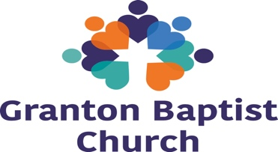

Granton Baptist Church
Person Specification for Children and Youth Worker

CRITERIA | ESSENTIAL | DESIRABLE
Work Experience/Skills
Ability to communicate effectively, develop appropriate relationships and build networks in a variety of settings with a wide age range of people (multi-agency partnership, other churches)
Experience in establishing, developing and maintaining positive professional relationships with children and young people who are growing up in areas of deprivation including an ability to communicate effectively in an interactive & engaging manner in small & large group settings.
Awareness of the Baptist church scene and Scottish school system
Experience of working with schools
Excellent written communication, record keeping and presentation skills
Computer literate, experience of Word, Excel, PowerPoint and email
Able to inspire, support, train and encourage volunteers.
Leadership
Ability to inspire confidence and accept responsibility in a variety of contexts
Able to manage a varied and emotionally demanding job with some unsocial working hours.
Experience of leading teams and being able to delegate appropriately
Experience of envisioning, training and supporting volunteers
Education
Educated to degree level and/or a relevant qualification or significant experience in teaching, youth work, social work or theology
Social
A practising Christian whose lifestyle is in keeping with the Church’s ethos and having the confidence of his or her church fellowship
Able to undertake evening and weekend duties
Aptitude
Ability to articulate Biblical truth and share clearly with children and young people
Ability to encourage others in Christian discipleship
Ability to represent the organisation in a professional manner
Capacity to multi-task across simultaneous projects
Demonstration of commitment and drive
Ability to be both self-motivated and an adaptable team player
Willingness to engage with all aspects of support and fund raising
Other
Willing to use own transport and have a full current driving licence
Musical Ability
June 2020

