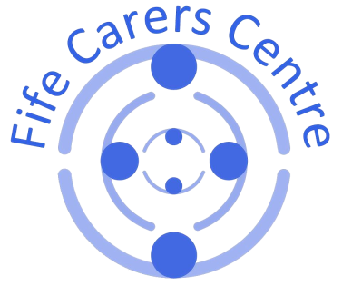**Fife Carers Centre**

**157 Commercial Street,**

**Kirkcaldy,**

**Fife, KY1 2NS**

**Data Protection Privacy Notice**

The new law on Data Protection comes into force on 25 May 2018. It affects all people associated with our Charity, including job applicants. I enclose a Data Protection Privacy Notice for Job Applicants which you should read carefully and keep in a safe place as it contains important information about:

•who collects personal information about you;

•which information we collect and how and why we do so;

•how we use the information and who we may share it with;

•any monitoring we undertake;]

•where we may hold your personal information;

•how long we may keep your information;

•your rights to correct and access your information and to ask for it to be erased;

•where you can find further information about some of the matters listed above; and

•how to complain if we get things wrong and cannot resolve them for you.

The reason we are sending you this notice is to make sure we comply with new legislation governing data protection. As a consequence of the new legislation, we will not be relying on your general 'consent' to us processing your personal information as a legitimate basis on which to undertake that processing.

We wish to maintain our open and transparent approach in relation to the protection of personal information. Please therefore do not hesitate to contact Mhairi Lochhead, Centre Manager who can be contacted by email [Mhairi.lochhead@fifecarers.co.uk](mailto:Mhairi.lochhead@fifecarers.co.uk) or telephone no 01592 205472 who will be pleased to help with any queries you might have.

Fife Carers Centre is a Company Limited by Guarantee with Charitable Status

Company No. 282309

Scottish Charity No. SC029466