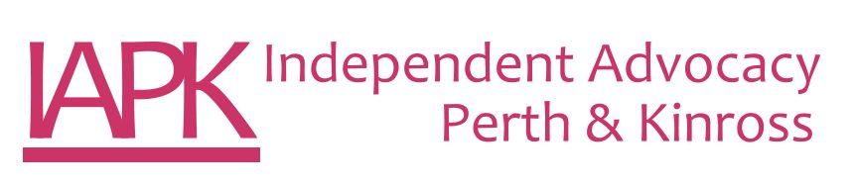
Duty Independent Advocacy Worker
Job Description

Post Title: | Duty Independent Advocacy Worker
Salary: | £15,034 per annum (pro rata £25,057 fte per annum)
Hours of work: | 21 hours per week – Monday to Friday. This post will entail some evening and weekend work. Time off in lieu applies.
Reporting to: | Advocacy Manager
Job Purpose: | The post holder will be the lead person to triage and respond to individual enquiries for advocacy support by gaining as much information about the person’s advocacy needs as possible and undertaking the initial outcome measurement. The Duty Advocate will ensure clear communication with the person throughout the whole enquiry process. The post holder will support the IAPK team by;  - Allocating enquiries to the appropriate team member  - Undertake any small amount of advocacy needed (where this is all that is required before closure) or to signpost to another organisation
Values: | IAPK requires that every member of staff be committed to promoting human rights and the values of inclusion, social justice and equality of opportunity. IAPK expects all members of staff will hold central to their work practice the ethos and principles of independent advocacy.
Tasks | - Respond to enquiries for advocacy support, identifying advocacy needs and supporting the allocation of referrals for advocacy support.  - Manage the waiting list as part of the duty and allocation process.  - Undertake any small amount of advocacy needed (where this is all that is required before closure).  - Where required, signpost to another more appropriate organisation.  - Undertake some short notice or cover advocacy work as required by the Advocacy Manager.  - Undertake some phone evaluation with advocacy partners in liaison with the Systems Administrator.  - Participate in relevant internal meetings, including Team Meeting, Practice Meeting and other meetings as required.  - Provide written reports and service delivery information as required.  - Publicise, promote and raise awareness of IAPK as required.  - Keep up to date with current developments, legislation and research.  - Attend training, planning and review meetings in relation to all work.  - Maintain accurate and up to date written information and records.
Other Duties | This job description is broad based and is not intended to be an exhaustive list of all possible duties as it is recognised that jobs change over time. Should the duties change radically then the post and salary level will be reviewed.

PERSON SPECIFICATION

EXPERIENCE | Essential | Desirable
Working in a third sector organisation or in a small business environment | X
Experience of working alongside people with mental health problems, learning disabilities, multiple disabilities or in a health or social care setting | X
Experience of working as part of a small team |  | X
Current experience or knowledge of the health and social care structure and services | X
A clear understanding of the importance of confidentiality | X

KNOWLEDGE/UNDERSTANDING
An understanding of disability issues, social inclusion and human rights | X
An understanding of the issues concerning people who require independent advocacy | X
Commitment to the Principles, Standards & Code of Best Practice of independent advocacy | X

ABILITIES/SKILLS
High degree of written and verbal skills | X
Good communicator | X
Ability to use IT resources and a willingness to build on existing skills | X
Ability to work under pressure to deadlines | X
Manage their workload effectively | X
Use own initiative | X

PERSONAL QUALITIES
Confidence | X
A commitment to equality and social justice | X
Good team member | X
Approachable | X
Good listening skills | X
Reliable | X

