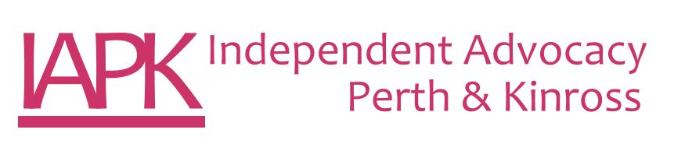

**Vision**

**Bringing about the day where everyone’s voice is heard and respected**

**Mission**

**Your Voice**

**Your Views**

**Your Human Rights**

**equals**

**Our Mission**