|  |  |
| --- | --- |
| Building communities with people who have learning disabilities  Relationship – Transformation – Sign | |
|  |  |

December 2020

Dear Enquirer,

**L’Arche Edinburgh Assistants Coordinator (Human Resources Manager)**

Thank you for your interest in this role with L’Arche Edinburgh.

This pack includes:

1. **Copy of the advert and information on application process**
2. **Job description and Person Specification**
3. **Information on L’Arche Edinburgh and Identity and Mission statement**

**Separately available on our website: Application Form**

**Please submit your completed Application Form** by **Friday 22nd January 2021 at 09.00am** to [kirsty.maccrimmon@larche.org.uk](mailto:kirsty.maccrimmon@larche.org.uk) . Interviews will take place via Zoom.

I look forward to hearing from you.

With regards



**Kirsty MacCrimmon**

Community Leader (Director)

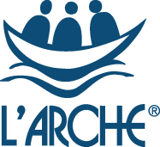**Do you believe in a world where all belong?**

**Assistants Coordinator (Human Resources Manager)**

**L’Arche Edinburgh**

**Do you have a passion for ensuring people with learning disabilities live fulfilled lives? Do you want to help lead a community that values people for who they are *and* what they can do?**

**L’Arche Edinburgh** is an ecumenical Christian community of more than 80 people, which welcomes people of all faiths and none. We are part of a global network of communities where people with and without learning disabilities live and share in life together, working for a world where we all belong.

We are seeking someone with management experience in social care who can lead the Assistants Coordinator (Human Resources Manager) role. Experience of management and HR processes are key requirements, along with a commitment to L’Arche values and ethos.

You will lead on recruitment and HR for the Community, working closely with the other leaders to ensure that we provide and develop high quality person-centred care which supports the practical, social and spiritual needs of those who call L’Arche home. A unique part of our mission is to welcome assistants to live alongside the people with learning disabilities we support, and your role will be key in ensuring we have live-in and live-out assistants with the right skills and potential to fulfil that mission.

If you are interested in being part of a mutually supportive and lively community, then we want to hear from you!

Enquiry pack and Application Form available at : [www.larche-edinburgh.org.uk](http://www.larche-edinburgh.org.uk)

**Finding out more about L’Arche**

L’Arche is more easily experienced than explained. If you would like to find out more about us, we would normally encourage you to visit us, but sadly, these are not normal times. If you are shortlisted, you will be invited to ‘visit’ one of our houses in a Covid-compliant way as part of your interview.

Kirsty MacCrimmon, Community Leader, would be very happy to talk informally with you to answer any questions and give you a feel for what being an Assistants Coordinator in L’Arche is like. Kirsty is available via 0131 553 3478 or [Kirsty.MacCrimmon@larche.org.uk](mailto:Kirsty.MacCrimmon@larche.org.uk).

You can find out more about L’Arche Edinburgh at [www.larche-edinburgh.org.uk](http://www.larche-edinburgh.org.uk)

and L’Arche in the UK at [www.larche.org.uk](http://www.larche.org.uk)

**L’Arche: What we do**

We believe that people with learning disabilities have much to teach us and contribute to the world. During the last fifty years, we have learnt that one of the best ways to enable this is by creating Communities with a culture of shared lives between people with and without learning disabilities, from which we can work together to build a more human society.

At L’Arche we celebrate people with learning disabilities and build circles of support around them. We go beyond supporting people's basic needs to attend to their emotional and spiritual lives, too. It is this focus on building relationships and cultivating a sense of belonging that makes us different from other service providers.

L’Arche Communities hold in balance four elements: service, community, spirituality & outreach. Experience has shown us that each element has an important role to play and needs to be present - not only for a Community to be healthy - but in order to make us better at each of the other elements.

L’Arche Communities around the world share this common philosophy and approach while reflecting and celebrating the ethnic, cultural and religious composition of the areas in which they exist

**Community life**

At the heart of L’Arche is the support we provide to people with learning disabilities. As well as providing high quality housing and supported living, we also work with individuals to access employment and voluntary opportunities. In addition, many of our Communities provide day support services. Furthermore, we assist people to access relevant healthcare and, where appropriate, receive therapeutic services. We work hard to ensure that the needs of individuals with learning disabilities are met holistically, and that people are supported to live fully integrated and empowered lives within the wider communities in which they live.

We have a long history of working with social services and social work departments, health authorities, primary care trusts, registration and regulatory authorities, housing associations and others, to provide high quality support that is recognised as being truly responsive to people with learning disabilities.

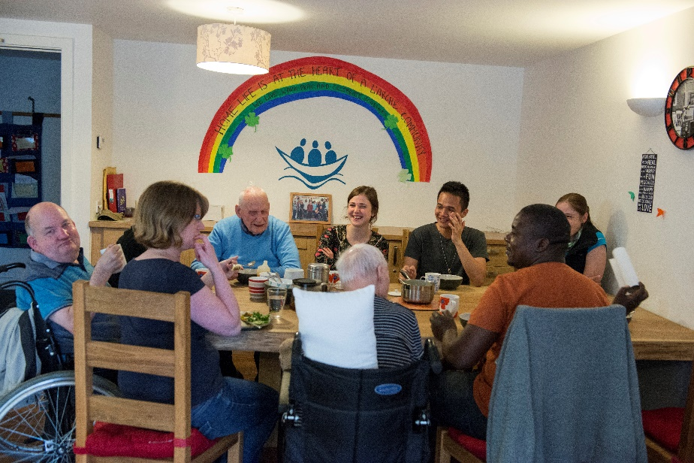

**L’Arche Edinburgh: Background information**

L’Arche Edinburgh is an intentional Community of more than 80 people with and without learning disabilities. It is one of ten communities that form L’Arche in the UK and belongs to an International Federation of 153 communities in 38 countries.

L’Arche Edinburgh opened its first house in 1991. It has grown since then and has a network of houses and flats. The community is made up of adults with learning disabilities, more than forty employed assistants, Committee members and many other friends and volunteers.

Our employed assistants are drawn from two sources. Most are local people employed on standard contracts, whom we term “live-out assistants”. But what makes us different is that up to a third of our assistants live in our houses alongside the people with disabilities to whom they provide support. They receive board, lodging and expenses. This experience of living in community alongside people who are different from themselves is a source of huge richness. Many of these “live-in assistants” are from outside the UK, and Brexit brings us new challenges in this area.

Our services are registered with the Care Inspectorate under their dual category of Care at home and Housing Support.

***Shared Households:***

* *David House:* a house for four people with more complex support and healthcare needs. 11 assistants support David House, some of whom live in the house
* *The Skein:*  home to four people with learning disabilities today and supported by a team of 10 assistants, four of whom live in the house. This was our first house, opened in 1991
* *Creelha:*  home to four people with disabilities, supported by eight assistants, some of whom live in the house

***Flats for individuals:***

* *Fox Street:* we support four people who live independently in adjacent flats, and who choose to live as neighbours

***Work and day opportunities:***

We do not run centre-based day activities, but instead have been ahead of the time in developing individualised day opportunities in the local community.

***Community and spiritual life***

L’Arche Edinburgh is an inclusive, ecumenical Christian Community which welcomes people of all faiths and none. The Community has a rich and vibrant community life. Whole Community Gatherings are held regularly, and there are many parties, outings, celebrations and meals to bring together large and small groups. The major feasts such as Christmas and Easter are celebrated together, and there are other opportunities for prayer, reflection, and quiet time for those who wish to participate.

**L’ARCHE EDINBURGH**

**JOB DESCRIPTION**

**Job Title:**  Assistants’ Coordinator (Human Resources Manager)

**Responsible to:** Community Leader (Director)

**Location:** L’Arche Edinburgh office in Leith, with the option to work some

hours from home

**Salary: £29,671 - £30,775 FTE (£23,737 - £24,620 pro-rata)**

**Hours:** Part time role,32 hours per week, worked flexibly depending on the needs of the Community, with occasional evening and weekend commitments locally, and some events requiring travel

**Overall Purpose of the Job:**

* Ensure L’Arche Edinburgh meets its regulatory obligations with regard to the recruitment, selection, vetting and performance management of all employees and volunteers
* As a member of the senior Coordinating Team, contribute to the leadership and development of L’Arche Edinburgh, it’s structures and Service Improvement Plan, in line with the L’Arche Identity and Mission Statement
* Provide HR support and advice to the leadership, ensuring implementation of employment legislation, and compliance with Safer Recruitment, national policies and initiatives, and SSSC requirements

**Main Duties and Tasks:**

1. ***Recruitment***

* Lead on the recruitment of Live-In and Live-Out Assistants, involving people with learning disabilities and their relatives where appropriate
* Lead on advertising and managing applications and interviewing suitable applicants
* Manage employment offers and support new employees during their trial period and induction, working closely with the Formation and Training Coordinator
* Create and maintain a Recruitment Plan based on known and expected needs
* Oversee the recruitment and induction of volunteers

1. ***Appraisal, Review and Performance Management***

* Ensure good systems and procedures are in place for appraisals and reviews, and provide a lead on these
* Conduct leaving interviews for employees, and summarise any organisational learning points coming out of those meetings
* Provide professional guidance and support to leaders in all employment matters including participating in investigations, disciplinary hearings, capability reviews, sickness or attendance procedures as required

1. ***Administration***

* Issue contracts of employment to all employees, letters of variation as needed, and the Employee policy *Working with L’Arche* Handbook
* Ensure all employee and volunteer personnel records are kept up to date,
* Ensure all new start information, monthly salary variation information including sick leave and leaver information is recorded and provided to the L’Arche Finance office
* Ensure coordination and forward planning of annual leave for all employees
* Provide advice and support to enable non-UK nationals to access Tier 5 Charity Worker visas where appropriate, ensuring all of L’Arche UK’s licence terms with UK Visas and Immigration are met and strictly adhered to

1. ***Leadership***

* Promote L’Arche for recruitment purposes through talks and publicity
* Contribute to operational and strategic management of L’Arche, and professional development through leaders’ meetings and line management with the Community Leader (Director)
* Participate in Leaders’ meetings, chairing them when required
* Work closely and supportively with the Community Leader (Director), Support and Care Coordinator, (Registered Manager), and Formation and Training Coordinator

1. ***General***

* Take part in the out of office hours telephone contact and respond appropriately to emergencies
* Deputise for the Community Leader on occasion when required
* Spend time in the service to understand the service and community
* Attend L’Arche UK national HR meetings, approx 4 nights away per year
* Consult L’Arche UK’s national external employment advice and consultancy service in carrying out the above responsibilities to ensure compliance with employment law
* Provide reports to the Local Committee on matters relating to recruitment and HR
* Perform any other reasonable duties commensurate with the post which may be required from time to time by the Community Leader

**PERSON SPECIFICATION**

**EXPERIENCE**

**Essential**:

* Experience of managing staff gained in social care
* Experience of human resource processes such as interviewing, training, disciplinary

**Desirable:**

* Experience of a similar role with lead responsibility for employment and staffing matters

**SKILLS**

Essential

* Understanding of and identification with the aims, mission and values of L’Arche (see below)
* Advanced emotional intelligence
* A good judge of people
* Able to communicate effectively in person and in writing
* Able to work well with people of different cultures and nationalities
* Able to support and mentor employees and volunteers
* Able to appraise and performance manage employees
* Able to to take responsibility
* Able to problem solve and develop solutions
* Able to work well under pressure and meet deadlines
* Ability to inspire confidence in others within the organisation, ensuring that the adults with learning disabilities within our service are supported by the best possible teamwork
* Able to inspire confidence with those external to the organisation
* IT literate in Microsoft Office

**KNOWLEDGE**

**Essential**

* Knowledge of employment processes
* Knowledge of the current workforce issues in social care services in Scotland

**QUALIFICATIONS**

**Desirable**

* A social care or management qualification, or a human resources qualification is desirable.

**REQUIREMENTS**

**Essential**

* A satisfactory PVG criminal record check
* Able to attend L’Arche UK national meetings requiring 2 x 2 overnights per year
* Able to make use of Accompaniment (L’Arche internal support outwith line management) and other mechanisms within L’Arche to manage own stress, and model this to employees
* Able to act as Additional Countersignatory with the Scottish Social services Council (SSSC)

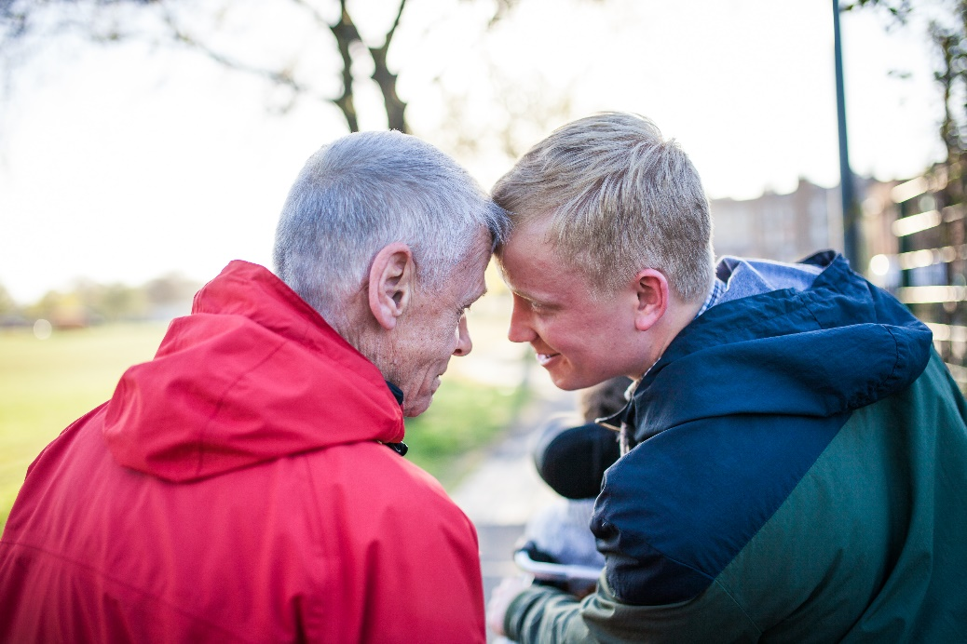

**L’Arche Identity and Mission Statement**

**Identity:**

* We are people with and without learning disabilities, sharing life in communities belonging to an International Federation.
* Mutual relationships and trust in God are at the heart of our journey together.
* We celebrate the unique value of every person and recognise our need of one another.

**Mission:**

* Make known the gifts of people with learning disabilities, revealed through mutually transforming relationships
* Foster an environment in community that responds to the changing needs of our members whilst being faithful to the core values of our founding story
* Engage in our diverse cultures, working together towards a more human society

**We value:**

* **Treating people with dignity and respect:** We value every person and celebrate who they are.   We do not just tolerate diversity, but actively embrace it in our communities. A key way we demonstrate dignity and respect is by being fully present to each other when we are together and listening deeply to one another.
* **Friendliness and welcome:** We are deeply committed to building friendships together, which calls us to live life with a joyful and grateful spirit. A key way we demonstrate friendliness and welcome is by offering meaningful invitation and welcome to newcomers and also to each other on a daily basis.
* **Empathy:** We are committed to understanding and sharing the feelings of one another.  We prioritise the qualities of compassion, caring, and kindness to nurture empathy. A key way we demonstrate empathy is through the quality of the shared life we build together.
* **Integrity:** We strive to have integrity in everything we do and in every relationship we build, seeking to be authentic and honest, trustworthy and open because to build meaningful relationships we need to reveal who we are. A key way we demonstrate integrity is through our willingness to be both vulnerable and courageous.
* **Commitment to community building:** We choose to share life together rather than merely work together. Sharing life means we create mutual relationships with one another and also share responsibility for the life and wellbeing of the community as a whole, practicing forgiveness and celebration and creating a place of belonging that is open to all who share our mission and values. A key way we demonstrate our commitment to community building is through our nurturing of our shared spirituality expressed through the community traditions and practices that shape our daily life together.
* **Openness to reflection, learning and growth:** We are personally committed to growth and development in the dimensions of L’Arche identity and mission and also support the growth of the whole community by nurturing the gifts of each person, creating a learning culture together and being attentive to our personal and communal spiritual life.  A key way we demonstrate our commitment to learning is the frequency and quality of our personal and group reflective practices and processes.
* **Commitment to the vision and mission of L’Arche:** We actively engage in all dimensions of L’Arche mission and practice both personally and communally.  A key way we demonstrate our commitment is our visibility as people with and without learning disabilities together engaged in our local neighbourhoods and the wider world in order to shape a more human society.

