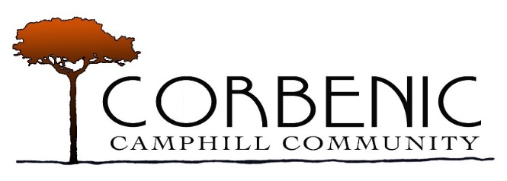
An exciting opportunity has arisen to join the Corbenic Community as a House Co-ordinator. We are looking for an individual to be responsible for the wellbeing and development of residents, the day to day running of the household, co-ordinating the house team and to take an active interest in issues regarding the whole community. ​
House Co-ordinator (Full-Time)
Salary £23, 774 – £26,872

Our Community has been a home for people with social, emotional, intellectual and learning disabilities in the heart of Scotland since 1978, providing day and residential care in beautiful surroundings near Dunkeld, Perthshire. Over the years it has developed into a community of approximately 120 people, 42 of whom are adults in need of special care. Set in 100 acres of land, Corbenic is made up of seven households and a variety of workshops. As an independent charity, we are part of the worldwide Camphill family and are dedicated to providing a holistic residential environment that meets the social, physical, emotional and economic needs of residents.

Vision statement
In Corbenic mutual respect and concern for the dignity of each person are actively fostered. Individuals are encouraged to contribute as much as possible to the life of the Community. Residents and Day Participants work side by side with voluntary co-workers from around the world and an experienced staff team.

Main Duties
- To be responsible for the safety and welfare of all living and working in the household.

- To support and supervise the voluntary Co-workers living and working in the household.

- To co-ordinate the daily living arrangements in the household and to ensure that all aspects of the care provided in the household comply with the standards agreed by the Community in accordance with best professional residential care practice.

- To be responsible for the management of the finances of the household and, as appropriate, to assist residents in the handling of their money.

- To liaise with workshop leaders to ensure that individuals’ needs are met within their work environment.

- To identify and ensure that the training needs of the voluntary co-workers are met.

- To uphold and contribute to the social/therapeutic impulse, as part of the Camphill philosophy. To be present and actively participate in the annual festivals.

The ideal candidate will:

- already hold SVQ 3 in Social Services & Healthcare or be willing to work towards gaining this qualification.
- be willing to register with the Scottish Social Services Council (SSSC) and work to SSSC standards whilst adhering to Corbenic’s policies and procedures.
- become a member of the Protecting Vulnerable Groups (PVG Group).
- knowledge of the factors involved in providing services for adults with learning disabilities.
- understanding of management practices applied in residential care settings.
- have extensive experience providing care and support to people with learning disabilities.
- have experience leading teams, ability to work effectively within teams and to motivate others.
- ability to communicate effectively, both orally and in writing have good communication with excellent interpersonal skills.
- the ability to effectively manage the demands of a busy household with good organisational and time keeping skills.
- have prior experience in writing reports and record keeping.
- ability to foster the creation of a warm and caring atmosphere within a household.
- have previous experience in supervising staff and attending reviews.
- be willing to liaise with multidisciplinary teams.
- have a flexible approach and ability to work shifts.
- be patient, approachable, sensitive and decisive.
- be committed to taking on training relevant to the post.
- have a full driving licence.

Closing Date for Applications Monday 1st March 2021
Please send completed applications to emma@corbeniccamphill.co.uk

