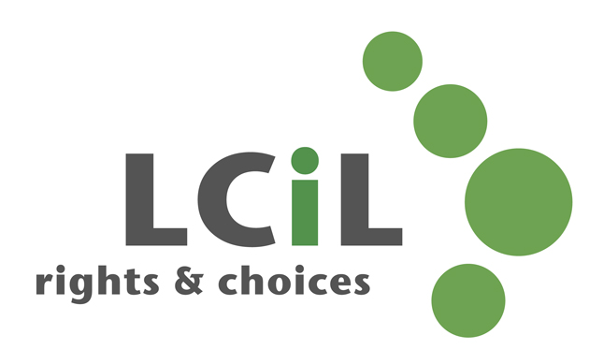
Lothian Centre for Inclusive Living
Job description

Job Title: Senior HR Administrator (Part time 30hrs) – fixed term to end March 2022

Salary scale: £22,000 to £24,000 – pro rata

Responsible to: CEO

Responsible for: LCiL HR support and Administration
LCiL Administrator

Job Purpose: Provide HR support for the organisation and its
staff in accordance with the policy objectives of
the Board and Employment Law

Ensure LCiL administration processes and activities facilitate the smooth running of the office

Location: Edinburgh, office based

Main Responsibilities

HR Administration
- Act as first point of contact to provide HR support across the organisation and with key stakeholders.
- Support the life cycle of employment (recruitment, induction, engagement and development) ensuring our approach aligns with LCiL’s mission and values and working closely with managers to ensure processes, documentation and changes are implemented.
- Oversee the HR system and supporting records to maintain employee information including updates for other departments e.g. payroll changes.
- Prepare regular management information reports for senior management and the Board on key performance indicators for HR support, learning and development and developing people.
- Ensure all staff policies and procedures are regularly reviewed and updated where necessary, including the updating of staff/ policy handbook.

Office Administration

- Ensure that LCiL office premises meet Health & Safety requirements, including taking the lead role of Fire Warden for LCIL and appointing deputies from staff group
- In conjunction with the CEO, make any purchases for the continued smooth running of the organisation.
- Liaise with Albion Trust (Landlord) in relation to building maintenance, security etc.
- Manage supplier contracts e.g. IT, Photocopier etc.
- IT - Liaising with IT Support, Installing programmes and support staff with IT issues.
- Coordination of LCiL administrative tasks, including cover for LCiL administrator when necessary.
- Cover for invoice payments and bank authorisations for Finance Manager when necessary.
- Ensure LCiL complies with all aspects of GDPR

Leadership
- Line management of LCiL Administrator, including regular 1-1’s and development plans.
- Work closely with CEO to assist in the achievement of organisational goals, including project work.
Any other duties as required.

Contacts:
- Disabled people, people with long term conditions and parent carers
- LCiL’s Board, staff and members
- Disability organisations and other voluntary organisations
- Schools and colleges
- Local authority and National Government officials and elected members

Supervision Received:
The post holder will receive regular supervision from the CEO in accordance with the terms and conditions of service. The post holder will be expected to attend staff meetings, team meetings, training courses, LCiL events and other meetings as appropriate to the functioning of the organisation.

Complexity and Creativity:
Lothian Centre for Inclusive Living is an innovative and demanding initiative which has a significant impact on the lives of disabled people, their families and the statutory authorities.

The provision of support which enables disabled people to increase their level of self-control in all aspects of their lives is highly complex. It requires sensitivity, a knowledge of services which are available to disabled people, up-to-date knowledge of relevant legislation, an understanding of the concerns of disabled people, a commitment to the Social Model of Disability, and an understanding of the Independent Living philosophy.

The post holder is required to take initiative on a wide range of tasks and work as part of a team to ensure LCiL maintains an integrated approach. They must be able to work under pressure within a challenging and sometimes uncertain social, political and financial climate.

It is essential that the post holder is able to work within an organisation which is led and managed by disabled people.

 | Essential | Desirable
Experience:
The post holder will have recent experience of working in an HR department. | x
The post holder will have experience of working in a busy office. | x
The post holder will have at least one year’s supervisory experience. | x
Knowledge:
CIPD Qualification or working towards qualification |  | x
Knowledge and understanding of employment law | x
Demonstrate Intermediate level office software, word-processing, spreadsheets and personal information management tools. | x
Knowledge of health & safety provisions and procedures |  | x
Skills:
Demonstrate good written and verbal communication and interpersonal skills. | x
Demonstrate accurate data entry. | x
Demonstrate ability to organise own work and prioritise often conflicting requirements. | x
Proficient IT skills with a willingness to adopt and learn new technologies and systems – this includes communication, collaboration, recording and office applications. | x
Demonstrate ability to proof, format and present documents. | x
Demonstrate effective time management skills. | x
Demonstrate effective negotiating skills |  | x
Other requirements
Commitment to LCiL’s mission and values with a desire to make a difference | x
Optimistic, represents with passion, acts as role model. | x
Open-minded, values equality and diversity, acts with care and is supportive of others. | x
Thoughtful and committed to learning, forward looking and solution-focused. | x
Proactive, flexible and collaborative who aims to exceed expectations. | x

Feb 2021

