***Café Development Manager***

***Application Pack***

At the core of our ambition as a Church to address food poverty is the Café and Garden Project, a social enterprise offering healthy food, healthy lifestyles and healthy interactions.

*Ruchazie Church*

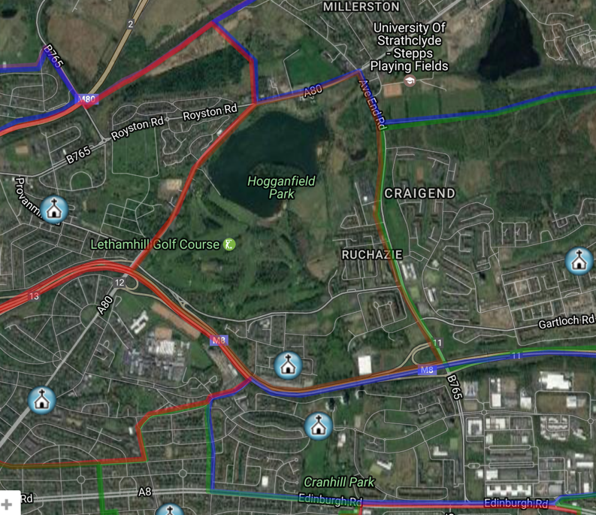Ruchazie Church is a new church “replant” within the Church of Scotland. In the last 3 years we have re-established a worshipping community within the parish. This has built on the previous ongoing work within the community - children’s and youth work, work with older people, supporting vulnerable families, etc. There is now a core team of about a dozen leading this work with a pre-covid congregation of about 50 gathering weekly. As a church we are rooted in the evangelical tradition, looking actively for the work of the Holy Spirit in our lives, and our style is informal, friendly and welcoming.

Ruchazie is an area of significant deprivation. 41% of the children live in poverty. 67% of those attending our local secondary school have or had male relatives resident in Barlinnie Prison. 36% of the 16-19 year olds are not in any form of employment, education or training. There is no lack of issues, but that is not what we as a church are about.

We believe in this community. We believe that it is full of wonderful, dynamic, creative people made in the image of God. We believe that there is huge potential for this community to be transformed.

*Previous “Open Space” Cafe*

At the core of Christianity is a deep call to hospitality. This means that God offers everyone a welcome into his family. This is reflected in our open, warm and inclusive welcome to everyone who comes into our building. The café space has been the core of this for the last 10 years. Even during the pandemic, we used the café facility as the base for providing emergency food supplies to the Ruchazie community throughout 2020.

Ruchazie Church’s 2018 “Big Strategy” included a ‘Cooperative Ruchazie’ category aiming to address food poverty. The focus of this was the development of the Pantry, a sustainable, dignified local food shop that provides high quality, low cost food – this we have done in the opening of the Ruchazie Pantry in October 2020. It is now time to address other aspects of food poverty in Ruchazie.

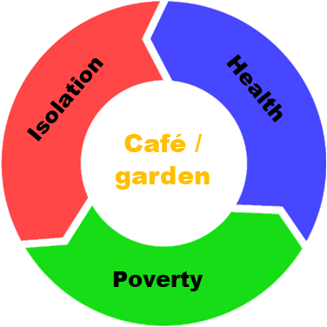We believe that by addressing food poverty in Ruchazie we can influence other areas of life for local people. It is too simplistic to say that food poverty is a standalone issue; it clearly intersects with other types of poverty, worklessness, health and social isolation.

At the core of our ambition to address food poverty is the Café and Garden Project, a social enterprise offering healthy food, healthy lifestyles and healthy interactions.

*About the Café Development Manager*

We are looking for a team player who can innovate, develop and lead. We are looking for someone who is not only able to re-establish the local café as a business, but shares our vision to see the Café located firmly in community well-being and connection.

We currently have start-up funding to re-open the Café in Ruchazie Church building, but we want to do more than just offer food.

Funding is available for 6 months to help get café side of the project up and running, with the expectation that the role would become self-funding through the cafe income after this period.

**Café Manager Remit**

1. Develop the café as a viable business

* Manage stock, menu planning, budget
* Develop and implement Health and Hygiene systems in the kitchen
* Ensure all kitchen users are fully trained

1. Work in conjunction with the Ruchazie Church Team to enable the development of projects and activities that sit within the Café orbit and address wider needs in the community. This will include, for example:

* Work in conjunction with the Volunteer Development worker to support and manage café volunteers
* Work in conjunction with Garden team to plan vegetable growing for Café menu
* Develop training programmes for volunteers and local people on budget cooking, healthy eating and other food-related topics
* Develop programme of placements to support hard-to-place workers

**Requirements:**

* Relevant qualifications:
  + Any HNC/HND Hospitality or Food Production or Hotel or Restaurant Management
  + Food Hygiene training
  + Health and Safety training
* Track record of managing a successful catering/retail business
* Ability to manage kitchen, stock, menu planning
* Ability to manage and support staff and/or volunteers, prepare rotas, train
* Good customer service skills to meet and address customers’ requests, demands and concerns
* Ability to prepare and manage budget and cashflow
* Good understanding of food hygiene, COSHH, health and safety, risk, and ability to implement sound procedures
* Commitment to environmental sustainability through our “reduce, reuse, recycle” policy
* Personable, friendly, efficient
* Able to create a comfortable and welcoming experience for customers yet be professional and command respect from staff and vendors
* A team player who recognises the skills and talents of the wider team
* In sympathy with the ethos of the Christian faith underpinning this project

**Desirable:**

* active Christian faith
* Ability to plan and deliver informal training for community members
* experience in the Voluntary Sector, including an understanding of grant funding and reporting requirements

*Additional Information*

* This is a half-time post – 18.75 hours per week.
* Salary is £25,000 per annum pro rata, that is £12,500.
* There is a 5% employers pension contribution available.
* These posts will be line-managed by the Congregational Development Worker.
* The nature of the work calls for a degree of flexibility, thus hours of work, which are as agreed with the line manager, may vary from day to day with a normal pattern being Tuesday-Friday in Ruchazie each week.
* The post is based at Ruchazie Parish Church, 4 Elibank Street, Glasgow, G33 3QN.
* Access to a desktop computer will be provided.
* There are 5 weeks *pro rata* paid leave in each full holiday year which runs from 1 January to 31 December. Entitlement is based on full weeks worked. There are also 9 *pro rata* statutory holidays.
* Travel expenses by public transport or by use of own car at rates as agreed by the employer and reviewed annually.

Closing Date: Tuesday 13th April at 9am, with interviews held on Thursday 15th April.

**How to Apply**

Applications should be sent by email to [amcwilliam@churchofscotland.org.uk](mailto:amcwilliam@churchofscotland.org.uk) and must be received by 9am on the closing date.

**Applications should comprise:**

• A personal statement, outlining how your skills, experiences and personal qualities match the requirements of the role outlined in the job description.

• A full CV, including educational and professional qualifications alongside a full employment history showing positions held, responsibilities and relevant achievements.

• A personal information form – see attached. Please include names and email addresses of two referees, who will not be contacted until later in the process.

Applications without a CV, personal statement and personal information form will not be taken forward in the process. CV & personal statement should be a maximum of 2 sides of A4 each.

For more information on any of our roles, please contact [amcwilliam@churchofscotland.org.uk](mailto:amcwilliam@churchofscotland.org.uk) (07702483503)

**CONFIDENTIAL INFORMATION FOR EMPLOYMENT**

Please complete Parts A & B: Print in **black ink** or type and

return it by no later than the deadline**.**

**Late applications will not be accepted**.

### Part A

### Personal

**POST DETAILS**

|  |  |
| --- | --- |
| Post Title: | |
| Closing Date | How did you hear of this post? |

**PERSONAL DETAILS**

|  |  |
| --- | --- |
| Name |  |
| Address |  |
| Postcode |  |
| Email address |  |
| Tel no |  |

|  |
| --- |
| We are committed to being an Equal Opportunities Employer and do not discriminate in any way.  If you consider yourself to have a disability, are there any arrangements that we can make to assist/adapt, for you, if you are called to interview or if successfully employed? Please give details below. |

**REFERENCES**

|  |  |  |  |
| --- | --- | --- | --- |
| **Name** |  | **Name** |  |
| **Occupation** |  | **Occupation** |  |
| **E-mail** |  | **Email** |  |
| **Organisation** |  | **Organisation** |  |
| **Address** |  | **Address** |  |
|  |  |  |  |
|  |  |  |  |
| **Post Code** |  | **Post Code** |  |
| **Tel No** |  | **Tel No** |  |
| **Relationship to applicant** |  | **Relationship to applicant** |  |

***Referees will not be contacted prior to interview***

**DECLARATION**

I confirm that all the information contained in Part A – Personal Information, Part B – Equal Opportunities Monitoring Information and Part C – Application for Employment is to the best of my knowledge correct and accurate. I understand that withholding or giving false information may be sufficient grounds for cancelling any agreements made.

I understand that the information provided in this application and monitoring form will be held and may be processed in keeping with the Data Protection Act 1998 for the purposes of employment and equal opportunities monitoring.

**Data Protection Act 1998**

Please read and sign below:

In applying for this post, I give my consent to Ruchazie Parish Church holding and processing data which is relevant to the recruitment process. This includes sensitive personal data which will be used for monitoring purposes.

Applicant’s Signature Date

### Part B

### Part B of the form will not form part of the selection process

**Equal Opportunities Monitoring Information**

The information you provide below will be treated as strictly confidential and will not form part of the selection process. We are committed to the principles of equal opportunities and aim to be an equal opportunities employer. To assist us in monitoring our progress in this, you are asked to complete the follow sections.

**Please tick the relevant box in each of the sections below**

Section 1: Gender Section 2: Age

Are You Are you

|  |  |  |  |  |  |  |  |  |  |  |  |
| --- | --- | --- | --- | --- | --- | --- | --- | --- | --- | --- | --- |
| Female |  | Male |  |  |  | 16-19 |  | 20-24 |  | 25-39 |  |
| Other |  | Prefer not to say |  |  |  | 40-59 |  | 60-64 |  | 65 + |  |
|  |  |  |  |  |  | Prefer not to say | | | | |  |

Section 3: Ethnic Group (background or culture)

|  |  |  |  |  |  |
| --- | --- | --- | --- | --- | --- |
| White Scottish |  | Other (South) Asian |  | Pakistani |  |
| Other White British |  | Chinese |  | Bangladeshi |  |
| White Irish |  | Caribbean |  | Mixed |  |
| Other White |  | African |  | Other |  |
| Indian |  | Black Scottish and other Black |  | Prefer not to say |  |

Section 4: Disability – do you consider yourself to have;

|  |  |  |  |  |  |
| --- | --- | --- | --- | --- | --- |
| No disability or impairment |  | A sensory impairment |  | A learning disability |  |
| A physical impairment |  | A mental health condition |  | Any other disability or impairment |  |
| Prefer not to say |  |  |  |  |  |

**Note:** The disability categories used are broadly based on the definition of a disabled person in the Disability Discrimination Act 1995 as “someone with a physical or mental impairment which has a substantial or long-term effect upon his/her ability to carry out normal day to day activities.

Section 5: Religion:

Which of the following religions, religious denominations or bodies do you currently belong to?

|  |  |  |  |  |  |
| --- | --- | --- | --- | --- | --- |
| None |  | Jewish |  | Other Christian |  |
| Church of Scotland |  | Muslim |  | Other Religion |  |
| Roman Catholic |  | Sikh |  | Buddhist |  |
| Hindu |  | Prefer not to say |  |  |  |

Section 6: Sexual Orientation - Are you

|  |  |  |  |  |  |
| --- | --- | --- | --- | --- | --- |
| Heterosexual |  | Gay |  | Transgender |  |
| Bisexual |  | Lesbian |  | Prefer not to say |  |