Role Profile – Policy and Research Officer

Reports To:
Head of Policy, Public Affairs and Research

Role Purpose:
You will support our ability to deliver policy campaigns to ensure that Sight Scotland and Sight Scotland Veterans have visibility, credibility and impact across a broad range of decision makers, elected representatives and influencers in Scotland. You will provide support through the production of research and high quality, evidence-based policy publications and campaigns, developed in conjunction with stakeholders and service users.
All roles within Sight Scotland and Sight Scotland Veterans are expected to work to our values and Our Ways of Working framework:
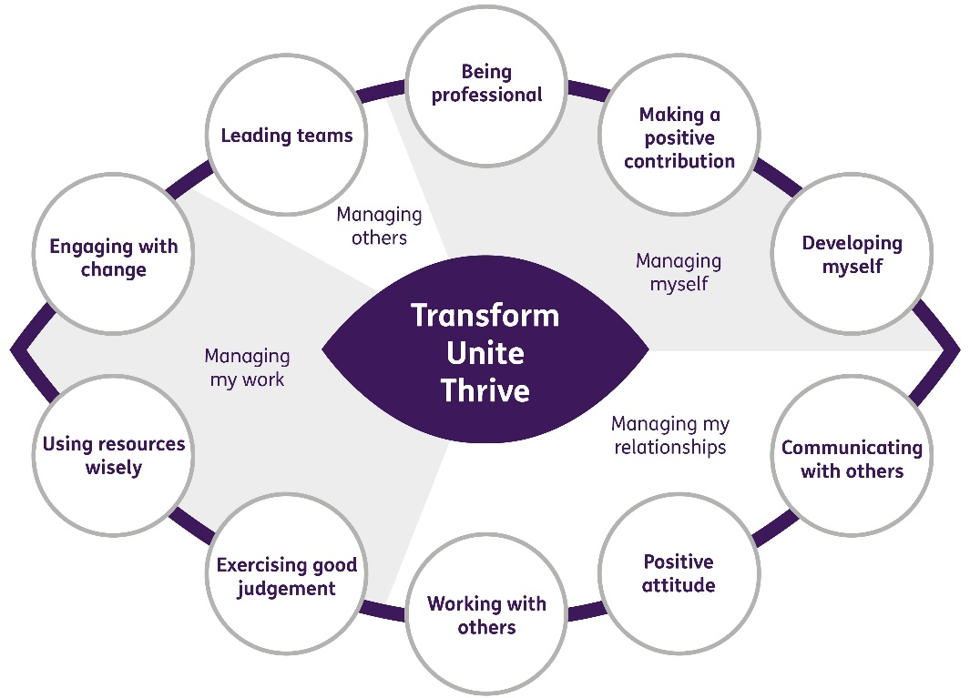

Our Ways of Working - Managing my Work

The main responsibilities and accountabilities of this role are that you will:
Research and policy development

- Support the Policy Manager in the development and implementation of appropriate campaigns of influence.

- Undertake research to inform campaigns which achieve positive change in vision impairment policies at all levels of government.

- Gather and research data to ensure policy positions are evidence based and to contribute to high quality briefings, consultation responses and publications.

- Support our policy processes so that the priorities and experiences of people living with sight loss determine influencing activity.

External engagement

- Work with the Head of Policy, Public Affairs and Research to engage with statutory and academic institutions involved in collecting data relevant to people vision impairment, and explore the potential for research projects which promote better understanding of social issues in relation to vision impairment.

- Liaise with national and local politicians and their staff and with officials of other organisations to promote policy priorities.

Parliamentary liaison

- Support the charity’s engagement in policy processes, including producing content for responses to relevant Scottish and UK Government and Scottish Parliament consultations.
- Contribute to Sight Scotland and Sight Scotland Veteran’s input into relevant Cross Party Groups of the Scottish Parliament.
- Support in ensuring our compliance with the requirements of the Lobbying Act.

Communications

- Support the strategic development and enhancement of the organisation’s media profile, specifically in relation to policy work, by drafting news releases, and occasionally representing the organisation in the media and/or supporting other relevant staff to do so.
- Produce high quality written material and support commissioning of material from third parties, for example blogs, reports and research.
- Update the charity’s website with policy related materials and information.

Contribute to the work of the Marketing and Communications department

- Represent Sight Scotland and Sight Scotland Veterans at exhibition stands and external events as required.
- Work with the Digital Marketing and Fundraising Officer to plan social media for policy campaigns.
- Work with the Communications and Publications Officer to plan and deliver case studies of service users for use in policy related media work.
- Work closely with other marketing colleagues to ensure effective reach and dissemination of evidence-based policy work.
- Undertake other duties from time to time as required by the Head of Policy, Public Affairs and Research and Associate Director of Marketing and Communications.

Our Ways of Working – Managing Myself and Managing my Relationships

To do this role, you will have:

- A degree or equivalent professional experience
- Good knowledge of public policy frameworks and processes in Scotland
- Keep up to date with developments in Scottish and UK politics.
- Experience working in a role related to policy development
- Demonstrable experience of researching data to inform policy engagement and campaigns
- Demonstrable experience of gathering evidence and data through a range of research methods and from a variety of sources
- Demonstrable experience of writing policy documents and research-based publications
- Demonstrable experience of maintaining networks in a public and/or third sector or academic setting
- High level of written communication skills including accuracy and attention to detail
- Strong verbal communication skills with the confidence to engage face to face with politicians, civil servants and other stakeholders
- Strong project management and organisational skills
- Excellent analytical skills
- An ability to establish and maintain effective working relationships with other staff and with stakeholders in the public, private and voluntary sectors
- Demonstrable experience of researching, analysing and organising diverse materials
- Commitment to ethos of the voluntary sector
- Ability to work out of hours, for which TOIL will be granted

It would be desirable for this role if you have:

- A research based degree or professional qualification
- Experience of working with Parliamentarians and Senior Civil Servants
- Experience of working with the media
- Experience of using social media in a professional setting

On a day to day basis you will work with different people and teams, these could be:
- Colleagues
- Sight Scotland and Sight Scotland Veterans services
- Senior Staff
- External Stakeholders
- Media
- Parliamentarians and Senior Civil Servants

Requirements of this role are:
- You are a member of the PVG scheme (paid for by Sight Scotland)
- You will have a 6 month probation period
- That you participate in all staff training and development and maintain your own professional development
- Keep up to date with developments in Scottish and UK politics.

What we can offer you:
- Generous annual leave entitlement which increases after 4 years’ service
- Generous pension scheme
- Access to learning and development opportunities
- Employee Perks through the Employee Assistance Programme
- Cycle to Work scheme
- And many more, please visit our website for more information

This job profile is not exhaustive. The duties of the post holder may be reviewed from time to time and the employee may be called upon to work in other locations within Sight Scotland.

