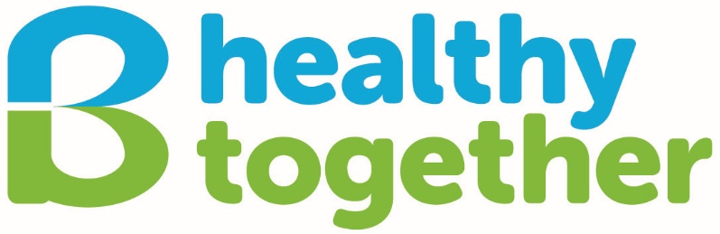

**Organisation Background**

**1.1 Aims and Objectives**

B healthy together (BHT) is a small, dynamic voluntary organisation and registered Scottish charity, developed by local people from Sighthill, Parkhead and Broomhouse in Edinburgh. BHT aims to facilitate health improvement for the local communities in the South West of Edinburgh (including Broomhouse, Sighthill and Parkhead), using an inclusive approach to promote healthy lifestyles and provide a variety of social health activities. BHT has was established over 25 years ago and has the following objectives:

1. To promote healthy lifestyles within the local community by providing access to affordable food and undertaking food and health activities.
2. To provide opportunities for the local community to seek peer support around relevant areas of health and reduce social isolation.
3. To provide volunteering opportunities, with the intention of generating greater confidence and self-esteem in those volunteers.
4. To work in partnership with local organisations to identify and address gaps in community-based health improvement activities within the local communities.
5. Using an inclusive approach, to involve and empower local people in the development and provision of B healthy together health improvement activities.

**1.2 Approach and Activities**

BHT uses a community development approach to bring people together who share common interests in health issues in their community. Local people and volunteers are central to the planning and delivery of all services. Services are delivered by a team comprising of salaried staff, hourly-paid staff and volunteers. Governance is provided by a Board of Trustees (maximum 12 members) which includes volunteers and professionals from other organisations.

BHT activities are free and currently comprise of adult and child cooking sessions, community meals, health and wellbeing workshops, wellbeing at home project, community growing space, craft group, BuggyGym, seated yoga, chair exercise, and a walking group. BHT also works in close partnership with local organisations to address gaps in health improvement activities.

**1.3 B healthy together Values**

1. **Innovative**: we support people on their journey to health and well-being by improving, innovating and adapting our services.  We want to work with our service users to learn from their feedback and continually improve the way we work to ensure our services meet the needs of the communities we work within.
2. **Diverse**: being healthy can mean different things to different people.  We recognise goals that celebrate health in many ways and we strive to work with people at their own pace and to help them along their individual journey.
3. **Inclusive**: we offer support to anyone wanting to improve their health and well-being.  Our services are for everyone no matter what age, class, ethnicity, religion, gender, sexuality or disability.
4. **Supportive**: being healthy is influenced by a range of external factors; we believe that, no matter what the challenge, we can support people to enjoy greater well-being by making healthier choices.
5. **Enabling:** we empower and build resilience with local people to utilise their skills and experience to the benefit of our communities
6. **Collaborative**: When meeting our aims, we take pride in forming partnerships with other organisations in order to make a significant difference to the communities it serves.
7. **Efficient**: we are honest and transparent in our activities and will use our resources efficiently and effectively to deliver sustainable services for the communities we work for.

**1.3 Funding**

BHT is funded by the Edinburgh Health and Social Care Partnership, Robertson Trust, Lottery and Scottish Government in addition to a range of other grants.

**1.4 Organisational Structure**

|  |  |  |  |  |  |  |  |  |
| --- | --- | --- | --- | --- | --- | --- | --- | --- |
|  |  |  | Board of Trustees |  |  |  |  |  |
|  |  |  |  |  |  |  |  |  |
|  |  |  | Chief  Executive |  |  |  |  |  |
|  |  |  |  |  |  |  |  |  |
|  |  |  | Senior Community Development Worker |  |  |  |  |  |
|  |  |  |  |  |  |  |  |  |
| Community Development Worker |  |  |  |  |  | Community Development worker and Specialist Tutor |  | Finance and Administration Officer |
|  |  |  |  |  |  |  |  |  |
| Volunteers in Specific Services |  |  | Volunteers in specific services |  |  | Volunteers in Specific Services |  |  |
|  |  |  |  |  |  |  |  |  |
| Sessional  Workers | | | | | | |  |  |

**1.5 Social Media details**

**Website:** [www.bhealthytogether.org.uk](http://www.bhealthytogether.org.uk)

**Facebook:** [www.facebook.com/bhealthytogether](http://www.facebook.com/bhealthytogether)

**Instagram:** [www.instagram.com/bhealthytgether](http://www.instagram.com/bhealthytgether)

**Twitter:** [www.twitter.com/Bhealthytgether](http://www.twitter.com/Bhealthytgether)