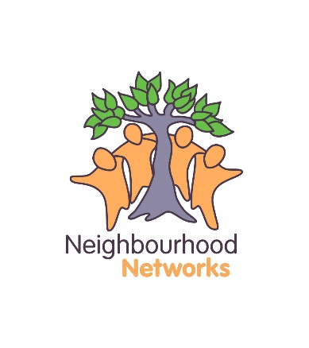
Job Description
Post: Community Living Worker
Responsible To: Network Manager
Salary: £19,519.50 (pro rata, equivalent to £10.01 hour)
Hours: Flexible 16 hours/week
Holidays: 6 weeks (fully flexible incl. Bank Holidays)

This job description outlines the purpose and main elements of the position. It is intended to act as a guide to the various roles and responsibilities that currently exist within the role. However, it is not meant to represent a wholly or comprehensive schedule to the job and is subject to change.

Description

The Community Living Worker plays an extraordinary role in the lives of our members: neighbour, advocate, group worker, supporter, and facilitator. They perform a completely different role to that of a Social Worker or what’s perceived as a traditional Care Worker. The Community Living Worker should be able to perform professionally while maintaining the ability to connect with the network members that they support. This forms a unique relationship within the lives of our members and one that allows them to feel both ordinary and supported at the same time.

Our Community Living Workers provide practical support around maintaining tenancies, facilitating mutual support, developing new relationships and having a say in their local communities. Community Living Workers also act on early warnings to ensure that, while supported by their manager, the appropriate agencies are notified of a potential crisis in a member’s life.

Values, Approach and Workload

We encourage staff to bring their own individual skills and style to the role of Community Living Worker and recognise that people will carry out their role in very different styles, which is something that we embrace. We expect Community Living Workers to use their judgement and common sense if there is a decision to be made which can’t be discussed with their Network Manager or Senior Management Team. However, we do expect such a decision not to be made without careful consideration for the organisations vision and values.

Community Living Workers need to carry out their work within an average of 16 hours across a 7 day week. As such, Community Living Workers may have to work during unsociable hours depending on the Network and Members within the Network.

Other aspects of the role away from direct work with members may include: supervision, liaison and networking in the local neighbourhood/community, Neighbourhood Network meetings, training and events, travel time, phone calls, administration work for weekly monitoring forms, processing expenses, etc. If multiple issues arise simultaneously, Community Living Workers will need to use their judgement to prioritise their workload, which can be done in consultation with their Network Manager.

Key Accountabilities and tasks

- To build warm, caring, positive and professional relationships with members ensuring that the individuals interests are central to the support offered.

- To carry out a broad range of tasks and activities in the most appropriate way for the individual and, as outlined in their Support Plan, to include working towards the outcomes: Independent Travel, Natural Friendships/Relationships, Money Management, Confidence & Self-Esteem, Community Participation, Life Skills, Health & Wellbeing, and Employment/Volunteering.

- Support will not include personal care as a matter of course, but the Community Living Workers discretion may be required in certain isolated circumstances.

- To notify the Network Manager of any change in the support needs, behaviour or health of members and ensure that effective communication is maintained at all times. This may also include liaising with outside agencies such as health, social work and the police.

- To work flexibly and creatively with individuals and groups in recognising their achievements, harnessing their skills and helping them to discover new skills.

- To support members on a practical level in tasks such as planning budgets, paying rent, household tasks, seeking legal advice, seek housing support, how to deal with an emergency, sharing skills, learning new skills, plus many more.

- To ensure that all information pertaining to members is communicated in line with the organisations Policies and Procedures, maintaining confidentiality and data protection throughout (both written and verbally).

- To work professionally at all times, not to act in a way that may threaten the reputation of the organisation and to adhere to the organisations Policies and Procedures.

- To record in writing any incidents, informing the Network Manager and Head Office immediately, and following Neighbourhood Networks’ Reporting of Incidents Policy (this will also include the need to take up or update Adult Support and Protection Training).

- To ensure that people connected to our members understand that the support offered is for the member alone and not their friends/family, however we do also recognise that some contact with the friends/family is appropriate in some circumstances.

- To ensure that your training record is maintained, updating training opportunities where required.

Additional Tasks which may be undertaken in consultation with the Network Manager

- To assist and contribute to the review of Individual Support Plans with members including risk management processes promoting choice, independence, dignity, diversity, culture and values. This will normally be done in consultation with the Network manager, but not exclusively so.

- To attend GP appointments or other health professionals with members where appropriate.

- Offer short-term emotional support to members.

- Support members to complete Income Support applications.

- To support members and their families together in the short term around their concerns (e.g. help them make a complaint against other agencies, Neighbourhood Networks or people).

- To actively participate in work reviews, support and supervision, training and development which will include in-house training and working groups (as required).

- To accompany members to external meetings and advocate on members behalf, where appropriate.

- Provide information and feedback to other agencies in line with Neighbourhood Networks’ Data Protection and Information Sharing Policies.

