(

**Director -Job Description**

**About Us:**

Since 2013, musicALL has been delivering high quality music opportunities for disabled young people. We achieve musical engagement and skill development, and create opportunities through the following channels:

* Involvement in two established bands
* Outreach work with diverse schools
* Intergenerational sessions in care homes
* Performance opportunities
* Expanding life and cultural experiences
* Bringing disabled and non-disabled people together through music
* A focus on inclusivity and recognising ability.

**NB:** Reflecting current Covid-19 restrictions we have successfully adapted our delivery utilising both digital and online platforms.

Through workshops, tuition, rehearsals and performances we bring people, with and without disabilities, together to make music, build relationships and offer young disabled adults access to continued music training and performance opportunities after leaving school.

**Our vision** is to contribute to the creation of a society that ensures all children and young people have access to opportunities that enable them to enjoy their rights and fulfil their potential. musicALL achieves this through the Framework of Music Support, a strengths-based inclusive approach whereby disabled and non-disabled musicians can create a musical framework together and access it at a level that’s right foreach individual involved.

We have several core values, shown below, that underpin all activities and are consistently reflected in all engagement with participants and key stakeholders.

* Participation
* Inclusion
* Transition
* Accessibility
* Equality

**Our Impact**

The fundamental and overarching contribution of musicALL is that it enables young disabled people to achieve **self-actualisation**. This is because participation appears to significantly **raise expectations and challenge assumptions** (about disability) across a range of channels in society. This includes young people without disabilities, parents of disabled young people, disabled young people themselves, and across communities who engage in diverse ways with musicALL.

musicALL offers provision that creates a sense of purpose for disabled young people and provides an identity and a real sense of being valued. The lack of control that disabled people experience in many aspects of their lives is mitigatedby the **sense of independence and control** that they experience through their engagement with musicALL.

**The Opportunity**

Due to the impending retiral of its founder, musicALL’s Board of Trustees are looking to recruit into the critical role of Director.

Working with the Board of Trustees to develop a new strategic plan, key priorities of the role include:

* Ensuring that the charitable purposes of musicALL are followed and that it delivers the charitable benefit and impact set out in its vision.
* Overseeing the development and implementation of a blended model of delivery, recognising both the significant benefit and impact of face-to-face interaction and the opportunities associated with new and emerging digital technologies.
* Developing and overseeing a strategic and proactive approach to extending the charity’s service provision, reach and, ultimately, its impact across Scotland.
* Ensuring the ongoing financial sustainability of the organisation, identifying and securing new funding streams.
* Developing and maintaining positive strategic partnerships with local authorities, schools, care homes, funders and other third sector organisations to ensure all have access to music opportunities that enable them to enjoy their rights and fulfil their potential.

**Key Responsibilities**

* Provide strategic vision and leadership to the operation and development of musicALL within the direction set by the Board of Trustees ensuring the interests and needs of disabled young people are at its heart.
* Responsible to the Board of Trustees for the overall financial health and ongoing financial sustainability of the organisation.
* Strategic and operational management of budgets and finance in collaboration with the external accountant and Treasurer of the charity.
* Deliver regular reporting to the Board of Trustees on the progress and development of the organisation.
* Oversee the growth and development of musicALL in line with the agreed direction, principles and ethos of the organisation.
* Write, review and approve all funding applications and also ensure all external reporting to funders is completed in good time and to a high standard.
* Maintain awareness of risks, including safeguarding, and changes in the external environment that affect the organisation or its service delivery.
* Seek out and develop new income streams and ensure future income streams and resources.
* Develop and maintain effective partnerships with new and existing stakeholders, funders and potential funders.
* Take overall responsibility for musicALL’s management and administration within the governance and accountability frameworks established by the Board.
* Represent the organisation externally to the public, key stakeholders and partners.
* Oversee the administrative functions of the organisation to ensure the smooth and efficient performance of all activities of musicALL.
* Overall management of staff and delegation of duties to staff, including self-employed delivery staff, ensuring collective responsibility and a continued strong focus on achieving the organisation’s mission and aims.
* Ensure the quality of provision is maintained to the standard required to meet the organisation’s goals.
* Oversee the recruitment of all new staff to support musicALL’s ongoing growth, ensuring continuing high standards within the organisation.

**Person Specification**

* A strong commitment to musicALL’s vision to contribute to the creation of a society that ensures everyone has access to opportunities that enable them to enjoy their rights and fulfil their potential through the arts.
* Good leadership skills and the ability to enthuse, motivate and develop a small team to deliver results.
* An inclusive leader who inspires excellence and delivers high performance coupled with the ability to set the strategic direction in the context of a changing external landscape.
* Previous experience leading an organisation operating within tight financial constraints is desirable.
* Strong experience of effectively managing resources and budgets, as well as experience of delivering long term financial sustainability and value for money.
* Understanding and experience of working with disabled people and a strong sense of both the challenges that can be overcome and the potential that can be achieved through engagement in expressive arts and a commitment to the social model of disability.
* A willingness to challenge stereotyping, prejudice, discrimination and bias.
* The ability to translate broad strategies into specific objectives and action plans and align processes and systems to achieve strategic priorities.
* Previous experience securing funding in a tough financial climate from various sources including securing commissioned contracts, trust and foundation applications.
* Strong stakeholder management experience, with a proven track record in building and maintaining a wide range of collaborative relationships and partnerships preferably within the arts or disabilities sector in Scotland.
* Demonstrable awareness of the opportunities that emerging digital technology offers in transforming frontline service delivery and engagement with children and young people.
* Willingness and ability to operate at all levels within the organisation to support staff and participants as required.
* A high level of interpersonal communication (verbal and written) and influencing skills.
* Proven advocacy skills coupled with the ability to effectively represent the organisation externally to a diverse range of external stakeholders.
* A strong understanding of, and commitment to, the key principles of safeguarding at an organisational and practice level.
* A commitment to diversity and inclusion.
* Self-directed and able to multi-task.
* Resilient, adaptable and a pragmatic problem solver.
* Compassionate, patient and empathetic
* An awareness and experience of the positive impact music or other expressive arts can have on people’s lives.

**Salary and benefits package**

Full time – 35 hours/week.

The role offers a salary between £38,000 – 42,000, a stakeholder pension scheme (6% employer’s contribution), and 30 days of annual leave, plus 10 days of public holidays.

**NB:** musicALL is a flexible employer and is happy to consider applications from candidates looking to work compressed hours.

**musicALL – some additional information from the Board of Trustees**

**Who are we and what do we do?**

We are a young, small organisation based in the West of Scotland with three employees and around ten self-employed musicians. We have an administrative post and work with an external accountant. We have two established inclusive bands, The Fridays and The Hazels, made up of disabled and non-disabled musicians who perform in schools, care homes and many other venues, large and small. They have performed in the Royal Concert Hall at Celtic Connections, Glasgow Central Station on many occasions, The Royal Conservatoire of Scotland as part of the International Society of Music Education Conference, in the Armadillo at the opening ceremony of the IASSIDD Conference, and on one memorable occasion, at Celtic Park to an audience of around 30,000 football fans!!

This year, the Fridays won the Creative Innovations award at the Scottish Commission for Learning Disability Awards 2020. This was a source of great pride and joy for the musicALL family, particularly during such a challenging year. We are also about to release a charity single, which was the result of a collaboration between the band and a professional singer/songwriter – watch this space!!

As well as band rehearsals and performances, we have a number of projects currently running in partnership with local authority schools and care homes. These include, for example, intergenerational projects bringing older people, school children and musicALL musicians together to interact and get to know one another through the medium of music. We run inclusive music workshops with schools aimed at giving children and young people opportunities to play as part of a band.

We have a strong and committed Board of Trustees who bring with them a wealth of experience from a range of fields – business, education, human rights and disability.

Prior to the Covid-19 pandemic, our base was in Scottish Youth Theatre and The Hazels and The Fridays rehearsed there two days per week. Over the last year, like so many other organisations, we have moved online giving us the opportunity to develop a new digital strand to our work.

**Success, ethos and values**

musicALL began 10 years ago in an additional support for learning school where the musical talents of disabled young people were very evident and the power of music to engage and connect people was clear. musicALL became a charity in 2016 and has reached out to several thousand people throughout Glasgow and surrounding areas.

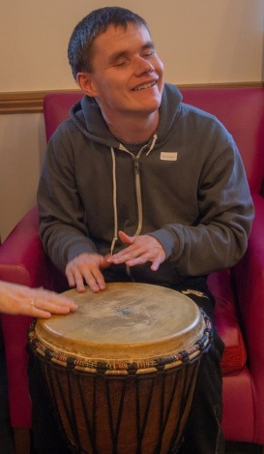The success of the organisation can be explained in many different ways: the commitment and tenacity of the founding manager and the staff; the musical talent of the musicians with and without disabilities who make up the two bands and who co-lead the projects in schools and care homes; the relationships with families, stakeholders and funders, which ensures ongoing support in every sense of the word, and the quality of the musical performance and engagement that is achieved, to name but a few!

But most important, in our view, are the ethos and the values that lie at the core of the organisation and permeate the decisions, actions and direction we take. This ethos is characterised by our belief in equality of opportunity and inclusion, i.e. the right of every person to be treated with respect and dignity and to be given the opportunities that allow them to fulfil their potential.

This ethos can be seen in our relationships – with each other, with our beneficiaries, our families and carers, our funders and everyone we work and engage with. It results in long-standing connections with funders such as Creative Scotland – Youth Music Initiative, Inspiring Scotland, Scottish Government, The National Lottery Community Fund, The Robertson Trust and many more, who support the work of musicALL. It results in loyalty and goodwill from staff, who give willingly of their time and effort above and beyond the ‘job’.

We see the results in parents, grandparents and carers, who are amongst our strongest supporters and fans! And in the schools, care homes and other organisations we work with, who inevitably look for continued engagement with us. It can perhaps most clearly be seen in the growth and development of confidence, independence and self-esteem in the disabled young people who are at the centre of our organisation.

The ethos also creates an atmosphere of mutual respect in which participants can enjoy themselves and have lots of fun – which we do!!

In searching for a musicALL Director, a belief in and commitment to the ethos and values of the organisation will be crucial. This goes hand-in-hand with a deep understanding of disability and of the challenges currently facing society in ensuring equal access to opportunities for all.

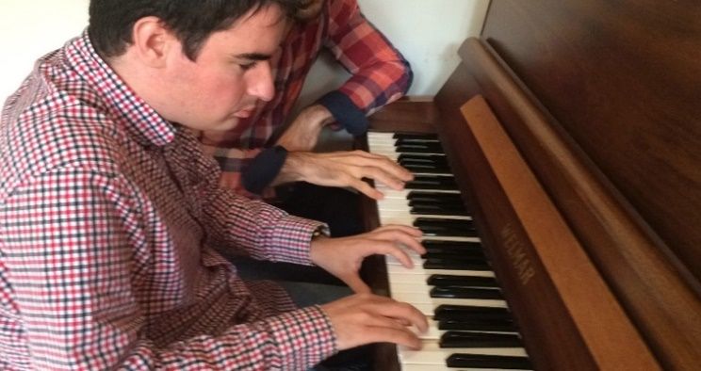

Here are some quotes from our projects:

*“I can’t believe I’ve played in a band – that’s a wee taste of what I can do!****”* Participating pupil**

“*Not only did the pupils enjoy participating but* *everyone in the school loved their performance and thought it was the best event to have taken place in the school ever!*”**Feedback from participating school**

*"A sense of purpose, that you matter, changes everything. From initiating conversations to creating songs and rhythms, I've watched the people I support blossom into confident musicians with authentic relationships. The changes are life-affirming."***Support worker**

*“The inclusive and positive nature of your project shone through throughout and our young people were engaged and inspired right from the first moment. We very much enjoyed working with you and the whole team throughout the whole preparation period. It would be wonderful if this event could be just the beginning of a series of future collaborations, and the whole school community would be absolutely delighted if you were to take part in a similar event in the future.”* **Music teacher, participating school**

**For more information, please visit our website at -** [**musicallscotland.uk**](https://musicallscotland.uk/)