SSF Enterprise Development Manager
Background Information

Organisation Background

SSF work with around 3000 individual people each year. We operate 50 weeks of the year: weekdays, evenings, and weekends, with only 2 weeks at Christmas with no service delivery. Prior to COVID-19, the vast majority of our delivery took place face-to-face, in indoor venues. Delivery ranged from one-to-one support to small group work, and larger group activities.

Some young people we work with for a determined period of time, typically from 12 weeks to a year depending on the intensity of the programme. Key to our work, however, is offering pathways for young people into our other delivery programmes, including longer term interventions. We find that most of our participants remain engaged with our activities beyond their initial period of support, with many going on to leadership and volunteering roles to support other young people in their communities. Our current youth trustee is a perfect example of this: joining us as a young participant 7 years ago, moving into a volunteering role, and eventually a position on our Board of Directors.

SSF provide a range of activities for young people between the ages of 10-24 which:
- Support people, families, and communities most affected by living in poverty.
- Support those most at risk of being involved in antisocial behaviour, offending, or reoffending, or at risk of entering the justice system.
- Support young people disengaged from education, or at risk of exclusion from education.
- Support young people facing challenges around mental health and wellbeing, in partnership with SAMH.

Going into COVID-19, the percentage of income we brought in through grants was around 95% with small amount of our income coming fundraising and trading. We are conscious that this is not a sustainable model going forward.

It is our intent that we would grow our total income marginally, however we do not intend to grow it through grants. Our approach will be to grow our income from social enterprise and corporate connections.

We intend to have this make up 11% of our income next year and to grow it by 5% each year after that. Based on current demand and interest we think this is achievable.

On this basis we believe our organisations financial position can remain strong but be much more balanced around grants and trading.

Enterprise Development

This new role will be integral to leading and implementing the enterprise activity and goals set in SSF’s business plan and strategy. Throughout the COVID-19 pandemic, SSF has been able to adapt quickly to meet the needs of the young people who we are working with and who require our support. Accessing resources and a strong digital presence has been critical to this.

Given the current and likely future challenges around the economic position and the potential for a possible reduction in available long term grant funding, there is a real need to diversify our funding streams and be less reliant on grant funding. However, there is also a need to keep strong relationships and visibility with the funders we currently work with.

Our unique approach to using youth work and sport to change lives and our ability to be agile has put SSF in a strong position. Growth of unrestricted funding will be key to ensure we can adapt and meet the ever-changing needs of young people and the communities we work with as we recover from the pandemic.

SSF has an offer in terms programmes and training which can be delivered digitally and face-to-face.

The key steps over the next 12 months will be to market and sell those programmes and training to new customers within both the third and public sectors.

The key areas that SSF can trade in or generate income from out with grant funding include:
- Training and development
- Purchase of our our programmes
- Corporate sponsorship and fundraising

Customer Relationships

SSF has very strong relationships and partnerships that continue to grow, there is a growing digital engagement across several platforms. We have now appointed a F/T Marketing Manager and the quality of our work in this area continues to be enhanced.

National and local organisations (see diagram 1) who have a relationship with SSF or follow our digital content in many cases also provide us with income to deliver services. There is an opportunity for us target and adapt our digital communication and products to grow this income through repeat custom.

Alternatively, there is an opportunity for us to us to target prospective customers who follow us but do not currently pay for our services. Gathering customer information and then relationship building with these organisations is an important step.

CRM System and Metrics

A plan is in place to map out what national and local organisations who currently have an interest in the above areas and work is underway to review our CRM system. There is a need to grow and engage with this customer base.

There will be ongoing analysis of online analytics to monitor profile views, impressions, followers and most popular content.

In addition to this however it is important that we can develop new relationships with online followers and as such a key metric will be around turning this engagement into a solid business prospect where, we have customer details and information.

KPIs will be set around the percentage of income generated against total income. This could be tagged by programme.
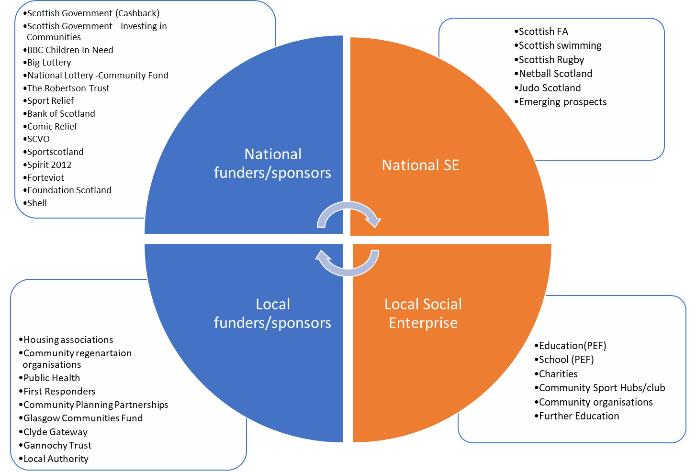

Education Through CashBack

SSF’s most established social enterprise product is our Education Through CashBack (ETC) training modules. The Business Development Manager will support the development of a business growth plan for the ETC programme, as well as identifying and establishing new business relationships and customer bases, to grow the trading potential of ETC.

Education Through Cashback (ETC) is a Scottish Sports Futures training programme combining youth work and sport to enhance knowledge of the Sport-4-Change approach. Eight practical and interactive modules develop understanding of working with young people and encourage personal development through sport. The modules are SCQF-accredited, allowing participants to receive tangible recognition for their completion of the programme. Training is flexible and adapted to suit the needs of the group.

Who is ETC for?

- Experienced coaches, youth workers, volunteers, and other practitioners looking to increase their knowledge of delivering Sport-4-Change programmes and understanding of the developmental value of sport and physical activity.
- Young leaders who are newer to coaching and looking to develop their skills and confidence in delivering activities effectively to a range of young people.
- Young people experiencing challenge, e.g. at risk of exclusion, low-attainment, who wish to develop skills that can be transferred into everyday life, through participation in practical sessions adapted to their needs.

ETC Modules

Working with Young People in Sport
The first module offers an introduction to understanding young people and the role of the coach.

Human Connection
This module aims to develop awareness of the importance of building relationships and the ‘human connection’ as part of effective coaching.

Planning Effective Physical Activity Programmes
This practical module utilises Kolb’s learning cycle (Plan – Do – Review) to explore the benefits of sport and physical activity and planning effective outcome-based programmes.

Communication
A practical module building understanding around the use of communication in sport and its applications beyond.

Goal Setting
A module focused on building understanding around the process of setting goals in sports and how these skills can be transferred into everyday life.

Conflict Resolution
This module will build on themes introduced in module 1, to provide participants with practical tools for dealing with conflict, aggression, and challenging behaviour in a sports setting.

Mental Health and Wellbeing in Sport
This interactive module provides an opportunity to explore mental health and wellbeing within a sporting context and looks at how to create conversations around these topics (suitable for 16 years +)
Adverse Childhood Experiences and Sport
This module aims to increase social awareness of ACEs and looks at how we can support young people experiences ACEs to fulfil their potential (suitable for 16 years +)

Pupil Equity Fund (PEF) Frameworks

SSF is currently an approved supplier on the PEF frameworks in a number of local authorities, including Edinburgh, North Lanarkshire, East Ayrshire, and West Lothian. This has been identified as a key area for potential enterprise growth.

