# RSE APPLICATION PACK

## INTERNATIONAL OFFICER (12 months Fixed-Term Contract)

Thank you for requesting an application pack for the position of **International Officer** at the Royal Society of Edinburgh.

**The Application Pack contains:**

* **A Job Description including key responsibilities, competencies, skills & experience needed to do the job, salary & hours, a person specification and the RSE expectations of Key Behaviours & skills**
* **Information about the Royal Society of Edinburgh**
* **Policy on criminal record disclosure**
* **A note summarising RSE non-pay benefits**

|  |  |  |
| --- | --- | --- |
| **35Job Title** | **INTERNATIONAL OFFICER** | |
| **Grade**  **Salary**  **Hours** | Grade: 2  Salary: £22,432  Hours: 37.5 hours per week, Full Time, Monday to Friday, 9.00 am to 5.30 pm (occasional work out-with these core hours)  The role would usually require occasional travel (UK or internationally), but this is not foreseeable in the interim as staff work from home and the relevant Covid restrictions remain. | |
| **Starting Date** | As soon as possible | |
| **End Date** | 12 months in the first instance | |
| **Role** | To help promote Scotland’s interests and strengthen its research and innovation profile and connections with the world by supporting the delivery of a high quality RSE International programme of activity. | |
| **Key Responsibilities** | * To support and deliver research and innovation-led collaboration activities (symposiums, roundtable meetings) in line with the international programme business plan and objectives * To coordinate closely with other RSE teams to ensure delivery of activity * To develop and support implementation plans for relevant international projects * To support the ongoing maintenance of international relationships with partners and networks * To provide secretariat support for the International Committee and Africa Working Group * To undertake the capture of impact information and evaluation of international activities * To coordinate the RSE’s response to academic-related International Human Rights case alerts * Maintain the international section of the RSE website and CRM records * To undertake any other tasks, appropriate to the role, that are required by the line manager and the RSE | |
| **Key Competencies /Skills** | **ESSENTIAL**   * Previous experience of working in a similar environment or international context * Experience in project coordination and developing/ delivering activity in collaboration * An awareness of international issues including political and cultural sensitivities * Excellent planning and organising skills * Ability to engage well with others and influence key stakeholders * Diplomacy as well as excellent written, listening, and verbal communications skills * Strong commitment to equality, diversity, and human rights | **DESIRABLE**   * Knowledge of the Scottish University and research sector * Second language |
| **Key IT Skills** | **Word** | **Excel** |
| Intermediate level | Basic level |
| Outlook | PowerPoint |
| All skills | All skills |
| Customer Relationship Management system | Others |
| Role specific procedure level | Website content management system  Zoom, MS Teams  Knowledge of social media platforms |
| **Staff Management**  **Responsibilities** | The post has no staff management responsibilities | |
| **Responsible to** | International Relations and Awards Manager | |
| **Key Customer Groups** | **External**: International academies/ learned society networks, UK National academies, Scottish HEI’s at all levels, Scottish Government, Scottish Funding Council, relevant Embassies & Consulates, and other key stakeholders such as British Council, Universities Scotland, Scottish Development International & Scottish Enterprise.  **Internal**: All RSE staff, Fellows (FRSE) both in UK and abroad (corrFRSE) and Senior officers, Committee Members and Conveners (Vice-President International) | |

**Person Specification**

**To support and deliver research and innovation-led collaboration activities (symposiums, roundtable meetings) in line with the international programme business plan and objectives**

* Co-ordinate arrangements for international activities and ensure that they are delivered on time and to a high standard
* Coordinate the RSE’s participation in joint workshops, projects, delegation visits and other events with overseas and UK partners are delivered to a high standard
* Work closely and directly with FRSE activity leads and engage with relevant stakeholders on delivery actions
* Provide briefing and information packs where relevant for RSE participants involved in activities
* Provide activity progress updates to the line manager

**To coordinate closely with other RSE teams to ensure delivery of activity**

* Work closely and directly with relevant RSE colleagues across teams on delivery actions such as Public Engagement, Policy, Awards, Communications and Business Support
* Develop and agree on relevant international activity-specific publicity with the RSE Communications team

**To develop and support implementation plans for relevant international projects**

* Produce and agree to a project delivery plan for individual activities/ projects with the line manager
* Lead on relevant scoping and coordination aspects for each project
* Ensure any project costs are delivered in line with the agreed budget

**To support the ongoing maintenance of international relationships with partners and networks**

* Support and understand the existing relationships with academies and learned societies across the world and how these are / should operate in practice
* Support towards building and fostering links and strategic partnerships with these academies and learned societies across the world, both priority and non-priority countries
* Support relationships with other relevant partner organisations
* Support towards RSE participation at Connected Scotland partners activity
* Harness the knowledge and international networks of RSE Fellows both in Scotland and overseas, engaging closely with the Fellowship Team on this
* Maintain and coordinate contact with relevant member networks such as the All European Academies (ALLEA)
* Respond to any partner requests for input, working groups and record on the CRM system
* Coordinate RSE representation at the annual ALLEA General Assembly meeting

**To provide secretariat support for the International Committee and Africa Working Group**

* Arrange annual meetings, prepare papers, contribute and minute of meetings
* Produce a minute/action note following the meeting and assist with relevant actions
* Maintain up-to-date records and skills matrix of current members and correspondence of departing/ new members
* Maintain regular contact with Vice President (International) and ensure he/ she remains sighted on updates and actions
* Assist with relevant scoping or horizon scanning exercises as agreed with the International Relations and Awards Manager

**To undertake the capture of impact information and evaluation of international activities**

* Capture relevant impact information for each activity as outlined by the international programme evaluation plan
* Ensure relevant information is collected and draft impact stories saved to the RSE system and CRM
* Support drafting of relevant international activity impact stories for the RSE’s annual impact report

**To co-ordinate the RSE’s response to academic-related International Human Rights case alerts**

* Point of contact between the RSE and the UK Human Rights Committee (UKHRC)
* Liaise with RSE representatives on the UK Human Rights Committee about the RSE response to each case from the UKHRC or the International Human Rights Network (IHRN)
* Feedback the RSE response on cases to the UK Human Rights Committee
* Record each case and the RSE response on the CRM
* Provide secretariat support as required by the RSE

**Maintain the international section of the RSE website and CRM records**

* Update and draft activity news bites for the international section of the RSE website
* Ensure content on the international section of the RSE website is kept up to date
* Maintain and ensure all relevant relations, activity and partner information is kept up to date on the CRM
* Provide relevant international update contributions as required to RSE publications and reports as agreed with the International Relations and Awards Manager

**Corporate Expectations**

* Apply RSE’s key behaviours and skills (See “Our Expectations” enclosed below).
* Adhere to the RSE vision, mission, and values
* Ensure all processes comply with data protection legislation and are in accordance with RSE record management policy and processes
* Observe all health and safety requirements
* Work within and promote policies in relation to the RSE Diversity Policy
* To undertake any training as required by the job description, in line with the business needs or required by your team leader
* To undertake other reasonable tasks as required by RSE

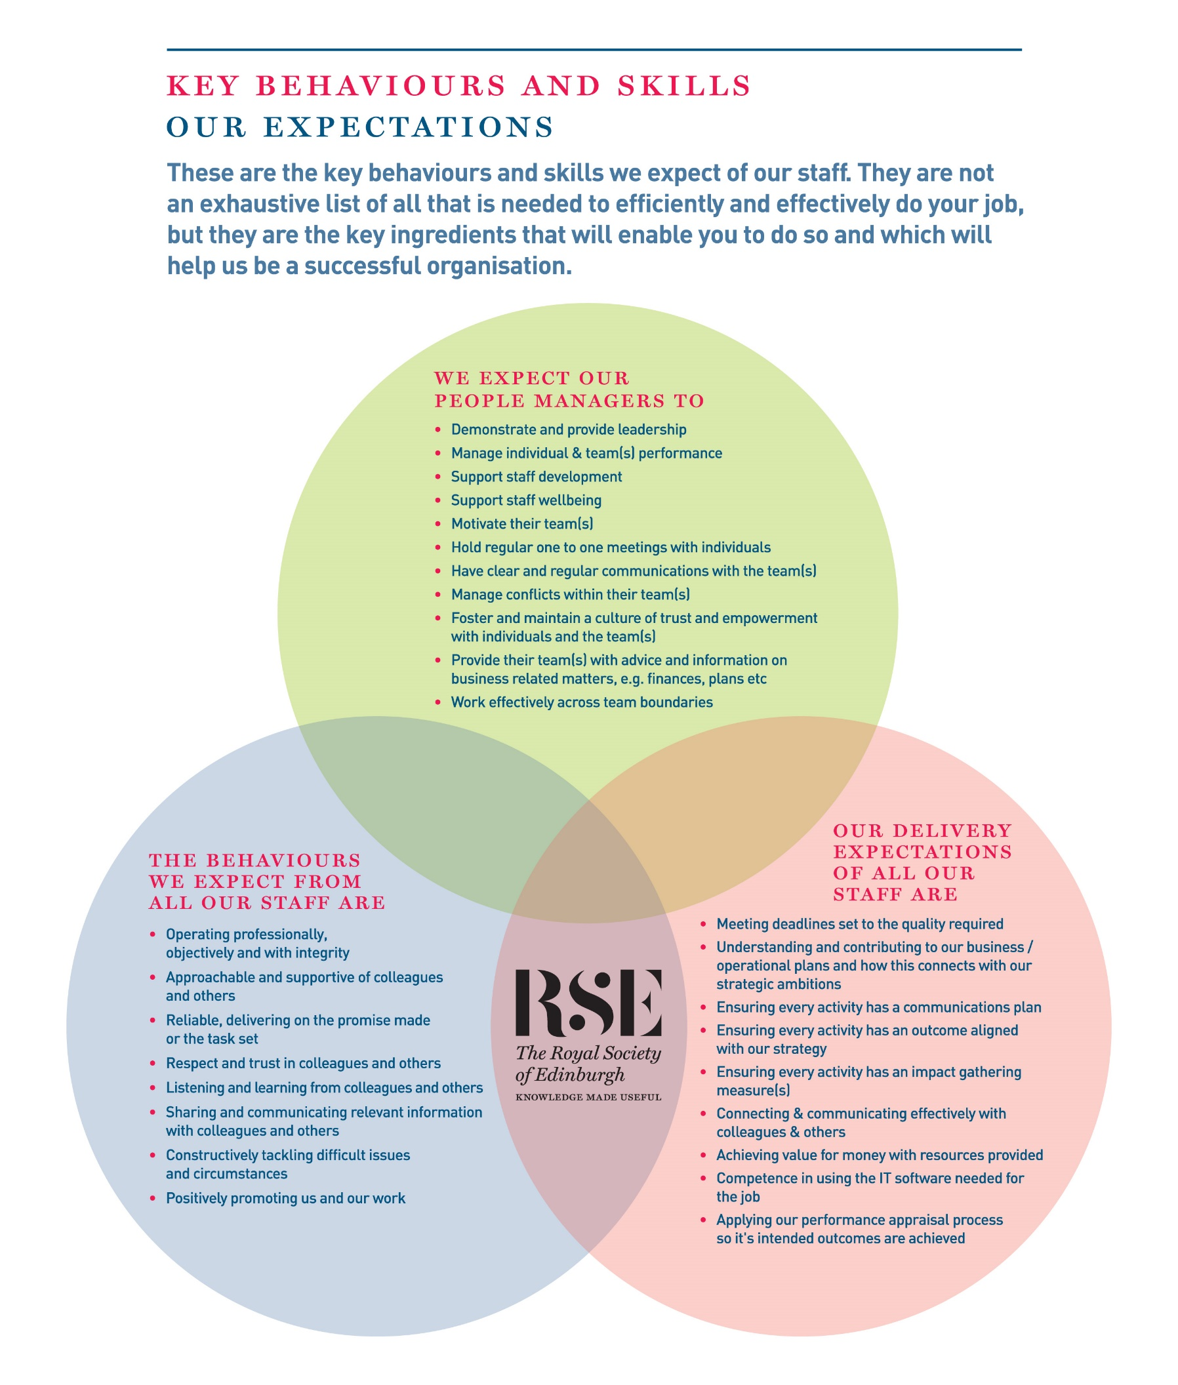

**About the RSE**

The Royal Society of Edinburgh, Scotland’s National Academy, is an educational charity that provides public benefit throughout Scotland through a diverse range of activity including awarding research funding, informing public policy, and delivering events across Scotland to inspire knowledge and learning.

The RSE’s mission, set out in its Royal Charter of 1783, is **“the advancement of learning and useful knowledge”.** Its contemporary purpose remains the same – the deployment of knowledge for public good: knowledge that contributes to the social and economic well-being of Scotland and its people and the nation’s wider contribution to the global community.

The RSE draws upon a body of elected fellows who are leaders and experts in their fields. The breadth of expertise and experience within the Fellowship ranges from life sciences, physical sciences, and technology, to arts, humanities, social science, business, public service, and civil society. The multidisciplinary breadth of the RSE – reaching well beyond the academic world – is a distinctive strength and unique within UK national academies.

Our staff group is responsible for executing our programmes of activities and ensuring due governance is followed.

**Our Strategic Framework**

Published in 2016, our Strategic Framework 2016-2021 sets out the Royal Society of Edinburgh’s vision and strategic objectives to 2021. It identifies the distinctive impact the RSE aims to make nationally and internationally, and the benefits that a vibrant multidisciplinary national academy can bring to Scotland.

The Framework sets out four strategic objectives to:

* ***Inspire*** and support Scotland’s most promising young talent across the research, business and public sectors, to create value for the economy and society;
* ***Engage*** on key contemporary issues by providing an impartial forum for public debate and discussion;
* ***Provide*** ***expertise*** to ensure that Scotland’s policy makers and influencers have access to the best national, and indeed global expertise;
* ***Promote*** Scotland’s interests and reputation on the global stage.

Alongside these strategic objectives, the Framework identifies four development aims:

* To create an active and more diverse Fellowship;
* To secure increased funding from a diverse range of sources;
* To enhance and widen the RSE’s outreach and impact;
* To redevelop our premises.

In line with the ambitions set out in the Strategic Framework the RSE is embarking on a major programme of change, building on existing strengths, to further enhance the Society’s visibility, reach and impact.

**POLICY ON CRIMINAL RECORD DISCLOSURE**

In line with its overall recruitment policy, the RSE seeks criminal record information before making an offer of employment to a successful job applicant. The note below describes the process that will be followed and what happens to any information received. Please read it carefully.

The post for which you have applied requires the applicant who is successful at the interview stage to complete a personal disclosure of any unspent convictions, details of any cautions, reprimands and final warnings administered, and details of any charged offences. There will, also, be open and measured discussion about disclosure information at the interview stage. If an applicant fails to disclose relevant information at interview, it may lead to the withdrawal of an offer of employment, orfollowing appointment, disciplinary action being taken, which may include the termination of employment.

If an interview, or subsequent personal disclosure, provide information about a conviction, cautions, reprimands, final warnings administered and charged offences, RSE will assess the relevance of the information by considering:

* The seriousness of the offence and whether it is relevant to the protection and safety of RSE staff, others and RSE property.
* The length of time since the offence took place
* Whether there is a pattern of offending behaviour
* Whether an individual’s circumstances have changed since the offending took place, making re-offending less likely.
* Relevant information offered by an individual about the circumstances which led to the offence being committed
* The country in which the offence was committed; some activities are offences in Scotland and not in England and Wales, and vice versa.
* If the offence has since been decriminalised by Parliament.
* The degree of remorse, or otherwise, expressed by an individual and their motivation to change.

Personal disclosure information provided will only be used for recruitment purposes and will only be shared with those authorised to see it during their duties. No image or photocopy of the information will be made. The Personnel Office will keep all information disclosed in a secure and confidential file for 6 months after the start of employment.



**In addition to the basic salary paid, the RSE offers staff a generous package of rewards. The package includes:**

|  |  |
| --- | --- |
| **Salary** | * Subject to what we can afford, you may receive an annual pay award to maintain the real terms value of your pay. There is also discretionary scope for additional consolidated or non-consolidated pay awards |
| **Contributory Pension Scheme** | * You can join the RSE AVIVA Group Pension Plan. You contribute 3%. On your behalf, we pay a further contribution of 6% of your annual salary. Further information about the scheme is available here <http://www.aviva.co.uk> * There is scope for you to pay a higher employee contribution. If you decide to do so, the RSE will pay double the employee contribution rate up to a maximum employer contribution limit of 12%. * AVIVA may accept transfers from other schemes so please check with them prior to applying for a transfer. |
| **Annual leave** | **All employees employed after 1 August 2018** receive the following annual allowances (pro-rata for part time staff):   * 25 days up until completion of 3 years employment * 27 days following completion of 3 years employment **(+ 2 days)** * 30 days following completion of 5 years employment **(+ 3 days)** |
| **Public Holidays** | * You get 9 days public holiday (pro-rata for part time staff). This is built into your total holiday allowance (annual leave + public holidays) each year |
| **Sick Absence** | * You receive sick absence pay once you have satisfactorily completed your probation period. The period of paid absence increases progressively according to your length of service and reaches, after 4 years of service, full pay for 26 weeks absence and half pay for a further 26 weeks absence |
| **Family Leave** | * We recognise and fully comply with your legal rights in relation to paid (Adoption, Maternity & Paternity leave, Shared Parental Leave) and unpaid time off, and flexible working. Where your contracted salary is greater than the statutory minimum for paid time off, during, or for part of the absence, you will be paid your contracted salary. In addition to these legal rights, you can also, depending on the circumstances, receive paid “Family Responsibility Leave” to cover unforeseen family circumstances. |
| **Performance Management** | * We care about your performance and development and assess, manage and support it through our performance review system. |
| **Flexibility with medical appointments** | * We are flexible in how we deal with dental and medical appointments. We expect these to be arranged out-with your normal hours of work, but we recognise that for many reasons this might not always be possible. Where that is the case, we exercise discretion and provide reasonable time off during your normal working hours to attend your appointment. |
| **Healthy Working Lives** | * We are part of the Healthy Working Lives Award Programme. We obtained our Bronze Award in 2005 and have obtained our Silver Award in July 2011 and since then maintained both Awards. A group of staff volunteers organise events focussing on health promotion, occupational health and safety, health, and the environment, raising awareness about mental health and well-being and we are working towards the Gold Award. * Types of Events: RSE Wellness Day - Health Checks for staff (diabetes, cholesterol, BMI, Blood Pressure), Big & Healthy breakfast, Running Club at lunchtime (Jog Scotland), Pedometer Competitions, Walking group, Lunchtime Yoga classes, social cycle rides at the weekend, training on First Aid for baby and child for all new parents, event of information on Nutrition, Cancer, Salt Intake, Legal Highs, etc. |
| **Support with VDU** | * As part of the Health and Safety at Work legislation, employers are required to designate which staff members are classed as regular users of computers. We have designated that all staff fall into this category. * Employers also have an obligation to provide eye tests, or a facility, which will allow staff to have their eyes tested so that their ability to see the screen properly can be assessed. We are committed to complying with this obligation by paying for eye tests related to computer usage only. * Additionally, if a member of staff requires glasses **for computer use only**, we will contribute to the cost for an amount of up £45 * We organise online DSE checks for all staff and monitor these as part of our wellbeing programme |
| **Occupational Health** | * These services include guidance and advice on health-related issues, promotion of health in the workplace, and counselling. * The service is available to all staff, individually and collectively. Anyone wishing to draw on it should speak to the HR Office, which has the contact details and can advise on appropriate courses of action (Physiotherapy, Counselling, helping with Mental Health issues, etc…) |
| **Learning & Development** | * We support your learning and development and have a budget dedicated to these activities as well as an annual Learning & Development programme. You can also apply for up to a 50% contribution towards the costs of maintaining or achieving a professional membership or qualification. |
| **Travel Loans (frozen during COVID)** | * You can apply for an interest free loan to cover the cost of a public transport season ticket. |
| **Overtime (Frozen during COVID)** | * You will get time off in lieu (TOIL) to compensate for overtime worked out-with normal hours at our request, which is not already compensated through your annual leave entitlement. |
| **Give as you earn** | * We are committed to supporting you should you wish to donate to charities directly from your monthly salary. The Direct Donation allows you to personally nominate your own favourite charity or charities to benefit from regular donations straight from your pay. Giving through your pay is tax free and flexible. You can make donations to any charitable or voluntary organisation in the UK. This can include places of worship, schools, scout groups and many other organisations. We pay the administration fee to the scheme and all your donation will therefore go to your nominated charity. |
| **Staff Away Day** | * We arrange and pay for a staff away day each year. The purpose of this is to give you an enjoyable, informal day away from your normal workplace, where you can get to know your colleagues better. Due to COVID 19, this event has been postponed |