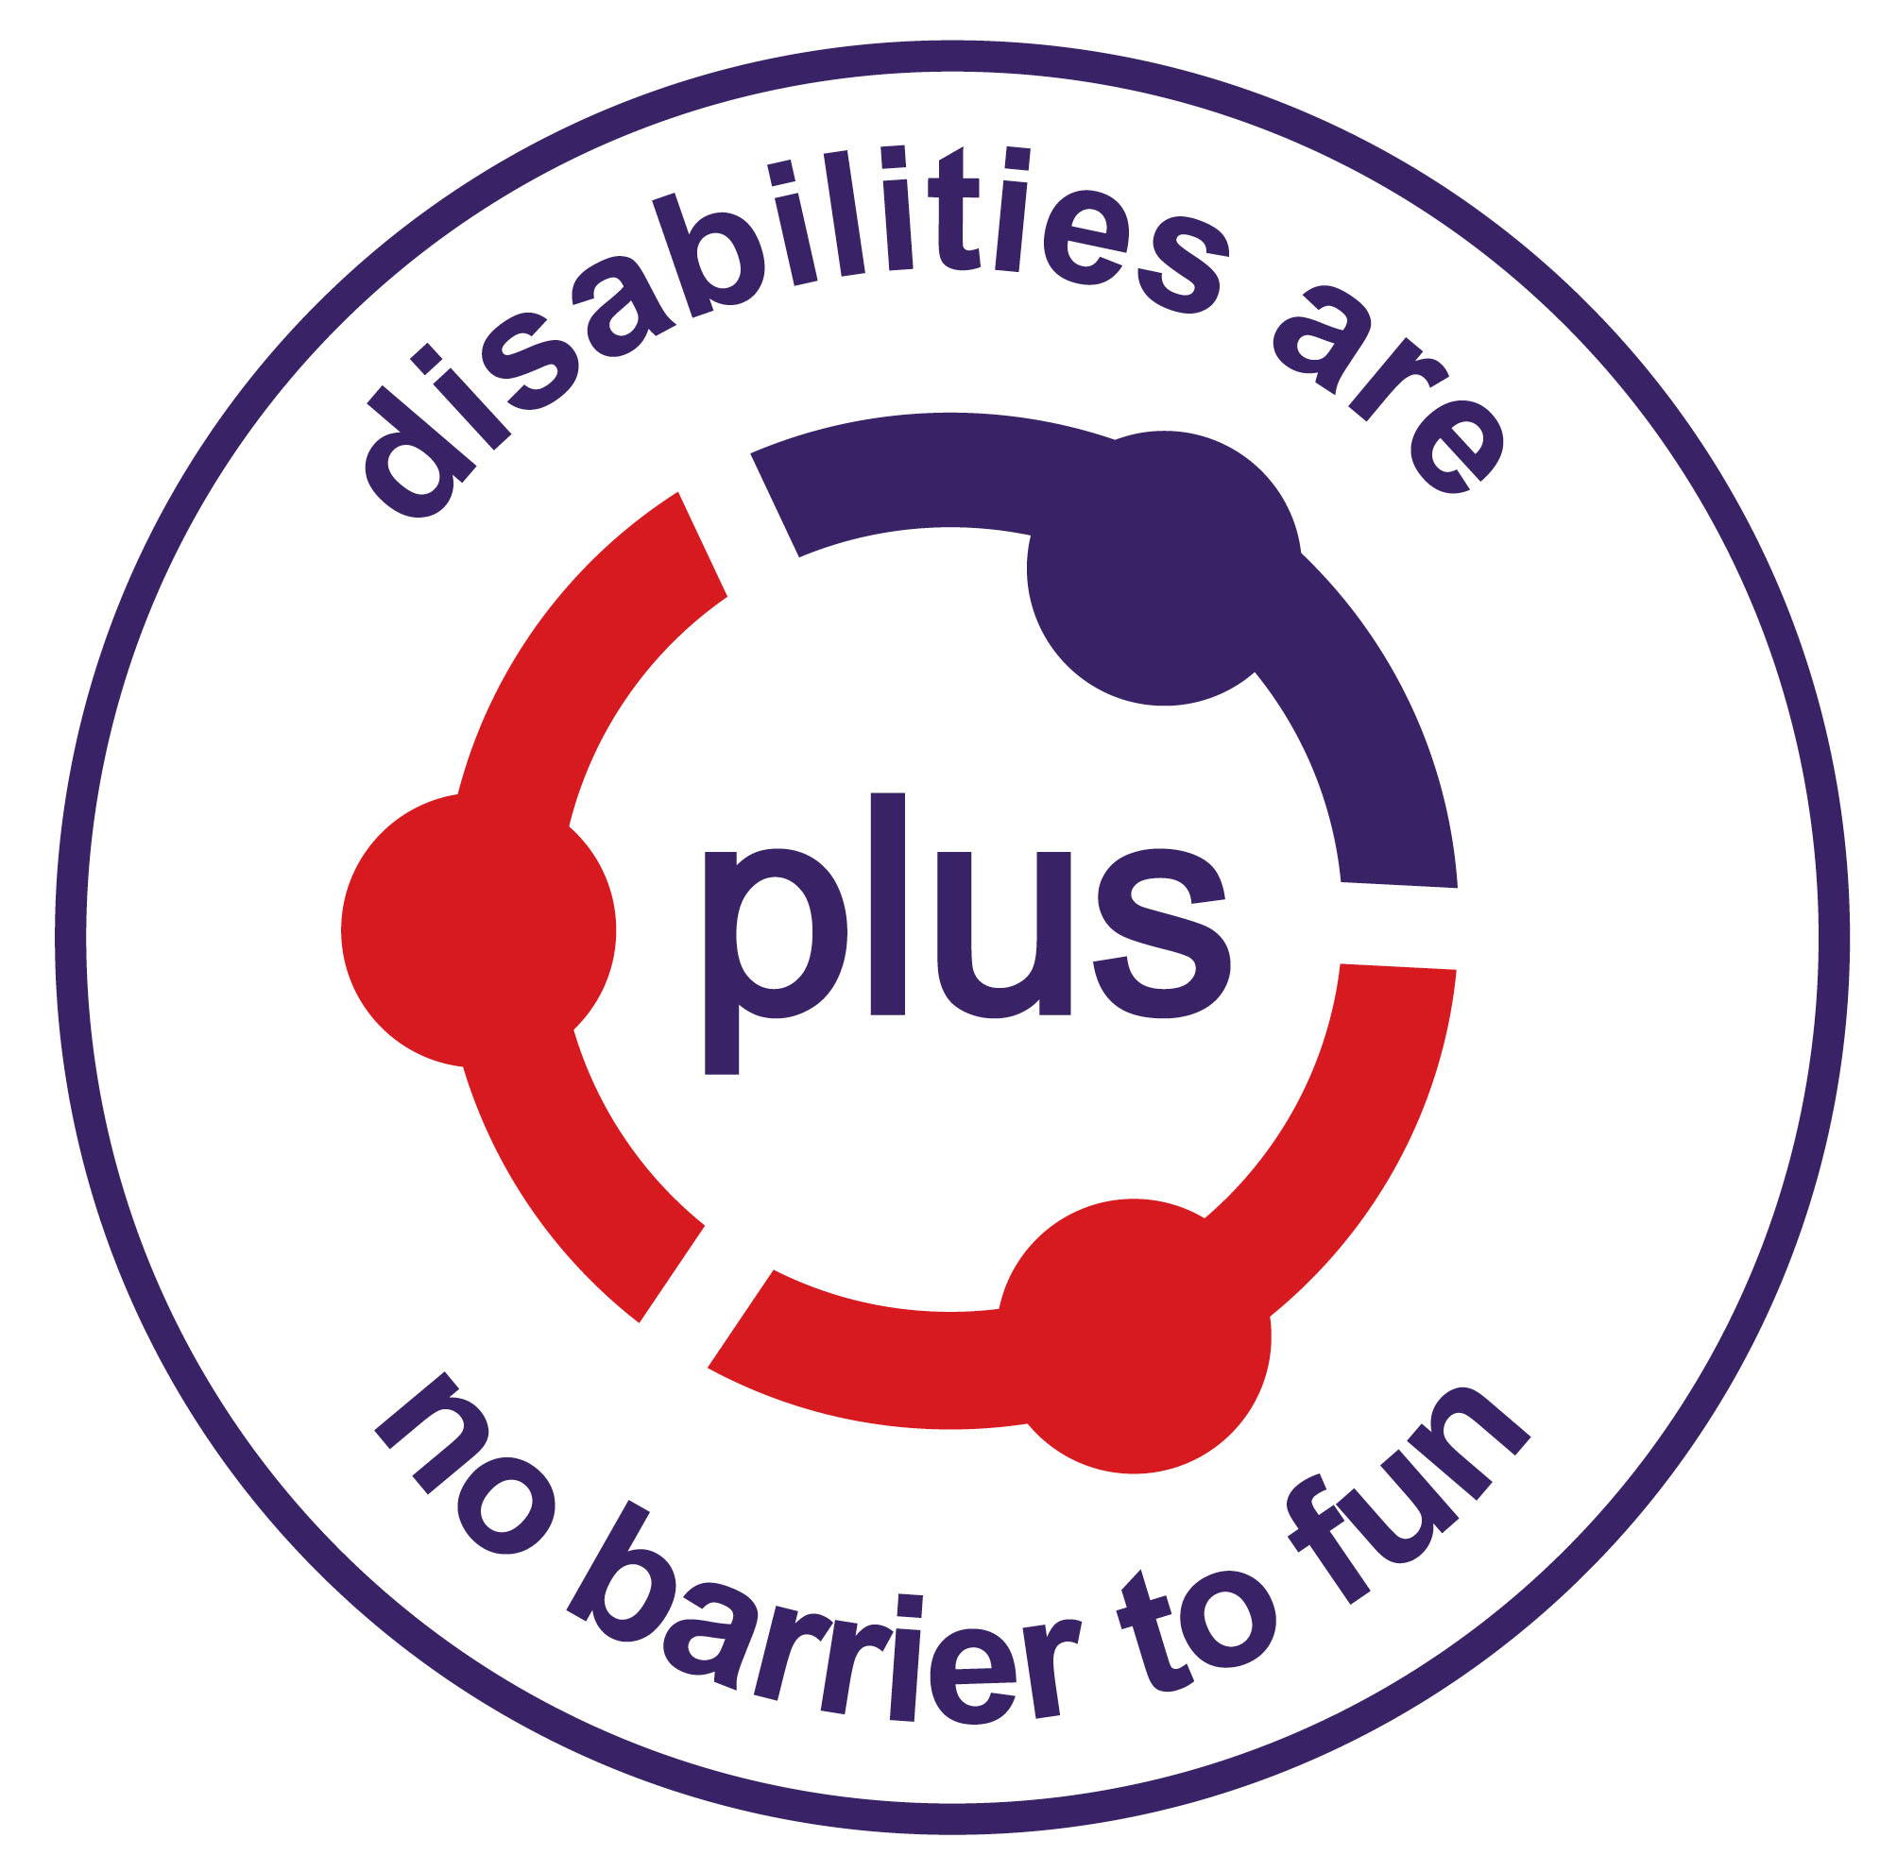

Person Specification
Project Coordinator

 | ESSENTIAL | DESIRABLE
KNOWLEDGE and EXPERIENCE | Experience of working directly with children and young people with disabilities  Knowledge and experience of work with services for children and/or young people with disabilities  Good working knowledge of disability and associated legislation, particularly Self Directed Support  Knowledge of issues relating to the safeguarding of children and vulnerable adults | Experience of working in the voluntary sector  Knowledge and experience of volunteer/staff recruitment, training and supervision  Experience of delivering services in partnership  A working knowledge of collating and analysing statistics and managing budgets
SKILLS and ABILITIES | Excellent verbal and written communication skills  Skilled at developing and delivering training and facilitating groups  Excellent organisational and project management skills  Strength in using and developing techniques for monitoring and evaluation  Driving license and access to car for work purposes  Ability to relate to children and young people, their family members and a range of professional staff  Competent in IT and social media | Have a sense of vision, ability to grasp complex ideas and think strategically
PERSONAL QUALITIES | Ability to sensitively support and enable others  Available to work flexible hours including evening and weekend work with time off in lieu  Happy to work flexibly in a small team  Enthusiastic, hard working and a commitment to continuous learning and development  Strength in multitasking and quickly adapting to change in challenging situations | Understanding of the impact of disability on children and young people and their families
QUALIFICATIONS | Educated to tertiary level  This post may require registration with the SSSC in the future | A degree in an appropriate subject and/or a relevant nationally recognised qualification, for example in youth work, community work, social care or childcare

