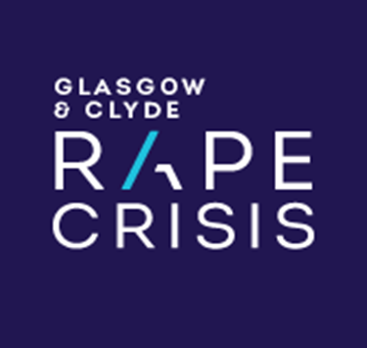
GLASGOW AND CLYDE RAPE CRISIS
Advocacy Worker
JOB DESCRIPTION

TITLE: Advocacy Worker (fixed to end Sept 2021)

SALARY: £27,033 - £29,445 plus 6% pension contributions

HOURS: 35 hours a week (including evening
work)

LEAVE ENTITLEMENT: 30 days p/a + 12 days public holidays

RESPONSIBLE TO: Advocacy Team Leader

Responsibilities

The overall aim of this post is to provide support and advocacy to survivors who are engaged, or considering engaging, with the criminal justice system following an experience of sexual violence.

It is expected that the Support Worker will have a strong commitment to anti discriminatory work and will be responsible to the Advocacy Team Leader and Director for maintaining the working values, principles, objectives and policies of Glasgow and Clyde Rape Crisis as outlined in the organisation’s governing documents including:

- Provide a support and advocacy service to survivors of sexual violence engaging, or considering engaging, with the criminal justice system following an experience of sexual violence
- Provide emotional and practical support to survivors of sexual violence whose cases do not proceed to court, including access to follow on services
- Develop and ensure the effective implementation of relevant referral processes to ensure survivors of sexual violence have enhanced access to support and advocacy services throughout their involvement in the criminal justice process
- Work in partnership with relevant agencies to enhance responses to survivors of sexual crimes, including where appropriate the development and delivery of training inputs
- Publicise the service offered through the advocacy service to enhance access to the service across voluntary and public sector agencies.
- Contribute to the development of national policy and strategic work around the criminal justice system and sexual offences through attendance at national advocacy project meetings and provision of information and feedback to the Rape Crisis Scotland National Coordinator
- Contribute to monitoring and evaluation frameworks to evidence the impact of the advocacy service for survivors of sexual violence and for partner agencies; including production of statistical data and participation in any evaluations which may be commissioned
- Attend training as required
- Participate in regular support and supervision sessions
- Participate in team meetings
- Participate in centre meetings
- Any other duties that are relevant to the post and agreed with the Centre Manager including contributing to the learning and development of staff and volunteers within the centre in relation to criminal justice processes

GLASGOW AND CLYDE RAPE CRISIS

Advocacy Worker
PERSON SPECIFICATION

Previous Experience | E | D
Minimum 2 yrs post qualifying/training experience of working within a support service for survivors of sexual violence |  | ✓
Minimum of 2 yrs of post qualifying/training experience of delivering direct support to survivors of sexual violence |  | ✓
Experience of advocating on behalf of survivors of sexual violence, abuse or exploitation |  | ✓
Rape Crisis training programme fully completed |  | ✓
Skills and Qualities | E | D
An empathic, empowering approach to support work with sexual violence survivors | ✓
Proven ability to work under pressure and have a creative and innovative approach to the work of the project | ✓
Excellent oral and written communication and presentation skills | ✓
Ability to produce easy to understand written materials for survivors and workers where required. | ✓
Organisational skills, ability to keep own records and to maintain survivors’ records | ✓
Strong commitment to anti-discriminatory practice | ✓
Knowledge | E | D
Knowledge and understanding of the impact of sexual violence on the lives of survivors |  | ✓
Feminist/gendered analysis of sexual violence | ✓
Working knowledge of voluntary and statutory sector agencies and specialised services for survivors of sexual violence | ✓
Knowledge of the working of the rape crisis movement |  | ✓

