ACCESS & INCLUSION Project WORKER
Recruitment pack



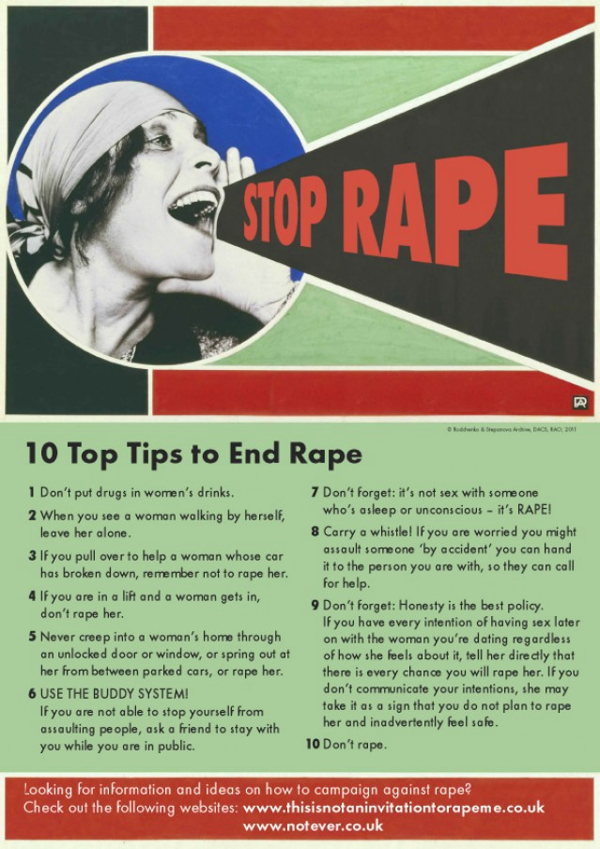

Dear Applicant,

Thank you for your interest in working with Shetland Rape Crisis. Please find enclosed the following documents:

- Information about Shetland Rape Crisis
- Advice on completing your application form
- Job Description and Person Specification
- Application form

Please do not send a curriculum vitae (CV) as this will not be considered.

Please note, all applications and relevant recruitment documents will be held confidentially and destroyed after 6 months, apart from documents relating to the successful applicant.

Your completed application should be submitted via email by sending it to contact@shetlandrapecrisis.scot before midnight on Sunday 21 March.

Please note that interviews will be carried out via Zoom on Tuesday 30th March.

This post is: 25 hours per week (35 hour full-time week).

This post is contracted until: 30th June 2022.

Please note only women need apply under Schedule 9, Part 1 of the Equality Act 2010

We look forward to receiving your completed application form.

Yours sincerely,

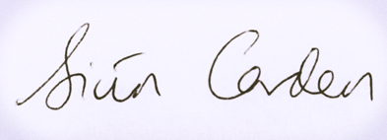

Siun Carden
Chair, Board of Trustees

About our service

Shetland Rape Crisis has been supporting survivors of rape, sexual abuse and exploitation and raising awareness about the damaging effects of sexual violence in Shetland since 2016. We are a registered charity.

Shetland Rape Crisis has a small team of 5 part time staff members and a range of volunteers.

We provide a range of services to survivors of sexual violence, abuse and exploitation including:

Support Service

We provide trauma-informed emotional and practical support and trauma therapy to survivors of sexual violence in Shetland. We currently have one Trauma Therapist and one Therapeutic Support Worker.

Advocacy Service

We are part of the National Advocacy Project for Scotland. Our dedicated Advocacy & Support Worker supports survivors who are thinking about or are engaging with the criminal justice system. This includes support in reporting to the police and court appearances. Other Support Workers in the service also provide advocacy support from time to time, with input from the specialist Advocacy Worker.

Prevention & Activism

We have a dedicated Sexual Violence Prevention & Activism Worker who works in all the secondary schools in Shetland delivering the Rape Crisis Scotland National Prevention Programme. She also facilitates BEE (Bold, Equal & Empowered) our young activists’ volunteer group.

Training and Awareness-Raising

We provide training on a range of topics including Zero Tolerance: healthy relationships for young people, No More! healthy relationships for learning disabled people, and specialist advice re: gender, GBV, and SV for other professionals. Additionally, we run community awareness raising events including a variety of events for the 16 Days of Action for Violence Against Women and International Women’s Day. All staff take part in this work.

ADVICE ON COMPLETING YOUR APPLICATION FORM

As part of Shetland Rape Crisis commitment to equal opportunities, candidates for each post are treated equally. Application forms are the only basis on which the first selection is made to decide whom to call for interview. Therefore, only information, which appears on the form (and continuation pages), can be considered. It is very important that your completed form contains both the information we want about your skills and experience and the information you want to give us. These advice notes are intended to help you to complete your form effectively.

- Read all the information provided especially the job description and person specification. These outline the duties you would be expected to carry out in this post and list the skills, knowledge and abilities that the shortlisting/interview panel will be looking for.

- Section 5 asks you to note down your general experience and is the most important part of your application. This is your chance to explain why you are suitable for the job. It is not enough to say you have the experience – you must demonstrate experience and skills with specific examples. Relevant experience may be from your current or previous jobs or from outwith formal employment.

- We have lots of information about our service on our website www.shetlandrapecrisis.scot

- Do not send your CV in addition to or in place of a completed application form as it will not be considered by the short-listing panel.

- A Protection of Vulnerable Groups (PVG) is required as part of the job.

- All applicants must complete all parts of the application form.

- Application forms must arrive on time. Forms arriving late will not be considered.

- References are normally taken up for the shortlisted applicants before interview. If you do not wish one or all references to be taken up at that point please indicate on the relevant page. It is our policy not to make a job offer without taking up references.

Job Description

Responsible to: Shetland Rape Crisis Service Manager

Salary: 29,049 pro rata (25hr p/w), inc. Distant Islands Allowance

Contracted to: 30th June 2022

Location: Lerwick, Shetland. Some homeworking required due to pandemic.

Holiday Entitlement: 30 Days plus 12 Public Holidays (pro rata)

Pension: Employer contribution at 8% to pension fund.
Job Title | Access & Inclusion Project Worker

Summary of main responsibilities and activities

Project Outcomes

- Improve access to support for survivors of sexual violence and their supporters.
- Proactively work to identify and overcome barriers to support.
- Engage and collaborate with survivors to identify and address their needs.

Job Purpose

- This project runs until June 2022 and has a focus on increasing Shetland Rape Crisis’ support capacity, the accessibility of the service, and its reach, for survivors of sexual violence in Shetland, and particularly for survivors from marginalised groups.
- The worker, in co-operation with the Service Manager and Staff Team at SRC, will develop and implement an Inclusion and Access Strategic Plan for the service.

Main Duties & Responsibilities

As part of improving access to support and capacity for delivery, a number of service development projects have been identified and these would be led by the new worker, alongside any other actions identified by the worker herself as part of the Inclusion and Access Strategic Plan. These include (but are not limited to):

- SRC has recently undertaken a review of its policies and procedures, service-user journey, and outcome and evaluation measures and methods. Working alongside the Service Manager and Staff Team, the new worker will be tasked with implementing the recommendations from this review in line with best practice.
- The worker, in collaboration with the wider staff team, will scope the need for, develop and implement a new strand of support work for the service: group-work.
- The worker, alongside the wider staff team and board, will lead on the creation of an ex-service user’s advisory group.
- Undertake a review and update of all current service communications, including the website and service leaflets.
- Work with the new Rape Crisis Scotland National Knowledge Exchange Lead to identify, review and refresh key SRC documents and processes locally, in line with best practice and the national Rape Crisis Model.

Monitoring and evaluation

- Maintaining performance recording, monitoring and reporting systems in line with Rape Crisis Scotland’s National Database.
- Maintaining appropriate records and statistics regarding the service to ensure that service is meeting the requirements of its funders, partners and other stakeholders.
- To keep financial records with full audit trail in order to evidence all costings relating to project delivery.

General duties

- Covering the SRC phoneline and responding to disclosures and referrals
- Acting in accordance with SRC’s policies and procedures
- Working in a manner which positively promotes the aims and objectives of the organisation
- Positively upholding and promoting SRC’s feminist ethos and commitment to equality, diversity and anti-discriminatory practices
- Taking reasonable care of personal safety and that of other persons and resources whilst at work
- Attending and participating in regular training when required
- Attending and participating in regular internal and external support and supervision, staff and other meetings as necessary
- Carrying out your own administrative duties, ensuring all records are maintained and treated in confidence according to internal policies and protocols.
- Participating in training to partner agencies and stakeholders
- Undertaking any duties consistent with the post as may be reasonably requested by the Service Manager

Person specification

CRITERIA |  | ESSENTIAL |  | DESIRABLE
Knowledge | E1  E2  E3 | Understanding of feminist analysis of gender-based violence  Understanding of the impact of sexual violence and trauma  Understanding of an intersectional approach | D1  D2 | Knowledge of current legislation, policy and strategy relating to the violence against women agenda  Thorough knowledge of issues relating to sexual violence
Skills and Abilities | E4  E5  E6  E7  E8 | Excellent communication skills both written and oral  Skilled in use of IT e.g. for reports, email, research  Capable of using own initiative and of meeting tight deadlines  Ability to work effectively with a wide range of partners in voluntary and statutory agencies  Report writing skills | D3 | Ability to communicate confidently and persuasively with a variety of groups, organisations and agencies.
Experience | E9  E10  E11  E12  E13 | Experience of responding to disclosures.  Experience of maintaining professional boundaries  Experience of service user involvement/participation  Experience of child protection and vulnerable adult protection guidelines and legislation  Experience working effectively as part of a team | D4  D5  D6  D7 | Experience of working directly with people affected by sexual violence and/or gender-based violence  Experience of project management, development or delivery  Experience of community engagement and promotion of services  Experience leading or facilitating group work
Qualifications | E15 | Qualification(s) in relevant area (e.g. in counselling, community education, social work, psychology, social sciences, gender studies or other related fields) or working towards this | D7  D8 | Degree in relevant area  Other qualifications in other relevant areas

Application to Shetland Rape Crisis
for the post of
Access & Inclusion Project Worker

To be returned to: contact@shetlandrapecrisis.scot

Section 1: Personal details
Surname: | First name:
Address: | Tel (home):
Address: | Tel (mobile):
Address: | Tel (work):  May we contact you at work?
Postcode: | Email address:

Section 2: Qualifications and training
(only enter those qualifications and/or training necessary or relevant to the job)
Qualification and/or training |  |  |  | Subject |  |  |  |  |  | Date
Section 3: Present employer
Name & address of employer: |  |  |  |  |  | Date commenced employment:
Job title: |  |  |  |  |  | Notice required: |  | Current salary:
Brief description of your main duties and responsibilities, with an emphasis, where possible, on those areas most relevant to the job applied for:

Section 4: Previous employment (list in order, with most recent employer first)
Please list all your previous employment, detailing any gaps between employments with reasons (continue on a separate sheet if necessary).
Dates |  | Name and address of employer |  |  |  | Job title and nature of work |  |  | Reason for leaving
From  DD/MM/YY | To  DD/MM/YY
Section 5: Relevant skills, experience and abilities

With reference to the job description and person specification, please outline how your work experience (including unpaid work) training, skills and abilities would enable you to carry out the duties of this post. Please include any information which you feel is relevant, paying specific attention to the Essential and Desirable points in the person specification as shortlisting will be based on your answering each point. Shortlisting will be based on the information given in this application so please be explicit and give examples from your own practice where helpful.

Section 6: References
Shetland Rape Crisis requires a minimum of 2 employment references to cover a three-year period – if necessary, please provide further referees covering the last 3 years.
Reference 1: Current / most recent employer
Name: |  |  | Position: |  |  |  | Tel no:
Company name: |  |  |  |  | Email:  Address:
May we, with discretion, contact your employer to discuss this reference:

Reference 2: Previous employer / supervisor
Name: |  |  | Position: |  |  |  | Tel no:
Company name: |  |  |  |  | Email:  Address:
May we, with discretion, contact your previous employer to discuss this reference:
Reference 3: Previous employer / supervisor
Name: |  |  | Position: |  |  |  | Tel no:
Company name: |  |  |  |  | Email:  Address:
May we, with discretion, contact your previous employer to discuss this reference:

Are you eligible to work in the UK?
Do you know of any reasons why you may not legally be able to take this position?
Do you have any specific requirements in order to perform this job effectively?

Section 7: Declaration
I certify that all the information contained in this form and any attachments is true and correct to the best of my knowledge. Offers of employment will be subject to satisfactory references, a PVG check and compliance with UK working restrictions. I realise that false information or omissions may lead to dismissal without notice.
(Virtual signature accepted due to covid-19).

Signature:

Date:

