**therapeutic Support worker  
Recruitment pack**



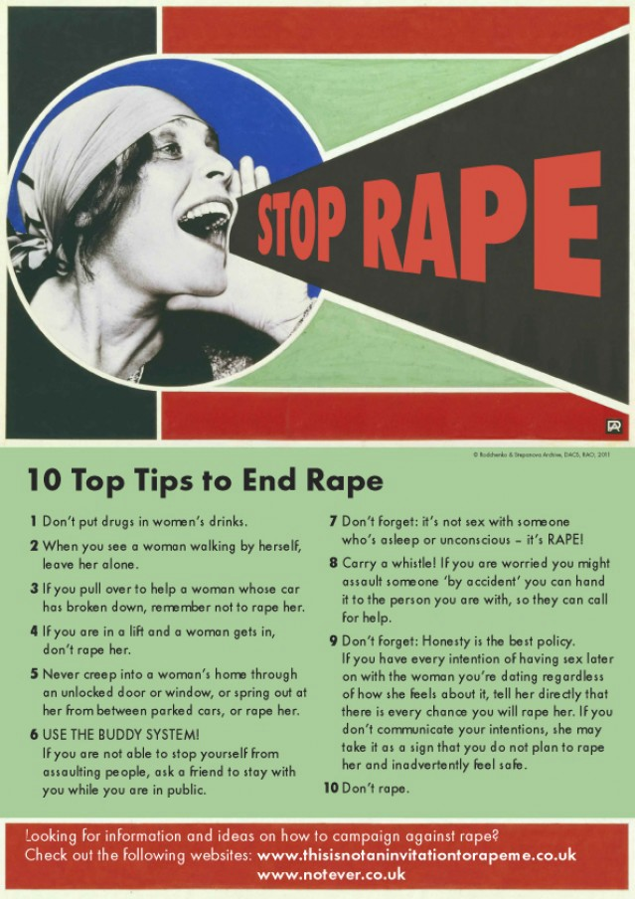

Dear Applicant,

Thank you for your interest in working with Shetland Rape Crisis. Please find enclosed the following documents:

* Information about Shetland Rape Crisis
* Advice on completing your application form
* Job Description and Person Specification
* Application form

**Please do not send a curriculum vitae (CV) as this will not be considered.**

Please note, all applications and relevant recruitment documents will be held confidentially and destroyed after 6 months, apart from documents relating to the successful applicant.

Your completed application should be submitted via email by sending it to [contact@shetlandrapecrisis.scot](mailto:contact@shetlandrapecrisis.scot) before **midnight on Sunday 21 March.**

**Please note that interviews will be carried out via Zoom on Thursday 1st April.**

This post is: **20 hours per week (35 hour full-time week).**

This post is contracted until: **31st March 2022 (renewed subject to ongoing funding).**

**Please note only women need apply under Schedule 9, Part 1 of the Equality Act 2010**

We look forward to receiving your completed application form.

Yours sincerely,

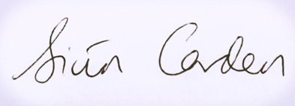

Siun Carden

Chair, Board of Trustees

# About our service

Shetland Rape Crisis has been supporting survivors of rape, sexual abuse and exploitation and raising awareness about the damaging effects of sexual violence in Shetland since 2016. We are a registered charity.

Shetland Rape Crisis has a small team of 5 part time staff members and a range of volunteers.

We provide a range of services to survivors of sexual violence, abuse and exploitation including:

**Support Service**

We provide trauma-informed emotional and practical support and trauma therapy to survivors of sexual violence in Shetland. We currently have one Trauma Therapist and one Therapeutic Support Worker.

**Advocacy Service**

We are part of the National Advocacy Project for Scotland. Our dedicated Advocacy & Support Worker supports survivors who are thinking about or are engaging with the criminal justice system. This includes support in reporting to the police and court appearances. Other Support Workers in the service also provide advocacy support from time to time, with input from the specialist Advocacy Worker.

**Prevention & Activism**

We have a dedicated Sexual Violence Prevention & Activism Worker who works in all the secondary schools in Shetland delivering the Rape Crisis Scotland National Prevention Programme. She also facilitates BEE (Bold, Equal & Empowered) our young activists’ volunteer group.

**Training and Awareness-Raising**

We provide training on a range of topics including Zero Tolerance: healthy relationships for young people, No More! healthy relationships for learning disabled people, and specialist advice re: gender, GBV, and SV for other professionals. Additionally, we run community awareness raising events including a variety of events for the 16 Days of Action for Violence Against Women and International Women’s Day. All staff take part in this work.

# ADVICE ON COMPLETING YOUR APPLICATION FORM

As part of Shetland Rape Crisis commitment to equal opportunities, candidates for each post are treated equally. Application forms are the only basis on which the first selection is made to decide whom to call for interview. Therefore, only information, which appears on the form (and continuation pages), can be considered. It is **very** important that your completed form contains both the information we want about your skills and experience and the information you want to give us. These advice notes are intended to help you to complete your form effectively.

1. Read all the information provided especially the job description and person specification. These outline the duties you would be expected to carry out in this post and list the skills, knowledge and abilities that the shortlisting/interview panel will be looking for.
2. Section 5 asks you to note down your general experience and is the most important part of your application. **This is your chance to explain why you are suitable for the job.** It is not enough to say you have the experience – you must demonstrate experience and skills with specific examples. Relevant experience may be from your current or previous jobs or from outwith formal employment.
3. We have lots of information about our service on our website [www.shetlandrapecrisis.scot](http://www.shetlandrapecrisis.scot)
4. **Do not send your CV in addition to or in place of a completed application form as it will not be considered by the short-listing panel.**
5. A Protection of Vulnerable Groups (PVG) is required as part of the job.
6. All applicants must complete all parts of the application form.
7. Application forms must arrive on time. Forms arriving late will not be considered.
8. References are normally taken up for the shortlisted applicants before interview. If you do not wish one or all references to be taken up at that point please indicate on the relevant page. It is our policy not to make a job offer without taking up references.

**Job Description**

**Responsible to:** Shetland Rape Crisis Service Manager

**Salary:** 29,049 pro rata (20hr p/w), inc. Distant Islands Allowance

**Contracted to:** 31st March 2022 (renewed subject to ongoing funding)

**Location:** Lerwick, Shetland. Homeworking required due to pandemic.

**Holiday Entitlement:** 30 Days plus 12 Public Holidays (pro rata)

**Pension:** Employer contribution at 8% to pension fund.

|  |  |
| --- | --- |
| Job Title | Therapeutic Support Worker |

**Summary of main responsibilities and activities**

**1. Emotional & Practical Support**

To respond sensitively to disclosures and facilitate people’s access to support services as appropriate.

To provide trauma-informed emotional and practical support to service users, and use your understanding of gender-based violence and experience maintaining professional boundaries to underpin this work.

To act on any child and vulnerable adult protection or wellbeing concerns identified during appointments, following the centre’s safeguarding and child and vulnerable adult protection policies and procedures. And to, where appropriate, participate in multi-agency initiatives to promote the service user’s safety and wellbeing.

To initiate and facilitate group wellbeing activities where appropriate for service users.

To be able to deliver all of this via telephone, VC, text, messaging and email as required, as well as traditional face-to-face. Due to the ongoing covid-19 pandemic, this will be an important aspect of the work and SRC will expect you to be able to work remotely.

Where required, to be able to provide limited advocacy to survivors, with input from the specialist Advocacy & Support Worker.

To use an integrated, adaptable and holistic approach to your work with service users.

**2. Monitoring and Evaluation**

Keep accurate records of client contact appointments in line with SRC policies and procedures.

Use SRC’s OASIS database and evaluation tools for accurate record keeping.

Write regular reports on activities on activities and outcomes.

**3. Equalities**

Promote and positively uphold SRC’s anti-discriminatory, non-violent and feminist values in all aspects of practice, in line with SRC’s vision and values.

**4. Accountability, supervision and professional development**

Attend regular support and supervision with the manager and external clinical supervision.

Attend regular team meetings with the SRC staff.

Undertake training and development as required. This may include some off-island travel and overnight stays.

Act in accordance with SRC’s policies and procedures.

Undertake any duties consistent with the post as may be reasonably requested by your manager.

**5. Team working and communication**

Work as a team with other centre employees.

Attend regular team meetings.

Take part in awareness-raising activities or lead on awareness-raising projects as part of the wider organisational goals.

Work with other organisations on promoting survivor’s interests.

**6. General**

From time to time, you may be asked to undertake other tasks in line with SRC’s organisational goals.

**Person specification**

|  |  |  |  |  |
| --- | --- | --- | --- | --- |
| **CRITERIA** |  | **ESSENTIAL** |  | **DESIRABLE** |
| **Knowledge** | E1  E2 | Understanding of feminist analysis of gender-based violence  Understanding of the impact of sexual violence and trauma | D1  D2  D3 | Knowledge of current legislation, policy and strategy relating to the violence against women agenda  Thorough knowledge of issues relating to sexual violence  Understanding of Trauma Informed Practice |
| **Skills and Abilities** | E3  E4  E5  E6 | Ability to engage therapeutically with anyone affected by sexual violence  Excellent communication skills both written and oral  Skilled in use of IT e.g. for case notes, reports, email, internet searches  Capable of using own initiative and of meeting tight deadlines | D4  D5 | Ability to work effectively with a wide range of partners in voluntary and statutory agencies  Ability to work in a variety of creative approaches |
| **Experience** | E7  E8  E9  E10  E11  E12 | Experience of responding to disclosures.  Experience of maintaining professional boundaries  Experience delivering individual support  Experience of working with people affected by gender-based violence and childhood sexual abuse  Experience of child protection and vulnerable adult protection guidelines and legislation  Experience working effectively as part of a team | D6  D7  D8  D9 | Experience delivering individual support to survivors of sexual violence  Experience delivering individual support to survivors of childhood sexual abuse  Experience delivering individual support to survivors via remote means (phone, VC, text-messenger, email)  Experience facilitating group support and wellbeing work |
| **Qualifications** | E13 | Relevant qualification (e.g. in counselling, community education, social work, psychology or other related field) or working towards this | D10 | Qualifications in other relevant areas |

**Application to Shetland Rape Crisis**

**for the post of**

**Therapeutic Support Worker**

**To be returned to:** contact@shetlandrapecrisis.scot

|  |  |
| --- | --- |
| **Section 1: Personal details** | |
| Surname: | First name: |
| Address: | Tel (home): |
| Tel (mobile): |
| Tel (work):  May we contact you at work? |
| Postcode: | Email address: |

|  |  |  |  |  |  |  |  |  |  |  |
| --- | --- | --- | --- | --- | --- | --- | --- | --- | --- | --- |
| **Section 2: Qualifications and training**  **(only enter those qualifications and/or training necessary or relevant to the job)** | | | | | | | | | | |
| Qualification and/or training | | | | Subject | | | | | | Date |
|  | | | |  | | | | | |  |
|  | | | |  | | | | | |  |
|  | | | |  | | | | | |  |
|  | | | |  | | | | | |  |
|  | | | |  | | | | | |  |
|  | | | |  | | | | | |  |
|  | | | |  | | | | | |  |
|  | | | |  | | | | | |  |
|  | | | |  | | | | | |  |
|  | | | |  | | | | | |  |
|  | | | |  | | | | | |  |
|  | | | |  | | | | | |  |
|  | | | |  | | | | | |  |
|  | | | |  | | | | | |  |
|  | | | |  | | | | | |  |
|  | | | |  | | | | | |  |
| **Section 3: Present employer** | | | | | | | | | | |
| **Name & address of employer:** | | | | | | **Date commenced employment:** | | | | |
| **Job title:** | | | | | | **Notice required:** | | **Current salary:** | | |
| **Brief description of your main duties and responsibilities, with an emphasis, where possible, on those areas most relevant to the job applied for:** | | | | | | | | | | |
| **Section 4: Previous employment (list in order, with most recent employer first)** | | | | | | | | | | |
| Please list **all** your previous employment, detailing any gaps between employments with reasons (continue on a separate sheet if necessary). | | | | | | | | | | |
| **Dates** | | **Name and address of employer** | | | | **Job title and nature of work** | | | **Reason for leaving** | |
| **From**  **DD/MM/YY** | **To**  **DD/MM/YY** |
|  |  |  | | | |  | | |  | |
|  |  |  | | | |  | | |  | |
|  |  |  | | | |  | | |  | |
|  |  |  | | | |  | | |  | |
|  |  |  | | | |  | | |  | |
|  |  |  | | | |  | | |  | |
|  |  |  | | | |  | | |  | |
|  |  |  | | | |  | | |  | |
| **Section 5: Relevant skills, experience and abilities**  **With reference to the job description and person specification, please outline how your work experience (including unpaid work) training, skills and abilities would enable you to carry out the duties of this post. Please include any information which you feel is relevant, paying specific attention to the Essential and Desirable points in the person specification as shortlisting will be based on your answering each point. Shortlisting will be based on the information given in this application so please be explicit and give examples from your own practice where helpful.** | | | | | | | | | | | |
|  | | | | | | | | | | | |
| **Section 6: References** | | | | | | | | | | | |
| Shetland Rape Crisis requires a minimum of 2 employment references to cover a three-year period – if necessary, please provide further referees covering the last 3 years. | | | | | | | | | | | |
| **Reference 1: Current / most recent employer** | | | | | | | | | | | |  |
| Name: | | | Position: | | | | Tel no: | | | | |  |
| Company name: | | | | | Email:  Address: | | | | | | |  |
| May we, with discretion, contact your employer to discuss this reference: | | | | |  |
| **Reference 2: Previous employer / supervisor** | | | | | | | | | | | |  |
| Name: | | | Position: | | | | Tel no: | | | | |  |
| Company name: | | | | | Email:  Address: | | | | | | |  |
| May we, with discretion, contact your previous employer to discuss this reference: | | | | |  |
| **Reference 3: Previous employer / supervisor** | | | | | | | | | | | |  |
| Name: | | | Position: | | | | Tel no: | | | | |  |
| Company name: | | | | | Email:  Address: | | | | | | |  |
| May we, with discretion, contact your previous employer to discuss this reference: | | | | |  |

|  |  |
| --- | --- |
| Are you eligible to work in the UK? |  |
| Do you know of any reasons why you may not legally be able to take this position? |  |
| Do you have any specific requirements in order to perform this job effectively? |  |

|  |
| --- |
| **Section 7: Declaration** |
| I certify that all the information contained in this form and any attachments is true and correct to the best of my knowledge. Offers of employment will be subject to satisfactory references, a PVG check and compliance with UK working restrictions. I realise that false information or omissions may lead to dismissal without notice.  **(Virtual signature accepted due to covid-19).**  Signature:  Date: |