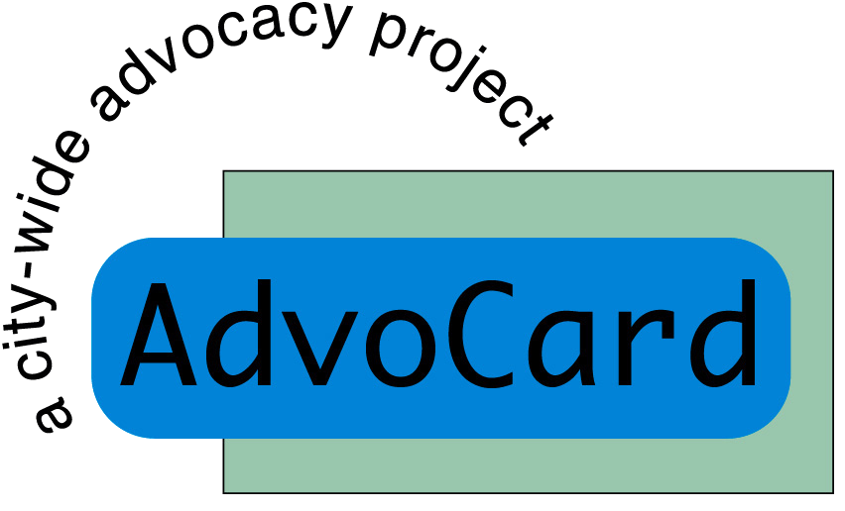

In order to assist us with our equal opportunities monitoring we would be very grateful if you could complete this short questionnaire. **This form will be separated from your application and the data kept anonymously. The selection panel will not see this information.**

**Gender:**

**Please tick ONE box**

Male □ Female □ Other □

Have you ever regarded yourself as transgender?

Yes □ No □

**Age:**

**Please tick ONE box**

16 – 24 □ 25 – 34 □ 35 – 44 □

45 – 54 □ 55 – 64 □ 65+ □

**Employment Status:**

Employed Full Time □ Employed Part Time □ Unemployed □

Student □ Retired □ Other, please specify……………….…

**Race / Ethnicity:**

Black □ please specify……………………………………

Asian □ please specify……………………………………

Chinese □ please specify……………………………………

White □ please specify……………………………………

Mixed □ please specify……………………………………

Other □ please specify……………………………………

**Disability:**

The Disability Discrimination Act defines disability as “a physical or mental impairment which has a substantial and long-term adverse effect on a person’s ability to carry out normal day to day activities”.

**Do you consider yourself to have such a disability?**

Yes □ No □

If YES, which words describe your disability best? Please tick ALL boxes that apply to you at the moment.

Physical Impairment □

Sensory Impairment □

Cognitive Impairment □

Mental Illness □

Long-term Health Condition □

Other □

Please specify …………………………………………

**Have you ever used mental health services?**

Yes, at the moment □ Yes, in the past □ No □

**Sexual Orientation:**

**Please tick ONE box**

Bisexual □ Gay Woman/Lesbian □ Gay Man □

Heterosexual/Straight □ Other □

Other, please specify ………………………………………………..

**Faith / Belief:**

**Which group do you most identify with?**

Christian □ Atheist □ Muslim □

Hindu □ Jewish □ Sikh □

Buddhist □ No religion □ Other □

**Where did you find out about this post?**

Third Force News □ Big Issue □ SIAA E Bulletin □

Other, please specify …………………………………………………….

Thank you for taking the time to complete this questionnaire. The information will enable us to monitor equality and diversity within AdvoCard and help us improve the extent to which we are accessible.

**This form must be returned along with your application in order for your application to be considered. It will NOT be seen by the selection panel.**

**Please return completed forms to:**