FIFE EMPLOYMENT ACCESS TRUST (FEAT)

JOB DESCRIPTION

Post: Employment Supervisor-
-Fife Individual Placement & Support (IPS)
Salary: £27,405 per annum
Hours of Work: 35 per week (full time)
Annual leave: 29 days + 8 public holidays
Responsible to: Strategic Clinical Lead (SCL)
Base Location: FEAT Office, Glenrothes
Funder: European Social and Investment Fund

FEAT Aims

- To deliver individualised employment advice, support, training and assistance to people who have experienced severe mental health conditions.

- To work closely with employers and other agencies to increase workplace support and opportunities for people with severe mental health conditions.

- FEAT’s mission is to enable and support individuals to flourish, to reach their full positive mental well-being in a culture where there is no stigma.

Employment Supervisor Job Purpose

To manage the operations within ‘Fife Individual Placement and Support’ (IPS) – a project aimed at people with complex mental health conditions who genuinely want to gain paid employment. The project offers dedicated one to one support from Employment Specialists enabling participants to focus on applying for work in competitive employment. The service is assessed externally each year and given a rating against a recognised ‘Fidelity Scale’ for IPS and we are proud to be currently rated as ‘exemplary’ - despite having just been established in April 2015.

The role of Employment Supervisor involves day to day project management, including management of a small team of Employment Specialists and one Occupational Therapist. The Employment Supervisor will innovate within, oversee and proactively manage a small caseload of individuals who have experienced mental health problems who are unemployed and/or currently off work. The post-holder is expected to deliver the Individual Placement and Support approach evidence-based model of vocational rehabilitation for people with mental health problems. Working directly with all relevant stakeholders: the individual, NHS Fife, CMHT staff, GPs, Employers, Job centre Plus and Occupational Health to enable individuals to gain and retain employment. The Fife IPS Service is a partnership of FEAT and Fife Health & Social Care.

Organisational Chart

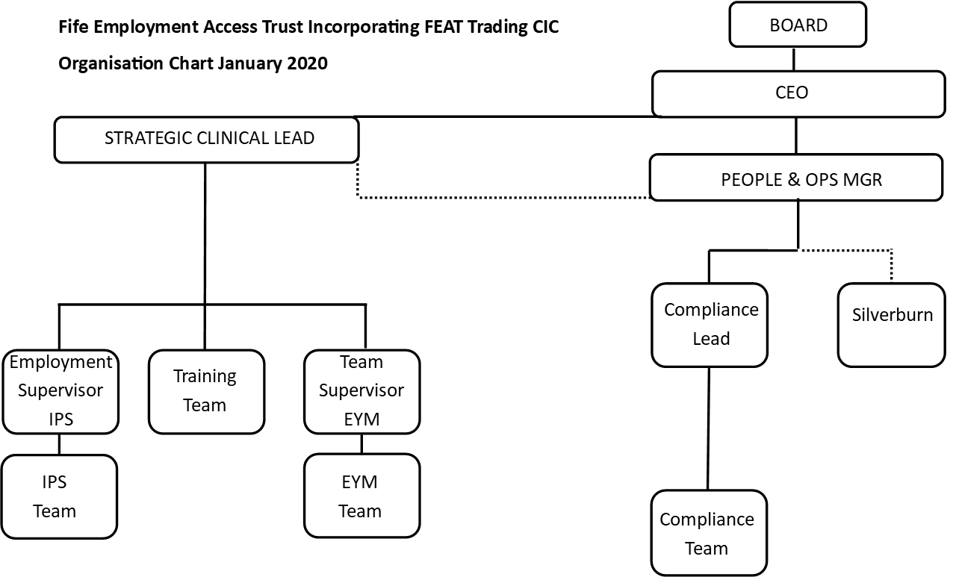

Duties and Responsibilities

The following duties and responsibilities are intended to give a broad indication of the variety of tasks that the postholder may be asked to undertake. This job description is not an exhaustive list and will be subject to annual review.

Management of Self and others

- To line manage a small team of Employment Specialists, carry out quarterly appraisals and to complete annual performance reviews, supported by the SCL.
- Be responsible for all aspects of the day to day management, organisation and running of the IPS project.
- Undertake to agree to and practise in line with FEAT’s Statement of Agreement: Ethical Standards and Professional Conduct.
- Co-ordinate and monitor annual leave within the team, co-ordinate, record and monitor staff training requests and attendance at training events; particularly post recruitment and induction.
- To support the SCL with recruitment, selection and induction of new staff to the IPS team.
- To review and plan team workload and client caseload including allocation of wider tasks.
- To organise and deliver training, disseminate information including presentations and update and monitor current systems, and suggest improvements where necessary.
- To support the SCL to ensure the assessment of risk to staff safety whilst working out-with FEAT.
- To attend and contribute to the IPS Steering Group.
- To collate basic statistical information, complete brief reports as required by the SCL, funders and partners.
- To support the SCL to ensure IPS complies with all aspects of audit and compliance , and work closely with the Compliance Lead to facilitate this.
- To attend and input to management meetings as requested by the SCL.
- To take a lead building relationships with employers, and foster excellent partnerships for both clients and future FEAT training provision.
- To take a lead on preparation for and presentation at any audits which may be required by: funders, internal or external compliance or other relevant body.

Individualised Support

- To manage a caseload of a maximum of 10 individuals at any one time who are currently off work/unemployed and who wish to return to work.

- To support the SCL to integrate IPS with the NHS Fife/CMHT Fife, being responsible for those individuals who want to return to employment, and to meet regularly with NHS Fife/CMHT staff to co-ordinate and integrate employment support into care plans.

- To provide education and support to employers, as agreed with the individual, which may include negotiating adjustments, return to work strategy and on-going contact with the employer to ensure job retention.

- To prepare individuals for a return to work through assessing each person’s individual employment needs through vocational profiling/assessment.
- To proactively undertake job development to secure employment opportunities for individuals.

Partnership Working

- To summarise information using databases and to provide up-to-date patient/case information to be input in to departmental databases.

- Identify the need for interventions from Occupational Therapy that will assist the individual to function effectively in work/maintain their role.

- Participate in and contribute to multi-disciplinary meetings regarding appropriate feedback about psychological assessment, intervention or employability.

- To keep up to date with IPS research and developments, audit and evaluations, conferences and study days and take part in supervision.

- To contribute to FEATs overall aim of creating innovative and needs-led services for individuals with complex mental health conditions.

- To take the lead building relationships with employers, and foster excellent partnerships for both clients and future FEAT training provision.

General Working Practices
- To work independently according to a project plan, with support from the SCL and in conjunction with FEAT and NHS Mental Health directorate staff and within professional guidelines and the overall framework of the service’s policies and procedures.
- To promote and maintain the highest standards of record keeping in accordance with professional codes of practice of FEAT and NHS. To ensure the team input data timeously and complete thoroughly all administrative tasks associated with the role. This includes completing thorough vocational profiles as well as associated funder paperwork.

Other Duties

- In addition to the main duties listed above the post holder will be required to perform other appropriate duties assigned by the line manager.

- To attend a minimum of three separate working days equivalent weekend or evening events for FEAT or FEAT Trading/partner projects in the course of any one year. This is in addition to the regular weekly hours worked.

FIFE EMPLOYMENT ACCESS TRUST

PERSON SPECIFICATION

POST : Employment Supervisor (IPS)

 | ESSENTIAL | DESIRABLE
Qualifications | - Educated to degree level and/or  relevant professional qualification,  or extensive relevant work experience | - Trained in IPS approach  - Full & current drivers’ licence  - NIDMAR
Knowledge/  Understanding | - Interpretation of welfare benefits and disability/employment related benefits  - Equality Act  - Managing people  - Vocational Profiling  - Outcome measures  - Funding sources & complexities of compliance for same  - Knowledge of disability and special needs issues in relation to employment/education  - An ability to negotiate diplomatically and effectively with staff at all levels  - Ability to work in a complex environment and can demonstrate a high level of perseverance, being committed to seeing plans through to their conclusion within agreed timescales  - Complexities of complex mental illness and world of work  - Necessity for accurate and up-to-date record keeping  - Confidentiality  - Understanding of relevant disability and employment policy and legislation  - Principles and practise of supported employment | - Support services available in statutory and third sector in Fife  - Models of change  - Knowledge of disability benefits packages  - Complexities of working with a youth population  - Knowledge of employment law
Skills | - Excellent communication with individuals with complex mental illnesses, and their families  - Excellent communication, both verbal and written, with colleagues and partner agencies  - People management  - Excellent organiser  - Computer literate  - Ability to engage with employers and third sector partners to source employment based opportunities  - Presentation and training skills  - Negotiation skills  - Reflect and critically appraise own performance | - Basic coaching skills  - Ability to travel to a variety of locations
Experience | - Managing people  - Project management  - Experience of working with and supporting people who have experienced complex mental health problems (or other unemployed disadvantaged groups) into and in employment within health, social services or the voluntary sector  - Experience of successfully helping people to obtain or keep education/work  - One to one support with individuals with complex mental health conditions  - Inter-agency working  - Working in an emotionally-demanding environment/role | - Vocational / Careers Guidance  - Previous experience of working within Job-seeking / Employability projects.  - Working in groups and/or 1-to-1 with highly emotive individuals with challenging behaviour  - Delivering psychologically informed interventions  - Working with young people (aged 15-18)

In addition candidates should be:

Highly motivated, with an openness and desire to strive for professional and team/project improvement
Share FEAT’s philosophy and values
Committed to high standards of performance and presentation
Committed to equality of opportunity for all

