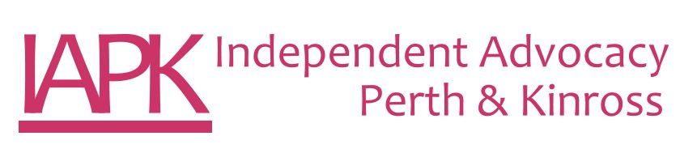
Independent Advocacy Worker
Job Description

Post Title: | Independent Advocacy Worker
Salary: | £15,035 per annum (pro rata £25,057 fte per annum)
Hours of work: | 21 hours per week – Monday to Friday. This post will entail some evening and weekend work. Time off in lieu applies.
Reporting to: | Advocacy Manager
Job Purpose: | To develop and maintain independent advocacy support to people who are vulnerable through disability, illness or life circumstances.
Values: | IAPK requires that every member of staff be committed to promoting human rights and the values of inclusion, social justice and equality of opportunity. IAPK expects all members of staff will hold central to their work practice the ethos and principles of independent advocacy.
Tasks | - To deliver independent advocacy ensuring that the highest standards are maintained and evidenced as appropriate.  - To work within the Principles, Standards & Code of Best Practice for Independent Advocacy (SIAA 2019).  - To be a self-starter, working to clearly defined objectives and specified targets, be familiar with work planning and effective time management.  - To have an understanding of team working and ability to work amicably and professionally with colleagues.  - To be able to work within clear codes of confidentiality.  - To maintain good communication links with advocacy partners, colleagues and all agencies, both written and verbal.  - To be able to maintain accurate and up to date written information and records.  - To maintain service statistics as performance indicators and make use of these to help identify service deficits, unmet needs and to establish levels of user satisfaction  - To function at a high level of IT proficiency.  - Participate in relevant internal meetings, including Team Meeting, Practice Meeting and other meetings as required.  - Provide written reports and service delivery information as required.  - Publicise, promote and raise awareness of IAPK as required.  - Keep up to date with current developments, legislation and research.  - To report regularly to, and receive ongoing support and supervision from the Advocacy Manager.
Self Management | - Adhere to policies, procedures and protocols of IAPK.  - Develop resilience strategies  - Take responsibility for personal safety in and out of the office according to IAPK’s procedures  - Present a positive image of Independent Advocacy and IAPK at all times  - Critically reflect on practice and participate in team practice discussions.  - Take ownership of own learning and development  - Work within the ethos and values of the organisation  - Undertake any other duties as reasonably requested by Management.
Other Duties | This job description is broad based and is not intended to be an exhaustive list of all possible duties as it is recognised that jobs change over time. Should the duties change radically then the post and salary level will be reviewed.

PERSON SPECIFICATION

EXPERIENCE | Essential | Desirable
Working in a third sector organisation or in a small business environment | X
Experience of working alongside people with mental health problems, learning disabilities, multiple disabilities or in a health or social care setting | X
Experience of working as part of a small team |  | X
Current experience or knowledge of the health and social care structure and services | X
A clear understanding of the importance of confidentiality | X

KNOWLEDGE/UNDERSTANDING
An understanding of disability issues, social inclusion and human rights | X
An understanding of the issues concerning people who require independent advocacy | X
Commitment to the Principles, Standards & Code of Best Practice of independent advocacy | X

ABILITIES/SKILLS
High degree of written and verbal skills | X
Good communicator | X
Ability to use IT resources and a willingness to build on existing skills | X
Ability to work under pressure to deadlines | X
Manage their workload effectively | X
Use own initiative | X

PERSONAL QUALITIES
Confidence | X
A commitment to equality and social justice | X
Good team member | X
Approachable | X
Good listening skills | X
Reliable | X

