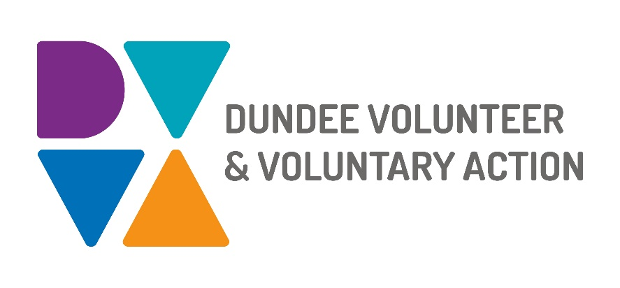

**Position: Network Coordinator (Substance Use)**

**Hours: 35 hours per week**

**Salary: £25,470-£28,300**

We are looking for a coordinator to facilitate and support engagement and involvement of people with lived experience of substance use challenges in the planning, development, delivery, and evaluation of substance use services and supports in Dundee.

An application pack can be downloaded from [www.dvva.scot](http://www.dvva.scot) or email recruitment@dvva.scot.

Dundee Volunteer and Voluntary Action strives to be an Equal Opportunities Employer and we welcome applications from all sections of the community.

The deadline for submitting applications is **10am on Monday 7th June**.