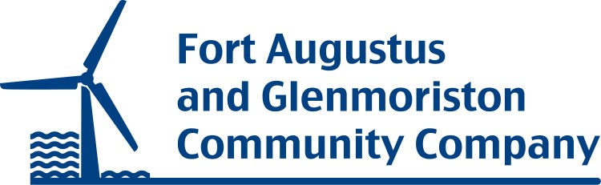

**Chief Officer: Background Information**

Fort Augustus & Glenmoriston Community Company was founded in 2007 and is a membership body that represents the two communities of Fort Augustus & Glenmoriston. We were created to receive the large amounts of community benefit given to the community from wind farms and hydro schemes in our area. We are a Company Limited by Guarantee (SC327824) and a Registered Charity (SC 038513).

We currently employee 7 staff (3 office based and 4 community caretakers) and we are hoping to recruit a further post to manage our residential properties.

We have an active board of 10 directors who are all based in the community.

**Activity**

**Our main objective is to distribute grant monies** to local community groups (see our website for grants that we offer and current recipients), but we also undertake projects ourselves which benefit both the community and the organisation including:

1. **Apprenticeship programme**: We are currently supporting 5 local young people undertaking a range of apprenticeships including electricians, joinery, quantity surveying & a mechanic. We also provide administrative support for the apprenticeship programmes for the Glengarry and Stratherrick Trusts.
2. **Community Action Plan**: This was developed by the local community, supported financially by FAGCC. This sets down community priorities for the 5 year period from 2018 to 2023. A review is planned for later in 2021.
3. **Community Caretakers**: We employ 4/5 staff, who have the role of looking after the villages of Fort Augustus & Glenmoriston. We have a service level agreement with Highland Council for litter picking, waste collection & grass cutting. We purchased a tractor to allow us to do the winter gritting and snow clearing. In addition we undertake small scale improvement projects when time allows.
4. **Grant giving**: This is core to our operations and has been a key part of our activity since our inception. We offer a range of grants to local organisations to support their activity. More details of the grants we offer can be found on our website.
5. **Housing**: We currently own 1 flat and are in the process of building 12 new homes for affordable rent (total project cost in order of 3 million). Although a private landlord, we have an affordable housing policy and local allocations policy to ensure that our properties are let out to meet local needs and at an affordable rent.
6. **Medical Centre**: In 2019 we completed the build of a new medical centre for the local community which is leased to NHS Scotland. In addition to the GP’s surgery downstairs, there are a number of consulting rooms upstairs available for hire along with a resource meeting room.
7. **Old Convent Land**: In 2018 we purchased 19 acres of community land and woodland that is a valuable local resource and is where we are building our new homes. There is a draft land management plan for the area which, once the housing is finished, will be discussed with the local community and implemented.
8. **Village hall**: we undertook an asset transfer for the village hall in Fort Augustus, which is where the offices of the company are now based. We are responsible for the day to day running of the hall which is hired out to local groups and businesses.

FAGCC is mostly funded through grants from Wind Farms & Hydro Schemes, we are a very fortunate community and have a substantial amount of annual income for the foreseeable future (until 2041). However, we also ensure we generate additional income through fundraising and income generating activities to ensure best value for the money we receive and to build up an investment fund for the future post 2041.

For further information visit [www.communitycompany.co.uk](http://www.communitycompany.co.uk)

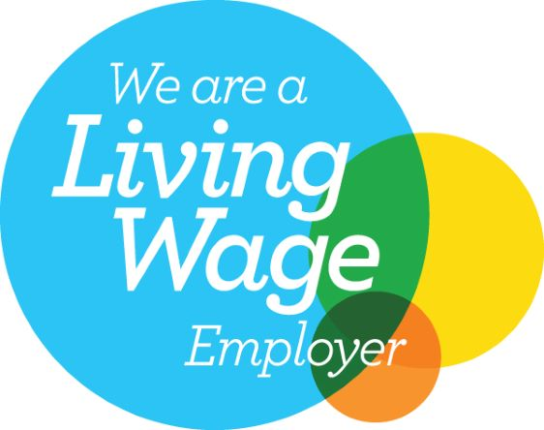

Fort Augustus & Glenmoriston Community Company is a registered Scottish Charity

No: SC 038513

A Scottish Registered Company: Registered Office: 28 Queensgate, Inverness,

No: SC 327824