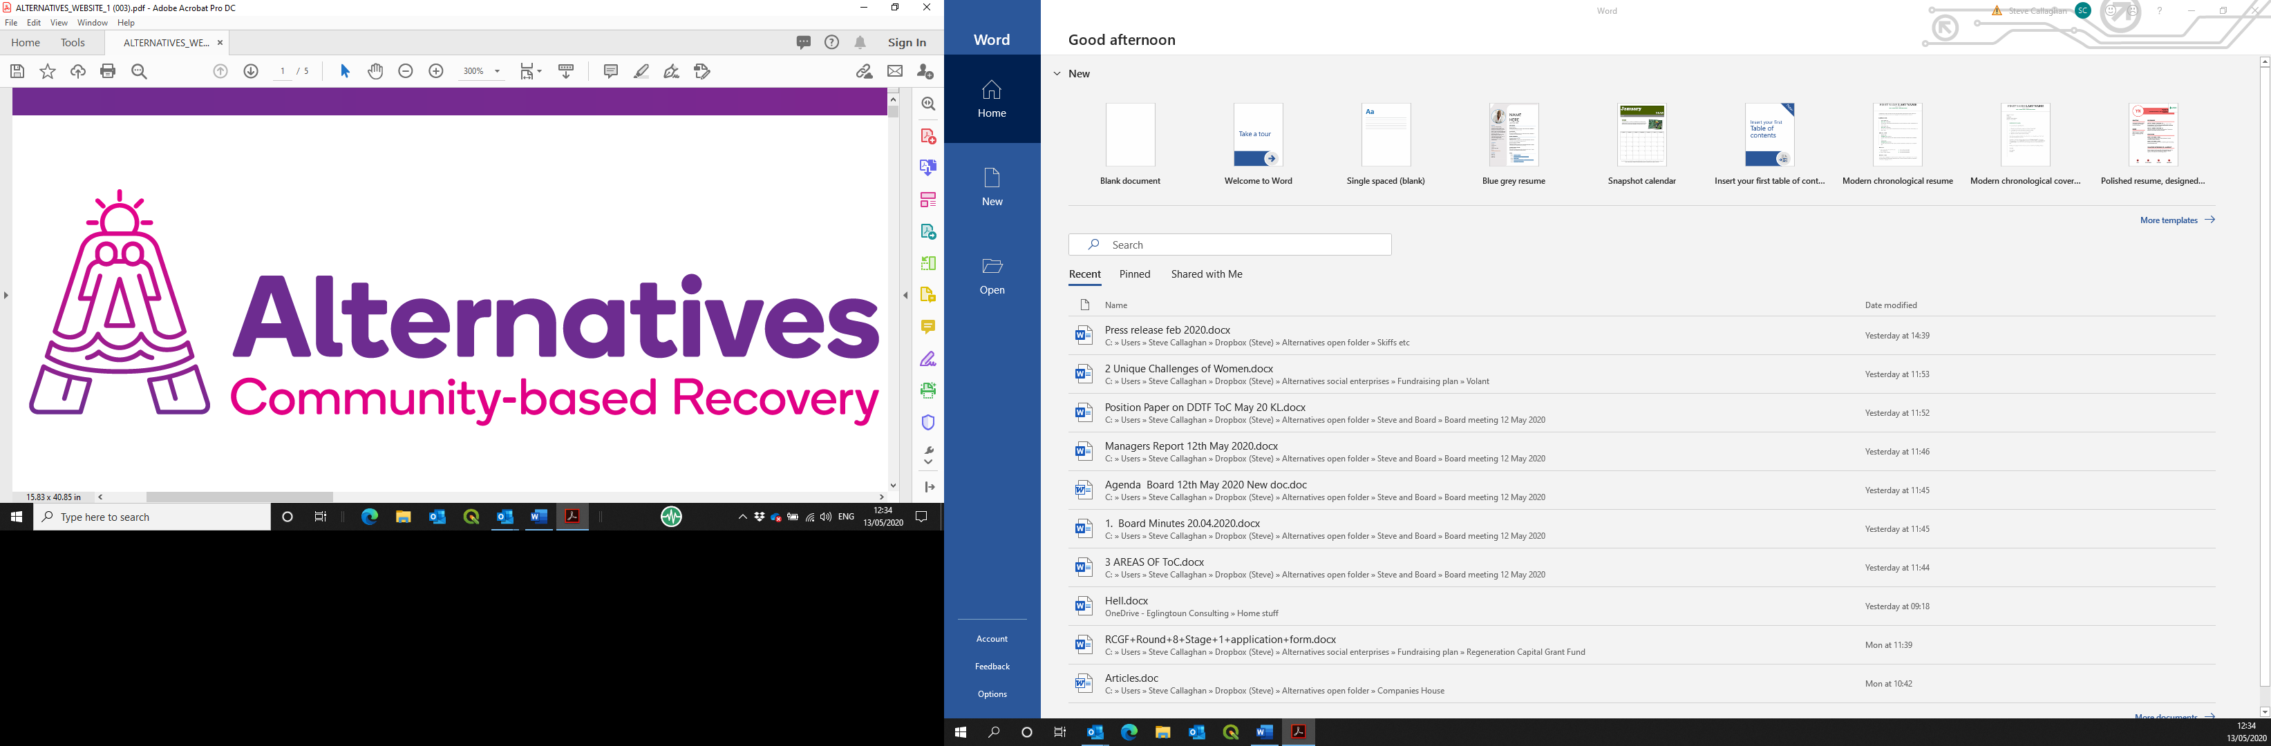

Post of Recovery House Project Worker
Application pack

Contents
Introduction and background information 3
Applying for the post on offer 3
Alternatives West Dunbartonshire Community Drug Services (Alternatives) 3
History and achievements 3
Social enterprises 3
Job description 4
Person specification 4
Application form 5

Introduction and background information

Applying for the post on offer
Please read this pack in its entirety, then apply using the enclosed electronic form. This should be returned by 5.00p.m. on 31 May 2021, by email to mhairi@alternativeswd.org .
Please add your surname to the name of the file as you save it before sending.
LATE APPLICATIONS WILL NOT BE ACCEPTED.

Alternatives West Dunbartonshire Community Drug Services (Alternatives)

History and achievements
Alternatives has been established since 1996 as a charitable company, with premises across West Dunbartonshire. Its operation base currently consists of:
- A main office in Quay Street, Dumbarton;
- A secondary office in Alexander Street, Clydebank;
- A 14-bed ‘Safe House’ in Jean Armour Drive, Clydebank;
- 11 x 2-bedroom ‘scatter flats’ in Drumry; and
- A catering operation within the Concord Community Centre, Dumbarton.

Alternatives’ core theme and purpose is to facilitate the personal journey from chaos to wholeness for individuals who have a substance dependency, by normalising a lifestyle without such a dependency.
Much of Alternatives’ core work is through its Service Level Agreement (SLA) with West Dunbartonshire Council for the delivery of community-based group work with service users in recovery from dependency on substances. Some of these service users are housed in the Safe House and associated scatter flats as part of their recovery journey, out with the SLA. The Care Inspectorate has recently awarded Alternatives a score of 6s across the board for its core work, the highest mark available and 5s for the rest, still an excellent accolade. This was the subject of a Private Member’s Motion in the Scottish Parliament during January 2020, where Alternatives and its team were praised and endorsed.

Social enterprises
New social enterprises as safe, therapeutic work placement opportunities are being developed within the operational structure through 2020/21, to take in a horticulture operation, an upcycling/life skills operation and an expansion of the piloted catering operation. A heritage-based operation will also follow in due course.

Job description

To support the day to day running of the Recovery House Programme including supporting the main house project and scatter flat operation, aimed at promoting positive alternatives to drug use and stability in the community.

This will involve working with individuals and families affected by drug misuse, collaboration with partner organisations and assisting in the implementation of the Safe as Houses Recovery Programmes and links to the community.

This role may be suitable for an internal or external secondment, as part of the candidate’s continuing professional development.
PVG Scheme Membership is required for this post.
Alternatives operates an Equal Opportunities Policy.

Job title: Recovery House Project Worker (fixed-term initially, with the possibility of continuation, subject to funding and satisfactory performance)
Place of work: Safe As Houses Project, Clydebank
Employer: Alternatives West Dunbartonshire Community Drug Services (Alternatives)
Reporting to: Recovery House Co-ordinator, Alternatives
Salary: £20,960.21 to £22,960.21 per annum dependant on level of qualifications and experience. There is a contributory Pension of up to 6%.
Hours: Rotating shift pattern averaging out at 36 hours per week covering over 7 days.
Job purpose/main scope of post:

To support the day to day running of the Recovery House Programme including supporting the main house project and scatter flat operation, aimed at promoting positive alternatives to drug use and stability in the community.
This will involve working with individuals and families affected by drug misuse, collaboration with partner organisations and assisting in the implementation of the Safe as Houses Recovery Programmes and links to the community.

- Under the direction of the service co-ordinator assist with the development and implementation of the structured Groupwork Programme.

- To assist with the day to day running of the Recovery House services.

- To provide support in the afternoons, evenings and weekends within the Recovery House and accompany residents to outdoor activities using company vehicles. .
- To be directly involved in the planning and supporting of residents care plans alongside partner agencies.
- To provide support to recovering participants in a non-judgemental manner

- To work jointly with all partner agencies towards meeting the needs of service users.

- To record work undertaken in a suitable form as designated by the Line Manager and to gather data and maintain data gathering systems.

- To actively promote the services provided by Alternatives in line with policy guidelines, protocol and service philosophy.

- To work as part of a team towards the aims of service users in line with agreed working practice and strategies.

- To undertake such training programmes as may assist this agency and personal development.

- To participate in formal consultation and supervision of as required.

- To undertake the development and support of volunteers/peers workers in the delivery of the Community Recovery Programme.

- To undertake such other duties, appropriate to the grade, as may be delegated by the service co-ordinator.

Person specification
Specification | Essential | Desirable | How demonstrated
Qualifications | Relevant social care qualification minimum of SV2 with willingness to undertake SVQ3 |  | Application form
Knowledge and Experience | Knowledge of Recovery Orientated Systems of Care. |  | Application form; detailed in interview and references
Competencies | Awareness of social, educational, emotional issues facing drug users and their families.  Understanding of innovative work in the local community.  Knowledge of social services.  Knowledge relating to record keeping and planning workloads.  Commitment to teamwork and user involvement in the planning and delivery of services.  Ability to work on own and as part of a team.  Knowledge of local resources.  Clean driving licence for minimum of 2 years and a willingness to drive company vehicles as required is essential.  A person-centred approach to working with people experiencing drug problems.  Ability to recognise and report concerns about the well-being of children and vulnerable service users.  Ability to work within appropriate legislation processes and procedures. | An understanding of vulnerable adults and trauma  An appreciation of lived experiences  Technical skills (simple IT)  Attention to detail | Application form;  Competency based interview; references

Application form
A | Post details
Post Title |  | Recovery House Project Worker
Employer |  | Alternatives West Dunbartonshire Community Drug Services

B | Personal details
Surname:Click or tap here to enter text. |  | First name(s):Click or tap here to enter text. |  | Known as:Click or tap here to enter text.
Address and Postcode: |  | Click or tap here to enter text.
Telephone (home): |  | Click or tap here to enter text. | National Insurance No: |  | Click or tap here to enter text.
Telephone (mobile): |  | Click or tap here to enter text. | Email address: |  | Click or tap here to enter text.

C | Referees
(we will only contact if successful at interview) |  | First reference | Second reference
Name: |  | Click or tap here to enter text. | Click or tap here to enter text.
Role: |  | Click or tap here to enter text. | Click or tap here to enter text.
Organisation/personal: |  | Click or tap here to enter text. | Click or tap here to enter text.
Address: |  | Click or tap here to enter text. | Click or tap here to enter text.
Postcode: |  | Click or tap here to enter text. | Click or tap here to enter text.
Telephone: |  | Click or tap here to enter text. | Click or tap here to enter text.
Email address: |  | Click or tap here to enter text. | Click or tap here to enter text.

D | Additional information
Notice required by current employer: |  | Click or tap here to enter text.
Are you allowed to work in the UK? |  | Click or tap here to enter text.
What driving licence do you hold? |  | Click or tap here to enter text.
Penalty points current: |  | Click or tap here to enter text.

E | Education and Qualifications
Attainment |  | Results obtained | Year
Click or tap here to enter text. |  | Click or tap here to enter text. | Click or tap here to enter text.

F | Other training and experience
Description |  | When undertaken/achieved
Click or tap here to enter text. |  | Click or tap here to enter text.

G | Membership of professional bodies
Institution |  | Class of membership | From | To
Click or tap here to enter text. |  | Click or tap here to enter text. | Click or tap here to enter text. | Click or tap here to enter text.

H | Employment history
Employer (most recent first) |  | Role held | Description of duties | Timeframe
Click or tap here to enter text. |  | Click or tap here to enter text. | Click or tap here to enter text. | Click or tap here to enter text.

I | Health
If offered employment, this will be subject to a required medical questionnaire. Please state that you will be prepared to complete such a documentClick or tap here to enter text.

J | Supporting information
Please give enough information for us to assess your application against the person specification
Click or tap here to enter text.

K | Declaration
Alternatives posts are covered by the Rehabilitation of Offenders Act 1974.
Before an offer of appointment, an Enhanced Disclosure Scotland check will be carried out.

- I agree to an Enhanced Disclosure Scotland check being carried out.
- I certify that all of the information I have provided is accurate and truthful; I realise that supplying incorrect or untruthful information on the form may form grounds for summary dismissal without notice.
Signed: |  | Click or tap here to enter text. | Date: | Click or tap here to enter text.

