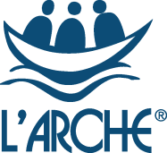
Do you believe in a world where all belong?

Support and Care Leader
L’Arche Edinburgh

Do you have a passion for ensuring people with learning disabilities live fulfilled lives? Do you want to help lead a community that values people for who they are and what they can do?

L’Arche Edinburgh is a community of more than 80 people with and without learning disabilities. It is a place of belonging where people with learning disabilities can live independent, yet connected lives. We’re looking for someone to join us as a Support and Care Leader.

You will lead a team of approximately 15, with the support of 2 Deputies. Together you will ensure that we provide and develop high quality person-centred care supporting the practical, social and spiritual needs of those who call L’Arche home. We are always looking to increase choice for the people we support as part of shared living at The Skein and in individual supported tenancies and explore ways that we can grow as a Community.

L’Arche Edinburgh is an ecumenical Christian community which welcomes people of all faiths and none. We are part of a global network of communities where people with and without learning disabilities live and share in life together, working for a world where we all belong.

Knowledge and experience in care or supported housing is a key requirement for this role, but we’re also looking for someone with an enthusiasm for our values and the ability to inspire others. You might be looking to step up from a senior support worker or to use your current management experience in a different way. If you are interested in being part of a mutually supportive and lively community, then we want to hear from you!

Enquiry pack and Application Form available at : www.larche-edinburgh.org.uk
The closing date is Monday 7th June at midday.
Finding out more about L’Arche
L’Arche is more easily experienced than explained. If you would like to find out more about us, we would normally encourage you to visit us, but sadly, these are not normal times. If you are shortlisted, you will be invited to ‘visit’ The Skein in a Covid-compliant way as part of your interview. Interviews will be held via Zoom.

Kirsty MacCrimmon, Community Leader, or Tom Cullimore, Support and Care Coordinator (Registered Manager) would be very happy to talk informally with you to answer any questions and give you a feel for what being a Care and Support Leader in L’Arche is like. Kirsty is available via 0131 553 3478 or Kirsty.MacCrimmon@larche.org.uk . Tom is available on 0131 553 3478 or Tom.Cullimore@larche.org.uk .
You can find out more about L’Arche Edinburgh at www.larche-edinburgh.org.uk
and L’Arche in the UK at www.larche.org.uk

What people who are part of Skein are looking for:
- A person with a vision for the house in their mind, and the ability to share and work in partnership on this with everyone in the house.
- A person who cares about the holistic well-being of the house: core members, assistants, spiritual life, and physical spaces all being equally important.
- A person with management skills, who takes care of the assistants, being available to listen to them, seeing and bringing out their gifts, valuing them and realising how they have so much experience, ability and care that, if nurtured and channelled (by the leader), then the house will flourish and the core members will be fully supported to live life to the full.
- A person who can delegate, with the deputy house leaders focusing more on practical tasks.
- A person who values Community – ‘a collaborative leadership approach and a fostering of a community-based house culture where we share our lives in meaningful ways besides just working together’.
What people who live in The Skein or their own individual tenancies are looking for:
- A person who genuinely cares about the core members, and isn’t just taking it as ‘a job’; someone whose heart is really in it.
- A person who is committed to communicating with family members on a regular basis, seeing that their loved one looks well and is taken care of.
- A person who is great at communicating – written and verbal – who knows what’s really going on.
L’Arche: What we do
We believe that people with learning disabilities have much to teach us and contribute to the world. During the last fifty years, we have learnt that one of the best ways to enable this is by creating Communities with a culture of shared lives between people with and without learning disabilities, from which we can work together to build a more human society.
At L’Arche we celebrate people with learning disabilities and build circles of support around them. We go beyond supporting people's basic needs to attend to their emotional and spiritual lives, too. It is this focus on building relationships and cultivating a sense of belonging that makes us different from other service providers.
L’Arche Communities hold in balance four elements: service, community, spirituality & outreach. Experience has shown us that each element has an important role to play and needs to be present - not only for a Community to be healthy - but in order to make us better at each of the other elements.
L’Arche Communities around the world share this common philosophy and approach while reflecting and celebrating the ethnic, cultural and religious composition of the areas in which they exist

Community life
At the heart of L’Arche is the support we provide to people with learning disabilities. As well as providing high quality housing and supported living, we also work with individuals to access employment and voluntary opportunities. In addition, many of our Communities provide day support services. Furthermore, we assist people to access relevant healthcare and, where appropriate, receive therapeutic services. We work hard to ensure that the needs of individuals with learning disabilities are met holistically, and that people are supported to live fully integrated and empowered lives within the wider communities in which they live.
We have a long history of working with social services and social work departments, health authorities, primary care trusts, registration and regulatory authorities, housing associations and others, to provide high quality support that is recognised as being truly responsive to people with learning disabilities.
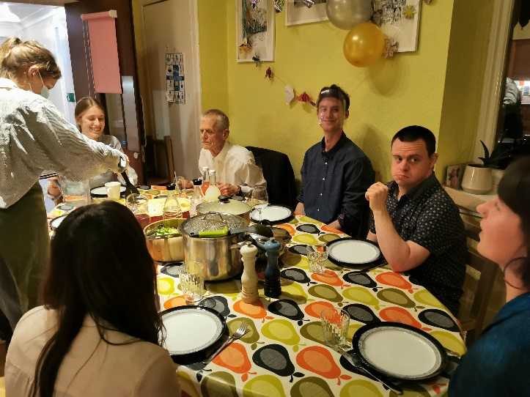
The Skein
L’Arche Edinburgh: Background information
L’Arche Edinburgh is one of ten communities that form L’Arche in the UK and belongs to an International Federation of 153 communities in 38 countries.

L’Arche Edinburgh opened its first house in 1991. It has grown since then and has a network of houses and flats. The community is made up of adults with learning disabilities, more than forty employed assistants, Committee members and many other friends and volunteers.

Our employed assistants are drawn from two sources. Most are local people employed on standard contracts, whom we term “live-out assistants”. But what makes us different is that up to a third of our assistants live in our houses alongside the people with disabilities to whom they provide support. They receive board, lodging and expenses. This experience of living in community alongside people who are different from themselves is a source of huge richness. Many of these live-in assistants are from outside the UK, and Brexit and Covid brings us new challenges in this area.

Our services are registered with the Care Inspectorate under their dual category of Care at home and Housing Support. This vacancy covers The Skein and two people who live independently in their own flats.

Shared Households:
- The Skein: home to four people with learning disabilities today and supported by a team of 14 assistants, four of whom live in the house. This was our first house, opened in 1991. Some of the assistants also work shifts in Fox Street.
- David House: a house for four people with more complex support and healthcare needs. 12 assistants support David House, some of whom live in the house
- Creelha: home to four people with disabilities, supported by 10 assistants, some of whom live in the house

Flats for individuals:
- We support four people who live independently in nearby flats, and who choose to live as neighbours

Work and day opportunities:
We do not run centre-based day activities, but instead have been ahead of the time in developing individualised day opportunities in the local community.

Community and spiritual life
L’Arche Edinburgh normally has a rich and vibrant community life involving Community Gatherings, parties, outings, celebrations and meals to bring together large and small groups. The major feasts such as Christmas and Easter are celebrated together, and there are other opportunities for prayer, reflection, and quiet time for those who wish to participate. It is hoped that many community activities will become possible again in the near future.

Job Description - Support and Care Leader – Shared Living and Supported Living

Full-time, permanent role, £25,688 - £26,715

L’Arche has been providing care and support services to adults with learning disabilities in Edinburgh for 30 years. We are a community of more than 80 people, part of an international federation of 150+ communities around the world. We provide registered supported living services in 3 localities in the Leith and Restalrig areas of Edinburgh, in small shared houses and individual flats. Our service is regulated by the Care Inspectorate and SSSC.
The role of Support and Care Leader is crucial in ensuring that the quality and standard of care and support to people living in our services complies with all requirements and that the assistant team are supported and well led. Promoting good communication is a key aspect of the role, along with ensuring L’Arche values of community and spiritual life are maintained. Family members of the people we support are actively involved and the Support and Care Leader works in close partnership with them.
L’Arche Edinburgh provides an innovative service that goes beyond the typical boundaries of professional care. We see people not as clients but as equal members of an active community and we support people to live a full and active life in their own homes and within the wider community. L’Arche is committed to providing genuinely person-centred outcomes for each person, and has a model that enables a higher than normal level of support to be provided.

The Support and Care Leader post holder manages a Care at Home/Housing Support service registered with the Care Inspectorate for 4 core members (service users) for The Skein and for 2 core members who live in their own flats. The assistant team is made up of a mix of ‘live-in’ and ‘live-out’ support workers (called Assistants in L’Arche) who together provide 24 hour support, including waking nights. Occasional sleepovers may be required for this post. The role comprises direct support and management and administration that needs to be worked flexibly according to service needs.

L’Arche Edinburgh
JOB DESCRIPTION

Job Title: Support and Care Leader
Reporting to: Support and Care Coordinator
Hours: 40 hours per week, including evenings and weekends
Sleepovers: Sleepovers are occasionally required and are paid at £83.70 per night
Salary: £25,688 - £26,715 (Live-out). Live-In option is available at a different rate.
Annual Leave: 30 days inclusive of public holidays (rising to 35 in second year)
Probationary Period: 6 months
Sickness: 20 working days paid in any 12 month period (post probation)
_________________________________________________________________________

Purpose of the role:
- To provide person-centred care and support to people with learning disabilities who may live in several different addresses, and to enable them to lead the lifestyle of their choice.
- To lead, manage and support the assistant team to enable them to provide quality support and care
- To work closely with the Support and Care Coordinator (Registered Manager) in fulfilling the requirements to meet service provision standards whilst upholding L’Arche values and the ethos of community living

MAIN RESPONSIBILITIES:
TO PROVIDE SUPPORT AND CARE TO ADULTS WITH LEARNING DISABILITIES
- Build positive working relationships with individuals using the service
- Provide direct support to people to help them achieve outcomes important to them
- Provide personal care to people that meets specific needs and requirements including being responsible for the safe handling and administration of medication
- Support people to maintain their home which may include support with personal finances, domestic tasks, maintaining tenancy/occupancy
- Ensure that core members are empowered to make choices and take control over their lives, balancing the individual’s right to make choices and take reasonable risks, and their need to maintain a safe and healthy lifestyle
- Ensure core members’ needs and wishes as described in their Support Plans are achieved through providing high quality person-centred support at all times, and that these plans are updated regularly
- Recognise that all behaviour is a form of communication that has a message and a value, and work closely with people in order to understand what is being communicated and respond appropriately
- Model positive ways of supporting people to team members and members of the public whom the person comes into contact with , and promote a culture of respect and dignity at all times
- Ensure all relevant parties responsible for the planning and delivery of support are regularly updated on changes and progress, in collaboration with the team and Support and Care Coordinator
- Work as a team member and actively contribute to effective and positive team working
- Recognise the value that families have in the lives of the people we support and work in partnership with Welfare/Financial Guardians, family members and other important people in the person’s life, and ensure they are kept aware of relevant issues
- Ensure communication of information is clear, timely and done with respect for confidentiality
- Occasionally accompany individuals on a short break or holiday

MANAGEMENT & ADMINISTRATION
- Work closely with the Deputy Support and Care Leaders to manage all aspects of the service delegating responsibilities as appropriate
- Provide regular support and supervision to team members
- Lead on team member appraisals and other performance management processes
- Plan and lead the Team meeting, including follow up and appropriate delegation of duties
- To effectively plan and manage the rota including sickness, holidays and training, arranging cover to ensure appropriate and cost-effective support is delivered to individuals in line with their support agreement.
- Prepare for and take full part in core members’ reviews and meetings related to their support
- To participate in recruitment and ensure all new team members are inducted into the team with knowledge of all polices and support plans
- To identify potential difficulties/complex situations arising from assistant management, report those to the Support and Care Coordinator or Assistants Coordinator (HR Manager) and work together on solutions
- To ensure individuals receive relevant support to manage their personal finances including welfare benefits if appropriate
- Ensure good quality record keeping is maintained

QUALITY AND DEVELOPMENT
- Contribute to on-going quality assurance and service improvement processes
- Ensure all care and support is delivered in line with the Health and Social Care Standards
- Ensure all L’Arche policies and procedures, and individual plans and guidelines are implemented
- Ensure the SSSC codes of practice are adhered to by all team members
- To contribute to the wider development of L’Arche as required

TO ENSURE GOOD QUALITY HOME LIFE IN LINE WITH L’ARCHE VALUES and HEALTH & SOCIAL CARE STANDARDS
- Promote a feeling of belonging for all who live and work in the house or flat, paying attention to any dynamics and facilitating quality relationships between individuals within an atmosphere of welcome and respect
- Ensure celebrations of birthdays, anniversaries and the house or flat spiritual life are well facilitated in line with L’Arche ethos of community living and spirituality
- Ensure the fabric, fixtures and fittings in the house or flat environment are in good order, and that the house or flat is kept to a high standard of cleanliness
- Implement an annual maintenance action plan agreed with the Support and Care Coordinator (Registered Manager)
PROMOTE AND MODEL EFFECTIVE COMMUNICATION
- Ensure effective communication within the team making sure that meetings, messages and systems for communication such as log books are working well.
- Promote and ensure good communication with families and professionals
- Ensure that information from the wider organisation, and from the community leadership team is communicated effectively to core members and the assistant team and team
- Be creative about the participation and involvement of people with learning disabilities as much as possible in the running of their home
TO IMPLEMENT SERVICE REGULATION AND COMPLIANCE REQUIREMENTS
- Assist the Support and Care Coordinator in preparing for and participating in Care Inspectorate inspections
- Contribute to HMO compliance requirements
- Ensure that all relevant Health and Safety regulations are observed within the service and promote a strong health and safety culture within the service
- Contribute to on-going quality assurance and service improvement process
- To continue to learn about best practice within the sector

TO DEVELOP YOUR PRACTICE AND PLAY AN ACTIVE ROLE IN LEADERSHIP TEAM
- Prepare for and attend meetings with other members of the wider community leadership team including the Leaders meeting, and contribute to discussion and decisions
- Use own support and supervision positively and be reflective about own performance seeking guidance when unsure
- Take opportunities for further learning, training and development where required and demonstrate personal responsibility for own learning
- Take part in ‘Out of office hours’ phone responsibilities
- Be open to and supportive of L’Arche traditions and practices including accompaniment (non-line management mentor)
The information given in this job description is given to ensure the post holder has the best opportunity of understanding what is required to be effective in the post. It is not intended to be prescriptive in every detail and it is expected the post holder will be as positive and flexible as possible while using this as a framework. There may be from time to time, other duties deemed appropriate and/or necessary by the Support and Care Coordinator or Community Leader.

Support and Care Leader – Person Specification

The people with learning disabilities within our services look for a Support and Care Leader who has the following skills and qualities:
- “They’ve got to get on well with people”
- “They’ve got to be able to sort things out if they go wrong”
- “Be able to answer the telephone, talk to people and make appointments for me”
- “I want them to take their time to get to know me”
- “Make sure people are here when I need them”

Leadership and Management – candidates should demonstrate experience and competence in
- At least 1 years’ experience of managing and supervising staff within in a social care setting
- Understanding and insight into working with staff groups and leading and motivating teams
- Communicate effectively verbally and in writing
- Good organisational and administrative skills
- Ability to delegate effectively and to manage a dispersed locality

Supporting People – candidates should have
- At least 2 years’ experience of support work within a social care setting with adults with learning disabilities
- Experience of working collaboratively with people with learning disabilities to plan their care and support
- Understanding of the emotional and behavioural support needs of adults with learning disabilities
- Understanding of the principles and practice of supported living
- Understanding of what it means to think and work in a person centred way

Personal Qualities – candidates should demonstrate
- personal authority in leadership
- personal motivation by the mission, values and objectives of L’Arche and an openness to the ‘vocational’ aspects of belonging to L’Arche and to becoming a member of the community
- emotional maturity and resilience to deal with leadership responsibilities
- ability to work with autonomy, initiative and responsibility

Qualifications
- SVQ 3 Health and Social Care or HNC Social Care, and the additional supervisory qualification required by SSSC OR have the ability and commitment to achieve SSSC required qualifications within the required time period (see Terms and Conditions).
- Evidence of openness to continuous professional development
- IT skills
- Full driving licence and ability to drive Motability vehicles (desirable)

TERMS AND CONDITIONS:
Full terms and conditions are contained in the L’Arche contract and Employee Handbook
- This post is subject to meeting SSSC registration requirements for the role of Supervisor in a Care at Home/Housing Support Service.
- Total working hours are 40 per week. The hours require shift working involving some evening and weekend work. There will be a typical and predictable pattern of days off, which may vary on occasion if needs arise. Split shifts may be required.
- The salary is on a 2 point scale starting at £25,688 rising to £26,715, dependent upon achieving the relevant qualifications required for the role along with a satisfactory performance appraisal after 12 months employment.
- Sleepovers are required occasionally for the Support and Care Leader role. Sleepovers are paid at £83.70 per night.
- The post is subject to a probationary period of 6 months which may be extended if necessary.
- During the probationary period sick pay is paid at the statutory rate only. On successful completion of the probationary period and during the subsequent period up to two years of service an employee, sick pay is paid at the full rate for 20 working days in any 12 month period.
- There is no payment for overtime. Time off in lieu will be given when circumstances require the post holder to work extra hours.

L’Arche Identity and Mission Statement

Identity:
- We are people with and without learning disabilities, sharing life in communities belonging to an International Federation.
- Mutual relationships and trust in God are at the heart of our journey together.
- We celebrate the unique value of every person and recognise our need of one another.

Mission:
- Make known the gifts of people with learning disabilities, revealed through mutually transforming relationships
- Foster an environment in community that responds to the changing needs of our members whilst being faithful to the core values of our founding story
- Engage in our diverse cultures, working together towards a more human society
We value:
- Treating people with dignity and respect: We value every person and celebrate who they are. We do not just tolerate diversity, but actively embrace it in our communities. A key way we demonstrate dignity and respect is by being fully present to each other when we are together and listening deeply to one another.
- Friendliness and welcome: We are deeply committed to building friendships together, which calls us to live life with a joyful and grateful spirit. A key way we demonstrate friendliness and welcome is by offering meaningful invitation and welcome to newcomers and also to each other on a daily basis.
- Empathy: We are committed to understanding and sharing the feelings of one another. We prioritise the qualities of compassion, caring, and kindness to nurture empathy. A key way we demonstrate empathy is through the quality of the shared life we build together.
- Integrity: We strive to have integrity in everything we do and in every relationship we build, seeking to be authentic and honest, trustworthy and open because to build meaningful relationships we need to reveal who we are. A key way we demonstrate integrity is through our willingness to be both vulnerable and courageous.
- Commitment to community building: We choose to share life together rather than merely work together. Sharing life means we create mutual relationships with one another and also share responsibility for the life and wellbeing of the community as a whole, practicing forgiveness and celebration and creating a place of belonging that is open to all who share our mission and values. A key way we demonstrate our commitment to community building is through our nurturing of our shared spirituality expressed through the community traditions and practices that shape our daily life together.
- Openness to reflection, learning and growth: We are personally committed to growth and development in the dimensions of L’Arche identity and mission and also support the growth of the whole community by nurturing the gifts of each person, creating a learning culture together and being attentive to our personal and communal spiritual life. A key way we demonstrate our commitment to learning is the frequency and quality of our personal and group reflective practices and processes.
- Commitment to the vision and mission of L’Arche: We actively engage in all dimensions of L’Arche mission and practice both personally and communally. A key way we demonstrate our commitment is our visibility as people with and without learning disabilities together engaged in our local neighbourhoods and the wider world in order to shape a more human society.

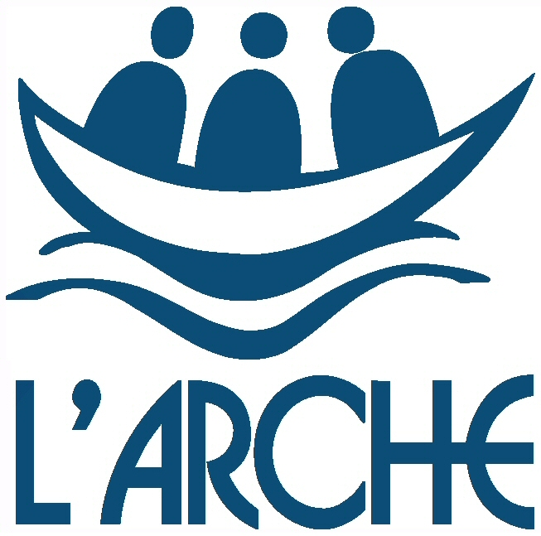



The Skein

