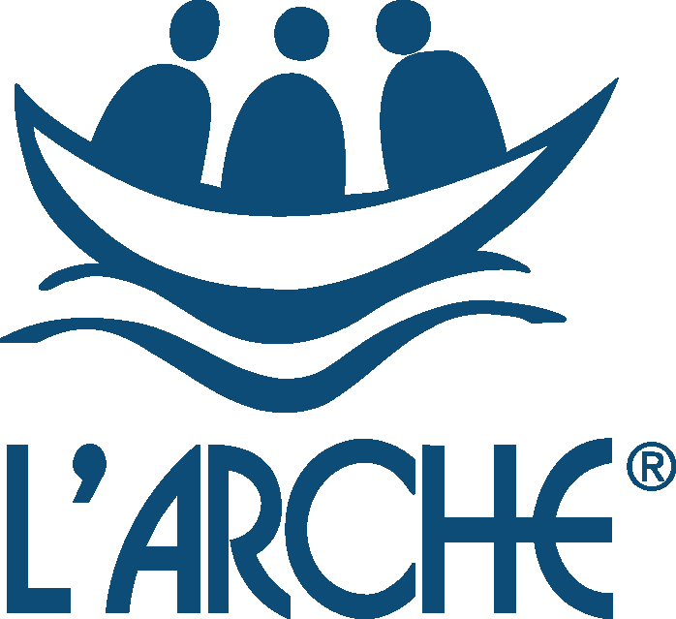

L’Arche Edinburgh

Job Description - Support and Care Leader – Shared Living and Supported Living
Full-time, permanent role, £25,688 - £26,715
L’Arche has been providing care and support services to adults with learning disabilities in Edinburgh for 30 years. We are a community of more than 80 people, part of an international federation of 150+ communities around the world. We provide registered supported living services in 3 localities in the Leith and Restalrig areas of Edinburgh, in small shared houses and individual flats. Our service is regulated by the Care Inspectorate and SSSC.
The role of Support and Care Leader is crucial in ensuring that the quality and standard of care and support to people living in our services complies with all requirements and that the assistant team are supported and well led. Promoting good communication is a key aspect of the role, along with ensuring L’Arche values of community and spiritual life are maintained. Family members of the people we support are actively involved and the Support and Care Leader works in close partnership with them.
L’Arche Edinburgh provides an innovative service that goes beyond the typical boundaries of professional care. We see people not as clients but as equal members of an active community and we support people to live a full and active life in their own homes and within the wider community. L’Arche is committed to providing genuinely person-centred outcomes for each person, and has a model that enables a higher than normal level of support to be provided.
The Support and Care Leader post holder manages a Care at Home/Housing Support service registered with the Care Inspectorate for 4 core members (service users) for The Skein and for 2 core members who live in their own flats. The assistant team is made up of a mix of ‘live-in’ and ‘live-out’ support workers (called Assistants in L’Arche) who together provide 24 hour support, including waking nights. Occasional sleepovers may be required for this post. The role comprises direct support and management and administration that needs to be worked flexibly according to service needs.
The closing date is Monday 7 June 2021 at midday.

L’Arche Edinburgh
JOB DESCRIPTION
Job Title: Support and Care Leader
Reporting to: Support and Care Coordinator
Hours: 40 hours per week, including evenings and weekends
Sleepovers: Sleepovers are occasionally required and are paid at £83.70 per night
Salary: £25,688 - £26,715 (Live-out). Live-In option is available at a different rate.
Annual Leave: 30 days inclusive of public holidays (rising to 35 in second year)
Probationary Period: 6 months
Sickness: 20 working days paid in any 12 month period (post probation)
_________________________________________________________________________
Purpose of the role:
- To provide person-centred care and support to people with learning disabilities who may live in several different addresses, and to enable them to lead the lifestyle of their choice.
- To lead, manage and support the assistant team to enable them to provide quality support and care
- To work closely with the Support and Care Coordinator (Registered Manager) in fulfilling the requirements to meet service provision standards whilst upholding L’Arche values and the ethos of community living

MAIN RESPONSIBILITIES:
TO PROVIDE SUPPORT AND CARE TO ADULTS WITH LEARNING DISABILITIES
- Build positive working relationships with individuals using the service
- Provide direct support to people to help them achieve outcomes important to them
- Provide personal care to people that meets specific needs and requirements including being responsible for the safe handling and administration of medication
- Support people to maintain their home which may include support with personal finances, domestic tasks, maintaining tenancy/occupancy
- Ensure that core members are empowered to make choices and take control over their lives, balancing the individual’s right to make choices and take reasonable risks, and their need to maintain a safe and healthy lifestyle
- Ensure core members’ needs and wishes as described in their Support Plans are achieved through providing high quality person-centred support at all times, and that these plans are updated regularly
- Recognise that all behaviour is a form of communication that has a message and a value, and work closely with people in order to understand what is being communicated and respond appropriately
- Model positive ways of supporting people to team members and members of the public whom the person comes into contact with , and promote a culture of respect and dignity at all times
- Ensure all relevant parties responsible for the planning and delivery of support are regularly updated on changes and progress, in collaboration with the team and Support and Care Coordinator
- Work as a team member and actively contribute to effective and positive team working
- Recognise the value that families have in the lives of the people we support and work in partnership with Welfare/Financial Guardians, family members and other important people in the person’s life, and ensure they are kept aware of relevant issues
- Ensure communication of information is clear, timely and done with respect for confidentiality
- Occasionally accompany individuals on a short break or holiday

MANAGEMENT & ADMINISTRATION
- Work closely with the Deputy Support and Care Leaders to manage all aspects of the service delegating responsibilities as appropriate
- Provide regular support and supervision to team members
- Lead on team member appraisals and other performance management processes
- Plan and lead the Team meeting, including follow up and appropriate delegation of duties
- To effectively plan and manage the rota including sickness, holidays and training, arranging cover to ensure appropriate and cost-effective support is delivered to individuals in line with their support agreement.
- Prepare for and take full part in core members’ reviews and meetings related to their support
- To participate in recruitment and ensure all new team members are inducted into the team with knowledge of all polices and support plans
- To identify potential difficulties/complex situations arising from assistant management, report those to the Support and Care Coordinator or Assistants Coordinator (HR Manager) and work together on solutions
- To ensure individuals receive relevant support to manage their personal finances including welfare benefits if appropriate
- Ensure good quality record keeping is maintained

QUALITY AND DEVELOPMENT
- Contribute to on-going quality assurance and service improvement processes
- Ensure all care and support is delivered in line with the Health and Social Care Standards
- Ensure all L’Arche policies and procedures, and individual plans and guidelines are implemented
- Ensure the SSSC codes of practice are adhered to by all team members
- To contribute to the wider development of L’Arche as required

TO ENSURE GOOD QUALITY HOME LIFE IN LINE WITH L’ARCHE VALUES and HEALTH & SOCIAL CARE STANDARDS
- Promote a feeling of belonging for all who live and work in the house or flat, paying attention to any dynamics and facilitating quality relationships between individuals within an atmosphere of welcome and respect
- Ensure celebrations of birthdays, anniversaries and the house or flat spiritual life are well facilitated in line with L’Arche ethos of community living and spirituality
- Ensure the fabric, fixtures and fittings in the house or flat environment are in good order, and that the house or flat is kept to a high standard of cleanliness
- Implement an annual maintenance action plan agreed with the Support and Care Coordinator (Registered Manager)
PROMOTE AND MODEL EFFECTIVE COMMUNICATION
- Ensure effective communication within the team making sure that meetings, messages and systems for communication such as log books are working well.
- Promote and ensure good communication with families and professionals
- Ensure that information from the wider organisation, and from the community leadership team is communicated effectively to core members and the assistant team and team
- Be creative about the participation and involvement of people with learning disabilities as much as possible in the running of their home
TO IMPLEMENT SERVICE REGULATION AND COMPLIANCE REQUIREMENTS
- Assist the Support and Care Coordinator in preparing for and participating in Care Inspectorate inspections
- Contribute to HMO compliance requirements
- Ensure that all relevant Health and Safety regulations are observed within the service and promote a strong health and safety culture within the service
- Contribute to on-going quality assurance and service improvement process
- To continue to learn about best practice within the sector

TO DEVELOP YOUR PRACTICE AND PLAY AN ACTIVE ROLE IN LEADERSHIP TEAM
- Prepare for and attend meetings with other members of the wider community leadership team including the Leaders meeting, and contribute to discussion and decisions
- Use own support and supervision positively and be reflective about own performance seeking guidance when unsure
- Take opportunities for further learning, training and development where required and demonstrate personal responsibility for own learning
- Take part in ‘Out of office hours’ phone responsibilities
- Be open to and supportive of L’Arche traditions and practices including accompaniment (non-line management mentor)
The information given in this job description is given to ensure the post holder has the best opportunity of understanding what is required to be effective in the post. It is not intended to be prescriptive in every detail and it is expected the post holder will be as positive and flexible as possible while using this as a framework. There may be from time to time, other duties deemed appropriate and/or necessary by the Support and Care Coordinator or Community Leader.

Support and Care Leader – Person Specification

The people with learning disabilities within our services look for a Support and Care Leader who has the following skills and qualities:
- “They’ve got to get on well with people”
- “They’ve got to be able to sort things out if they go wrong”
- “Be able to answer the telephone, talk to people and make appointments for me”
- “I want them to take their time to get to know me”
- “Make sure people are here when I need them”

Leadership and Management – candidates should demonstrate experience and competence in
- At least 1 years’ experience of managing and supervising staff within in a social care setting
- Understanding and insight into working with staff groups and leading and motivating teams
- Communicate effectively verbally and in writing
- Good organisational and administrative skills
- Ability to delegate effectively and to manage a dispersed locality

Supporting People – candidates should have
- At least 2 years’ experience of support work within a social care setting with adults with learning disabilities
- Experience of working collaboratively with people with learning disabilities to plan their care and support
- Understanding of the emotional and behavioural support needs of adults with learning disabilities
- Understanding of the principles and practice of supported living
- Understanding of what it means to think and work in a person centred way

Personal Qualities – candidates should demonstrate
- personal authority in leadership
- personal motivation by the mission, values and objectives of L’Arche and an openness to the ‘vocational’ aspects of belonging to L’Arche and to becoming a member of the community
- emotional maturity and resilience to deal with leadership responsibilities
- ability to work with autonomy, initiative and responsibility

Qualifications
- SVQ 3 Health and Social Care or HNC Social Care, and the additional supervisory qualification required by SSSC OR have the ability and commitment to achieve SSSC required qualifications within the required time period (see Terms and Conditions).
- Evidence of openness to continuous professional development
- IT skills
- Full driving licence and ability to drive Motability vehicles (desirable)

TERMS AND CONDITIONS:
Full terms and conditions are contained in the L’Arche contract and Employee Handbook
- This post is subject to meeting SSSC registration requirements for the role of Supervisor in a Care at Home/Housing Support Service.
- Total working hours are 40 per week. The hours require shift working involving some evening and weekend work. There will be a typical and predictable pattern of days off, which may vary on occasion if needs arise. Split shifts may be required.
- The salary is on a 2 point scale starting at £25,688 rising to £26,715, dependent upon achieving the relevant qualifications required for the role along with a satisfactory performance appraisal after 12 months employment.
- Sleepovers are required occasionally for the Support and Care Leader role. Sleepovers are paid at £83.70 per night.
- The post is subject to a probationary period of 6 months which may be extended if necessary.
- During the probationary period sick pay is paid at the statutory rate only. On successful completion of the probationary period and during the subsequent period up to two years of service an employee, sick pay is paid at the full rate for 20 working days in any 12 month period.
- There is no payment for overtime. Time off in lieu will be given when circumstances require the post holder to work extra hours.

