

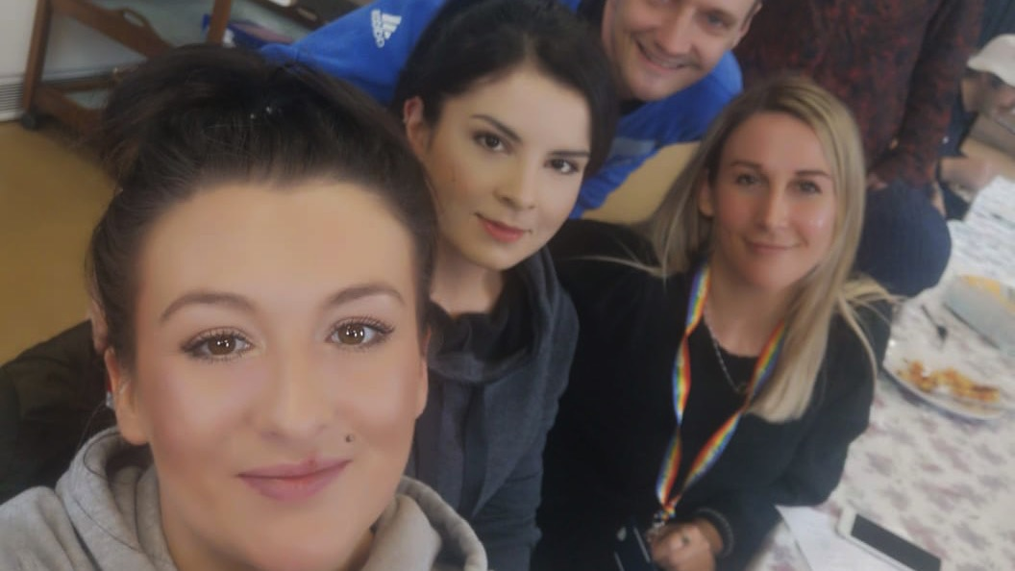

1st Step Development Ventures has been operating for 5 years and started as a constituted community group wanting a safe space for people in recovery from addictions to meet. The group had directly experienced a **huge gap in opportunities for people in recovery to socialise, learn and volunteer in a safe and trusted space with peers as positive role models.**

In October 2018 we became a charity (SCIO). Our main charitable purpose is to provide safe, supportive environments for people affected by illegal substance addictions. Importantly, to create opportunities for people in early recovery to gain confidence, build diverse supportive relationships, develop skills, learn and build better relationships with the wider community.

We work with diverse partners including the NHS, West Lothian and Falkirk Councils, West Lothian Food Bank, social work teams, criminal justice teams; Change Grow Live (CGL) and the Cyrenians.

Prior to Covid-19 we offered:

* Weekly recovery meeting at the Longcroft Hall in Linlithgow
* Weekly community café at the Longcroft Hall in Linlithgow
* A Community garden
* 1st Step Bike training and refurbishment social enterprise
* Mustard Seed outside catering social enterprise

The 1st Step café is the heart of 1st Step providing a safe and supported space for many people at the start of their recovery. The café is often the “first step” people take to recovery before “growing” into our social enterprise opportunities.

The cafe garden provides food for the café and encourages people to learn to grow and enjoy the benefits of being outside.

Over the last 3 years we have developed 1st Step Bikes offering bike refurbishment training courses (people affected by addiction/poor mental health), bikes repairs, services and monthly bike sales The training courses target people at the right point in their recovery to start to learn new skills, develop routines, make wider social connections (important to preventing relapse) and start to rebuild their lives. Social connections, purpose, tackling boredom and stigma and importantly hope are the key ingredients needed to build recovery capital and recover sustainably.

In 2018 we were awarded “Cycling UK Community Group of the Year”.



Due to Covid-19 in March 2020 we suspended the Café but responded to new urgent needs and adapted very quickly. We are now providing essential food parcels to over 140 people. This is led by our volunteers and has been really important to maintaining recovery journeys for the volunteers who describe it as “a life line” and, of course the many vulnerable individuals and families they support.

1st Step Bikes has continued to function as an essential service and has continued to work training volunteers and servicing and repairing bikes initially just for key workers. We are now taking bookings for people who would like their bikes services or repaired and we even have a number of appointments under the UK Cycling scheme which contributes £50 towards work done on your bike.

If you would like to find out more about 1st Step, would like to refer someone to us or have a bike you would like to donate or repaired please email Maria Throp [firststepdevelopment@gmail.com](mailto:firststepdevelopment@gmail.com)

Follow us on Facebook 1stStepcafeandbikes

