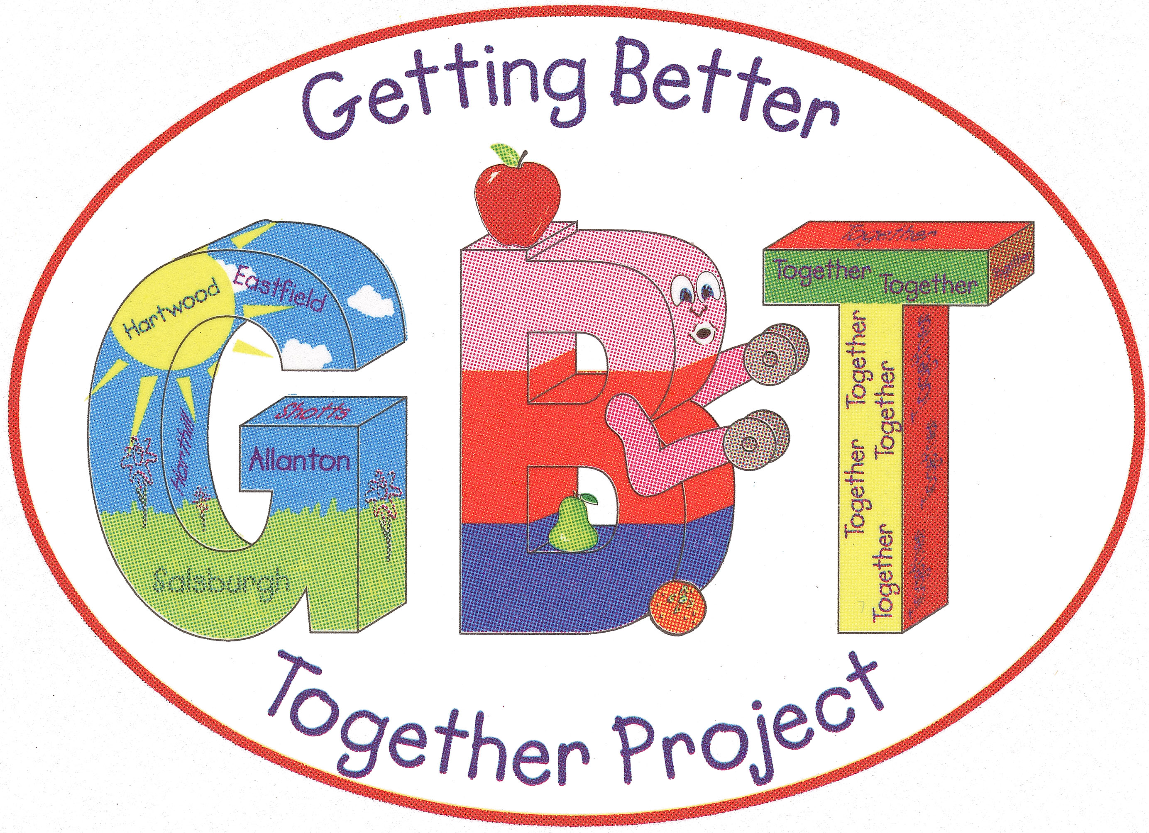

Job Description

Title: Executive Manager Salary: £43,000.00

Hours: 35 hours per week

Location: Getting Better Together
Shotts Healthy Living Centre
Kirk Road
Shotts
ML7 5ET

Purpose(s):

- As Chief Officer the Manager is responsible for providing Leadership, Vision and Strategic Development of Getting Better Together.
- Overall management of the Human, Financial and Physical Resources within the organisation.
- Personally, accountable, and responsible to the Board of Directors for the implementation of appropriate policies and procedures and achievement of Getting Better Together strategic objectives and targets.
- To prepare, agree and regularly review policy, strategies, operational plans, and budgets to ensure that Getting Better Together’s mission and targets remain relevant and within GBT’s capacity to deliver.
- To protect and improve GBT’s standing and reputation with both partner agencies and organisations.

Responsible to:

Personally, responsible, and accountable to the Board of Directors/Trustees with support and supervision, line management and communication links to the Board provided through the GBT Chair.

The post holder will be required to have a UK driving licence.
A PVG will also be required for this post.

Key tasks:

Professional

- Provide strategic policy guidance to the Board, taking account of the political, sectoral, economic, and institutional environment in which GBT operates, at local and national levels.
- Cultivate and maintain a positive and professional operating culture and ethos within the organization at all levels (Staff and Board)
- Maintain up to date knowledge of best practice in Health Improvement Activity.
- Maintain up to date knowledge of the (North Lanarkshire) operating landscape and Scotland wide.
- Working with the Board, prepare, agree, and regularly review the business plan, policies, strategies, operational plans, and budgets to ensure that GBT mission and targets remain relevant and within GBT’s capacity to deliver.
- Support the Board to ensure legislative compliance in relation to the governance of the organization.
- Being able to research and identify suitable funding sources and put applications together.
- Represent the organization at local, regional, and national forums.
- Develop and sustain effective and productive strategic and operational partnerships in order to underpin the work of the organization.
- Carry out the Company Secretary role in relation to the administration of Board and sub-group meetings.
- To ensure that you adhere to equality and diversity guidelines.

Managerial

- Lead, manage and work with staff, in the preparation, implementation and monitoring of individual and team workplans in line with GBT’s overall strategic objectives and targets.
- Enhance the character of GBT in the Fortissat Ward.
- Enhance the character of GBT in North Lanarkshire. Scotland and UK Wide.
- To identify and implement appropriate and effective internal operating structures to allow the organization to best service customers.
- Promote new ways of working and new ideas for tackling contemporary issues.
- Achievement of GBT’s targets in line with agreed policy and strategy.
- Ensure legislative compliance in relation all matters legal – e.g., Health & Safety, Employment Law and OSCR.
- To work with the Operational Manager to ensure that the Shotts Healthy Living Buildings are maintained and cleaned to an appropriate standard.

Organisational

- Provide visible and effective leadership for GBT internally, with members and partner agencies.
- Actively and successfully represent GBT in its dealings with partner agencies, working with Heads of division as appropriate.
- Make sufficient allocation of GBT’s resources – people, time, funds, premises, equipment – to achieve planned targets.
- Develop and submit funding applications to support the work of the organization and to develop the service as appropriate.
- Prepare and submit regular monitoring reports to funders and organisations.
- Monitor and report to the Board on the overall performance of GBT activities against plan and targets.
- Develop and coordinate an effective marketing and promotion strategy for the organization.
- As Executive Manager focus on strategic and managerial responsibilities and design the operational structure of the organization to ensure effective and appropriate allocation of input to operational matters.

Outputs:

- Through consultation with Board members, staff and key stakeholders produce and deliver against a detailed organisational Business Plan.
- Produce and deliver against a comprehensive Operational Plan taking account of all core and project income sources and associated delivery targets and milestones.
- Offer leadership to the staff compliment and support the Board in relation to appropriate and compliant governance.
- Represent the organisation – as appropriate at strategic partnership forums.
- Provide regular (bi-monthly) strategic update reports for Directors.
- Provide regular (bi-monthly) operational update reports for Directors.
- Work with the Operation Manager to provide (bi-monthly) financial reports for Directors.
- Provide support and supervision for development staff.
- Ensure the timely completion and return of all monitoring and financial reporting requests from stakeholders, partners, and funders.
- To ensure that all of the development staff who are leading on funded programmes are completing and are compiling the necessary statistical information and outcomes for the reports.
- Develop and implement appropriate and effective systems, procedures, and processes to support and sustain the strategic, operational and governance aspects of the organisations activity.
- Work with identified staff and appointed auditor to produce annual accounts compliant and reflective of the organisation’s activity.

Operating Principles:

Getting Better Together Shotts Health Living is an organisation committed to delivering a range of services predicated upon identified need and quality. The organisation is committed to Partnership and effective joint working. Our aim is to promote Community health improvement opportunities to the communities of North Lanarkshire and expect all of our staff to act in a manner that positively promotes the company (GBT). The organisation is well recognised locally, nationally, and UK Wide.

Signed (postholder): Signed (GBT):
Date: Date:

