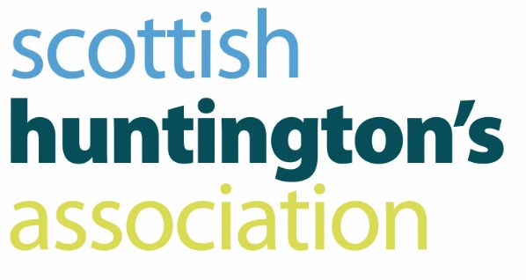

**Job Description**

|  |  |
| --- | --- |
| **Post** | Specialist Youth Advisor |
| **Division** | Scottish Huntington’s Association Youth Service |
| **Responsible to** | Youth Service Manager |
| **Salary** | £28,694 - £30,399 |

**Scottish Huntington’s Association Vision and Values**

Our vision is that every family in Scotland impacted with Huntington’s disease will have access to expert, committed, informed, honest and practical support as they navigate their complex HD journey.

Our core values guide how each one of us works in our individual day to day job: -

* Empowering individuals, families and groups to meet the challenges of Huntington’s disease
* Supporting people living with Huntington’s Disease in a way that promotes respect, dignity and self-worth and recognises that they have an important role to play in their community
* Passionate about the right of individuals to make choices about matters that affect their lives
* Flexible and designed around the individual needs of people living with Huntington’s disease

**General Purpose**

* To assist and support the development of SHAYP through effective engagement in direct work with vulnerable children, young people and families
* To work in partnership with parents, carers, families and professionals to increase knowledge and understanding of HD, increase resilience, support positive family relationships, and improve outcomes for children

**Key Results Area**

**Relationship with Children, Young People and Families**

* Engage in direct work with children, young people, and families, which will include individual, group work, conferences and residential/camps.
* To provide information, advice, advocacy and guidance to young people living in families impacted by HD
* To provide emotional support using a counselling approach to empower young people and families impacted by HD
* To plan and deliver a range of groups, group events and summer camps that will provide young people with support, reduce isolation and provide opportunities to discuss the issues that affect their lives
* Empower young people to promote awareness of HD in their communities and reduce stigma

**Relationships with Others**

* To liaise with professionals to help young people obtain the support and services required to achieve the best outcomes
* To work collaboratively, along with providing advice and guidance, with a range of external agencies promoting a multidisciplinary ‘team around the child’ approach
* To contribute to the development of the team and service objectives, actively participate in team meetings, and develop positive working relationships with other team members and colleagues across the charity
* To provide training and education to a wide range of professionals who work with young people living with HD.
* To support volunteers and where appropriate take an active role in their recruitment and development

**Operational Requirements**

* To organise, manage and plan your own case load and diary
* To maintain accurate case records and assessments on SHA database
* To continually operate through the process of assessment, monitoring and review
* Using a strength based approach, contribute to assessments of needs of children, young people and families
* To contribute to the creation, development and maintenance of resources for work with children, young people and families
* To maintain and participate in the operation and content production of SHAYP’s social media channels
* To contribute to all team meetings
* To initiate and participate in appropriate monitoring, evaluation and audit procedures relating SHAYP
* To make constructive use of internal support and supervision processes, and take responsibility for own professional development, undertaking mandatory and relevant courses as required
* To adhere to all SHA policies, along with relevant legislation
* To support activity which contributes to the sustainability of the service
* To support the wider organisational activity and strategy of SHA
* To support activity which develops and strengthens the SHA brand and public profile

**Additional Duties**

Any additional duties will normally be to cover unforeseen circumstances or changes in work, and will usually be compatible with the regular type of work. This job description may be subject to review following discussion with the post holder and Management of the SHA.

**The duties and responsibilities of the post will be undertaken in accordance with the policies procedures and practices of the SHA.**