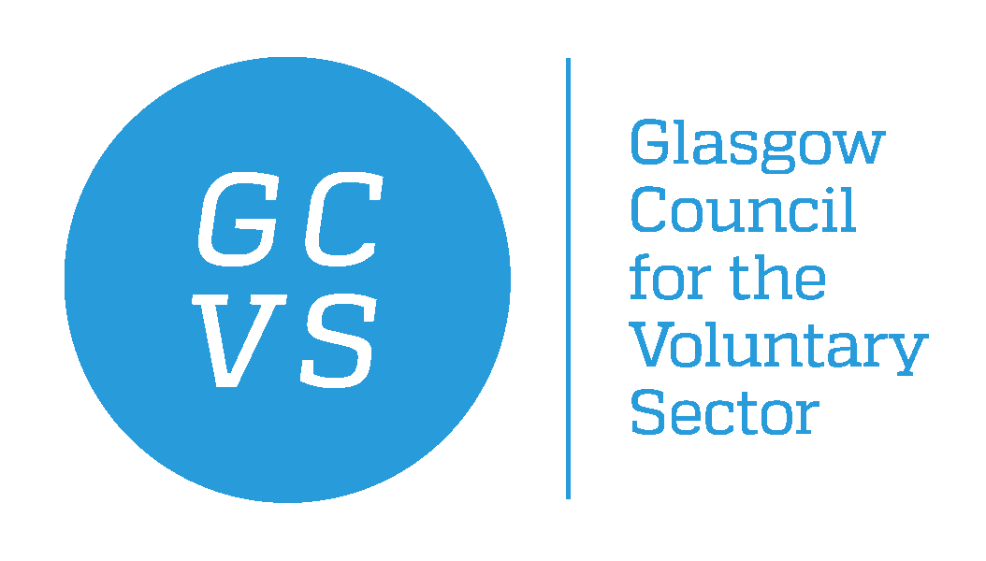

May 2021

Dear Applicant

Post Title: Wellbeing Service Advisor
Hours: Part time - 21 hours per week
Salary: Grade 6 point 31 – 34 (26,467 – 28,828) pro rata
Term: One year contract with a view to extension funding dependent
Responsible to: People & Safety Services Manager
Location: GCVS / Home based supporting organisations throughout Glasgow.
Thank you for your interest in the above post. In response to your request for an application pack, please find the following enclosed:

GCVS application form comprising four parts:

- Part A – Application Form for Employment
- Part B – Contact Details and Data Protection Declaration
- Part C – Equal Opportunities Form
- Part D – Criminal Declaration Form

Please also find enclosed the following information:
- Guidance notes for candidates (within the application pack)
- Job Description
- Person Specification
- GCVS Equal Opportunities Statement (within the application pack)

When returning completed application, please mark application for the attention of Farah Portela to the address below or by email to recruitment@gcvs.org.uk , to arrive no later than Sunday 13th June 2021. Late applications may not be considered. When possible we will appreciate that applications are sent by email.

Please notice that due to the high volume of applicants, we will only respond to candidates who are selected for interview.

We thank you for your interest in employment with GCVS.

Yours sincerely,

Farah Portela
HR Manager
GCVS
11 Queens Crescent,
Glasgow
G4 9AS

