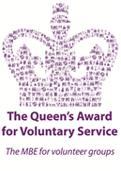
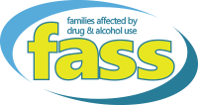
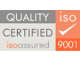

PERSON SPECIFICATION

Outreach Family Support Worker

E = Essential D = Desirable.

Qualifications

- HNC or SVQ 2/3 in Social Care or equivalent E
- Background in Family Support or Community Development work
or previous experience in a related field E
- Driving licence and have access to a car for business purposes E

Skills

- Strong organisational skills E
- Good written and verbal communication skills E
- Good interpersonal skills E
- Planning and co-ordinating skills E
- Time management skills E
- Good admin and IT skills, with a working knowledge of
Email, word, excel and access E
- Competent report writing skills E
- Good Team Work Skills E
- Ability to Empower People E
- Counselling Skills D
- Ability to work in a person centred manner E

Experience
- Experience in monitoring, evaluating, report writing E
- Recording, Reporting and Evidencing Outcomes D
- Experience in Partnership working E
- Working with vulnerable and disadvantaged families E
- Supporting large groups D
- Delivering / facilitating group work D
- Supporting families affected by addiction E

Knowledge

- Awareness of drug/alcohol issues and their impact on families E
- Ability to Understand and comply with organisational policies
and procedures E
- Understanding of issues, challenges and discrimination
experienced by Kinship Care families affected by a loved
one’s addiction E
- A good working knowledge of support agencies, organisations,
Projects etc. across Glasgow i.e. childcare or respite providers,
Befriending or family support services E

Personal attributes

- An empathetic approach E
- Flexibility E
- Use own initiative E
- Positive attitude E
- Self-directed E
- Non-judgemental attitudes E
- Willingness to undertake training and development opportunities E
- Good team player E
- Proactive E
- Available to work flexible hours, including evenings E
- Self-confidence and awareness E
- Demonstrate positive values E

