Of th
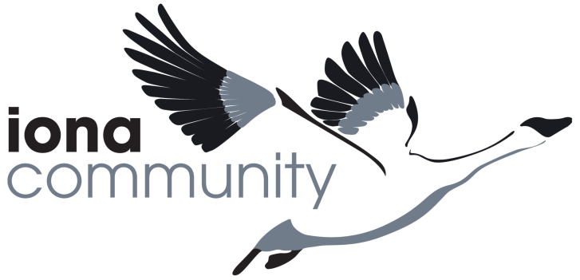
Job Description

 | JOB DETAILS
 | Job Title | Finance and Compliance Manager
 | Line Manager | Executive Director
 | Location | Home-based, but with regular meetings in our mainland office in Glasgow and occasional UK travel including to the islands
 | Salary Grade | H - £31,933
 | Pension | Nest Pension scheme is offered to all employees
 | Holidays | 32 days inclusive of public holidays
 | Probation period | 3 months
 | Hours of work | 35 hours – flexible working hours are offered to meet needs of the post.
 | Date of this version | April 2021
 | MISSION OF THE IONA COMMUNITY
 | Inspired by our faith, we pursue justice and peace in and through community
JOB PURPOSE
Oversees all financial processing, monitoring and reporting including the annual audit. Responsible for ensuring the Iona Community is run in full compliance with the law and strives to model best practice in all our policies, procedures and implementation. Acts as Company Secretary and ensures proper statutory registration and reporting for every aspect of the IC and its subsidiaries in particular with OSCR, Companies House, the Information Commissioner, HMRC. Oversees internal policies and procedures including human resources, accounting, payments and banking, payroll, budgeting, financial reporting, grant management and compliance to charity and donor regulations.
MAIN RESPONSBILITIES

- Financial processing
  - Ensure the Iona Community maintains full efficient, accurate and transparent financial records using Xero our financial software and implement an annual budget process.
  - Develop and maintain our procurement policies and procedures
  - Ensure the production of monthly reports and projections to enable cost-centre heads and Trustees to monitor progress against budget.
  - Manage all financial sub-contracts including all insurances and pensions.
  - Oversee payroll.

- Compliance and risk management
  - Act as the Iona Community’s main point of contact with the Office of the Scottish Charity Regulator for all registration and compliance matters.
  - Act as Company Secretary for the Iona Community and its subsidiaries
  - Ensure all data is held in compliance with GDPR and privacy legislation
  - Maintain and develop the organisation’s Risk Register.
  - Ensure the organisation fully complies with health and safety regulations.
  - Build and maintain an up to date ‘Policies and Procedures’ handbook

- Human resources
  - Ensure the delivery of effective recruitment processes for staff and volunteers including out-source contractors.
  - Maintain all HR records including staff contracts
  - Oversee the implementation of the annual Professional Development process across the charity to include ensuring all staff have a personal learning and development plan.
  - Support the development of flexible working, including remote home-working.
- Administration, records and IT infrastructure
  - Maintain and develop the Iona Community’s use of Sharepoint and Office 365
  - Ensure the preparation of all paperwork required for the annual financial audit.
  - Negotiate contracts for goods and services to ensure best use of the Community’s resources including leases and tenancy agreements.
  - Ensure all support service and secretariat needs for the Community Resources are met and personally
  - Personally provide secretariat support to the Iona Community Council and ensure secretariat support is provided to the Community Resources Committee from within your team.

- Any other reasonable task as requested by your line manager.

SUPERVISION AND BUDGET RESPONSIBILITY
- Line manage the Finance and Compliance Team, currently an Administrator and part-time Bookkeeper.
- Manage and engage specialist consultants as required
- Liaise closely with Accountancy, Auditing and HR consultants
- Preparation of an annual revenue budget of £1.8M and capital of £0.5M.
- In conjunction with Executive Director, development of policies and procedures relating to the employment of up to 50 staff members
- Operational support to the Community Resources Committee and to Council.
- The post is generally 9-5 but also involves regular weekend/evening/away meetings, for which Time off in Lieu is given.

LEVEL OF AUTONOMY AND DECISION-MAKING
This is a strategic post that requires the postholder to be confident in putting forward new ideas while being comfortable with collaboration and collective decision-making.
COMMUNICATIONS
Along with those key communication elements of the role as outlined in the Job Purpose, the key internal and external lines of communication for this post include:
Internal:
- Leader and Executive Director
- Staff team, especially Cost Centre Heads across the organisation
- Community Resources Committee Convenor and members
- Members
External
- Regulatory and statutory agencies including OSCR, HMRC, ICO and Companies House
- External consultants and contractors eg accountant, HR, suppliers
- Customers and suppliers

COMPLEXITY
This is a leadership position and requires the postholder to coordinate multiple strands of work across their team to complement the work of the whole organisation.
PERSON SPECIFICATION

Essential

- Educated to degree level or at least ten years’ experience in a similar role
- Third sector experience and significant working knowledge of the statutory and regulatory frameworks affecting third sector organisations
- Experience setting and monitoring budgets
- Experience of line management, building and motivating a team
- Excellent IT skills and knowledge
- Excellent communication skills, written and face to face

Desirable
- Previous experience of upgrading existing internal systems and procedures
- A formal and/or professional qualification in Accountancy, HR or law
- Experienced trainer

All post holders are expected to
- be in sympathy with the purpose, values and practices of the Iona Community
- engage as an active learner in their field of expertise, taking up CPD and training opportunities as they arise
- be self-starters, managing their own core administration and taking initiative/acting in consultation where appropriate
- step in for and support colleagues as needed across the whole organisation
- uphold and enhance the reputation of the Iona Community at all times

 | AGREEMENT
 | Job Holder’s Signature |  | Date
 | Line Manager Signature |  | Date

