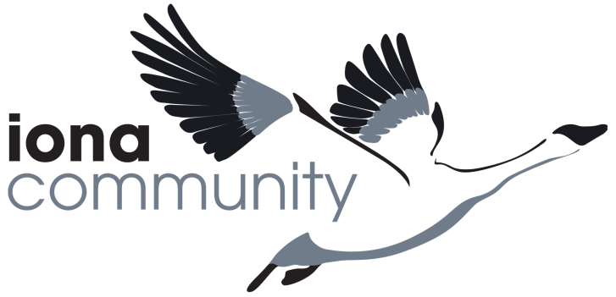

**Job Description**

|  |  |  |
| --- | --- | --- |
| **JOB DETAILS** |  | |
| Job Title | Membership Manager | |
| Line Manager | Executive Director | |
| Location | Home-based, but with regular meetings in our mainland office in Glasgow and occasional UK travel including to the islands | |
| Salary Grade | H - £31,933 | |
| Pension | Nest Pension scheme is offered to all employees | |
| Holidays | 32 days inclusive of public holidays | |
| Probation period | 3 months | |
| Hours of work | 35 hours – flexible working hours are offered to meet needs of the post. | |
| Date of this version | April 2021 | |
|  |  | |
| **MISSION OF THE IONA COMMUNITY** | | |
| Inspired by our faith, we pursue justice and peace in and through community | | |
|  | | |
| **JOB PURPOSE**  To consolidate and develop new and improved infrastructure to support the Iona Community as a membership organisation based around local Family Groups connected to wider region. This will include developing the existing member database (ThankQ), piloting new models for enabling the global community to flourish and developing systems, processes and communications routes to ensure that all in membership of this global community are connected, informed, engaged and inspired to live out the purpose and mission of the Iona Community, in line with the Strategic Objectives (2021 – 2031). | | |
|  | | |
| **MAIN RESPONSBILITIES**   1. **Systems**    1. Ensure excellent, efficient and accurate systems flow across all membership infrastructure to maintain accurate and up to date records compliant with GDPR and other legal requirements including database, web-site, subscriptions and donations, mail delivery systems.    2. Oversee the development and maintenance of the CRM (ThankQ) ensuring its functionality meets all the needs of the IC.    3. Consolidate all membership policies and procedures developed within the Community to construct and maintain a ‘Building Community’ handbook that will become the basis of scaling the community globally ensuring fairness, consistency and openness.    4. Develop and maintain renewal systems to ensure efficient and accurate reminders are sent/logged. 2. **Development and innovation**    1. Work closely with the Leader to develop a strategy and business plan for the growth, support and development of the membership structures, including Family Groups, Regions, National Networks and governance structures.    2. Ensure all support service needs for the Community Life Committee are met.    3. Oversee, implement and analyse pilots to trial new ideas, models of practice and/or activities to inform future decisions.    4. Research and write papers for Council and Committees as required. 3. **Communication**    1. Design and develop a Communications Strategy.    2. Manage membership communications including all queries to ensure excellent, regular, accurate and inspiring communication through a range of media platforms for existing and enquiring members.    3. Support existing and new groups (Family Groups, Regional Groups, Common Concern Networks) through providing excellent administrative and event-planning support.    4. Work with the Leader and Executive Director to design and develop a marketing plan for all levels of membership from online marketing to in person stalls and workshops at events and festivals.    5. Offer hands-on, in-person support and input to all membership groups as needed. 4. **Finances and Reporting**    1. Ensure all financial transactions are properly logged through the CRM and connect to the wider Iona Community financial processes.    2. Ensure membership income exceeds (to an agreed target) membership costs.    3. Be accountable for the membership budget and spend, forecasting regularly.    4. Implement reconciliation systems with the Finance Department to ensure that Membership and Finance reporting of membership income is consistent.    5. Synthesise and interpret membership data into comprehensive evaluative reports for senior management and Council. 5. **Any other reasonable task requested by your line manager** | | |
|  | | |
| **SUPERVISION AND BUDGET RESPONSIBILITY**   * Line manage staff in the Membership team, currently the Administrator and Member Engagement Administrator * Commission, secure, brief and project manage consultants as required eg CRM database development, freelance designers * Budget management (level to be agreed) * In conjunction with Leader, development of membership practices for a membership of over 3,000 globally * Operational support to the Community Life Committee. * The post is generally 9-5 but also involves regular weekend/evening/away meetings, for which Time off in Lieu is given. | | |
|  | | |
| **LEVEL OF AUTONOMY AND DECISION-MAKING** This is a strategic post that requires the postholder to be confident in putting forward new ideas while being comfortable with collaboration and collective decision-making. | | |
|  | | |
| **COMMUNICATIONS** Along with those key communication elements of the role as outlined in the Job Purpose, the key internal and external lines of communication for this post include:  **Internal:**   * Leader * Staff team * Convener, Community Life Committee * Members   **External**   * Potential partner or sister communities within the UK or internationally * Other third sector, membership organisations. | | |
|  | | |
| **COMPLEXITY**  This is a leadership position and requires the postholder to coordinate multiple strands of work across their team to complement the work of the whole organisation. | | |
|  | | |
| **PERSON SPECIFICATION**  Essential   * Educated to degree level or at least ten years’ experience in a similar role * Creative problem solver with a record of developing innovative solutions to organisational problems * Experience of line management, building and motivating a team * Experience of developing a Customer Relationship Management system, ideally within a member organisation ie with both internal and external ‘customers’. * Excellent communication skills, written and face to face   Desirable   * A formal project management qualification * Experience of fundraising * Working knowledge of the particular needs of member organisations   All post holders are expected to   * be in sympathy with the purpose, values and practices of the Iona Community * engage as an active learner in their field of expertise, taking up CPD and training opportunities as they arise * be self-starters, managing their own core administration and taking initiative/acting in consultation where appropriate * step in for and support colleagues as needed across the whole organisation * uphold and enhance the reputation of the Iona Community at all times | | |
| **AGREEMENT** | | |
|  | | |
| Job Holder’s Signature | | Date |
| Line Manager Signature | | Date |