

Role Profile – Fundraising and Finance Administrator (0.5 FTE)
Reports To: Head of Fundraising

Role Purpose:
This role is central to the coordination of income into the department. The Fundraising and Finance Administrator role will be responsible for being the link person between the finance and marketing departments to ensure income is appropriately coded and reconciled.
The role will also be responsible for all elements of processing regular givers. The role requires excellent attention to detail and the ability to work effectively with team members and other departments.
All roles within Sight Scotland and Sight Scotland Veterans are expected to work to our values and Our Ways of Working framework:
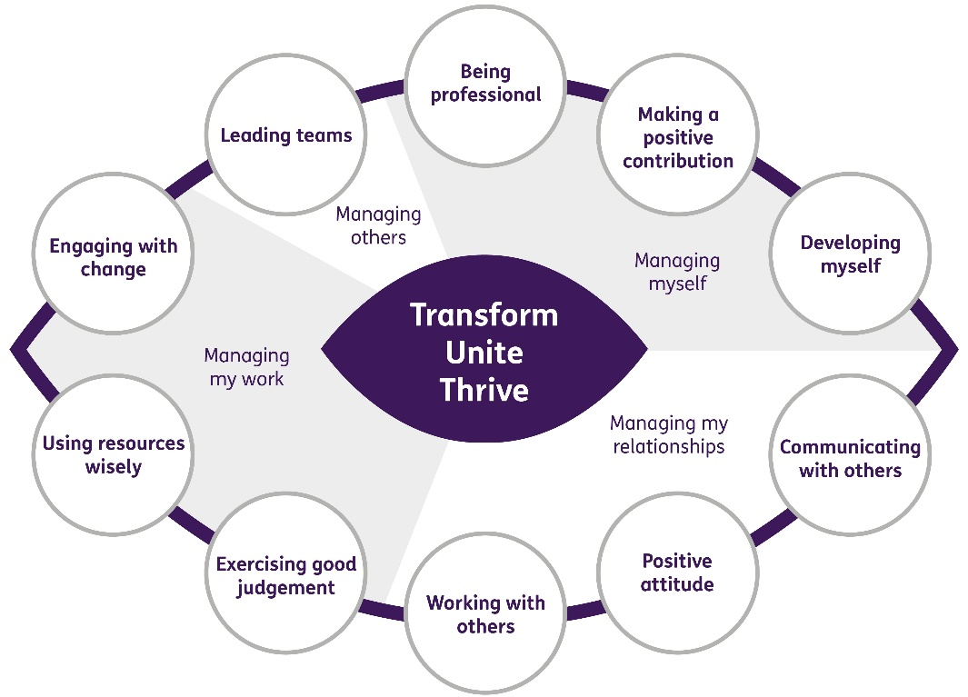

Our Ways of Working - Managing my Work
The main responsibilities and accountabilities of this role are:

- Reconcile the Raiser’s Edge NXT database with Sage on a monthly and yearly basis in line with procedures
- Prepare all financial documents for the year-end audit and be the main liaison person for the audit in the fundraising team
- Support the Planned Giving Officer with Gift Aid Claims and ensure that relevant audit trails are retained
- Bank income at least three times per week
- Coordinate and process the bi-monthly committed giving via the various systems in an accurate and timely way and in line with procedures.
- Working with the Relationship and Supporter Care Fundraiser ensure all cancellations are identified and followed up with and all correspondence is produced and recorded
- Take ownership of the direct debit log and report on attrition rates
- Process the monthly bank transfer
- Administer all finance related administration in relation to the following (but not limited to) payment providers Stripe, PayPal, Enthuse and CAF
- Accurately add gifts on to Raiser’s Edge NXT from all online fundraising platforms i.e. JustGiving and Virgin Money Giving
- Administration of credit card donation processing
- Liaise with fundraising colleagues with income directly to the bank account, ensuring it is coded correctly and the relevant colleagues enter the data and thank accordingly
- Responsibility for ensuring that we have up to date Gift Aid declarations for all supporters
- Support the Planned Giving Officer with Gift Aid claims
- Support the Planned Giving Officer with any database or systems requirements
- Process accordingly all donations received for Sight Scotland Veterans and send monthly income report to Direct of Services
- Administer all thank you letters and emails to Sight Scotland Veterans donors
- Manage the Privacy email account and update records accordingly

Other
- To be an enthusiastic and pro-active member of the fundraising team with a close involvement in team meetings, projects and training sessions
- Support fundraising projects and appeals where necessary, working as a team to collectively deliver the fundraising strategy throughout the year and exceed income generation targets
- Attend external fundraising conferences, groups and training where appropriate to ensure sector developments and trends are identified
- Adhere to the highest standards of fundraising practice
- Ensure that all activities comply fully with the relevant Data Protection obligations and any other legislation
- Keep up to date with changes in legislation.

Contribute to the work of the Marketing and Communications department
- Support cross team projects and events
- Work effectively and collaboratively with colleagues across the department
- Where needed represent the organisation at conferences, exhibition stands and events.

Our Ways of Working – Managing Myself and Managing my Relationships

To do this role, you will have:
Professional experience of:
- Using a CRM database, preferably Raiser’s Edge NXT or 7.

Knowledge of:
- Charitable sector
Skills:
- Strong administrative and organisation skills
- Data entry skills with a high level of accuracy and attention to detail
- Good understanding of the Microsoft 365 suite and strong digital literacy IT systems
- Strong numeracy skills
- Ability to prioritise workload and multi task
- Excellent customer service skills with a friendly and confident telephone manner
Other:
- Ability to work flexibly including evenings and weekends

On a day to day basis you will work with different people and teams, these could be:
- Heads of Service
- Directors
- Senior Leadership and Management Teams
- Service Users
- Families
- Colleagues
- Other Sight Scotland services
- Senior Staff

Requirements of this role are:
- You are a member of the PVG scheme (paid for by Sight Scotland)
- You will have a 6 month probation period
- That you participate in all staff training and development and maintain your own professional development
- You will wear the appropriate PPE in accordance with current guidance for the role.
- You will follow Sight Scotland’s guidance, policies and procedures relating to your own health and safety and that of colleagues and service users at all times.
- You will uphold the principles of Sight Scotland’s Dignity at Work and Equal Opportunities policies at all times, working in a way which supports an inclusive work environment that is respectful of differences.

What we can offer you:
- Generous pension scheme
- Discounts for Carers
- Access to learning and development opportunities
- Employee Perks through the Employee Assistance Programme
- Cycle to Work scheme
- And many more, please visit our website for more information

This job profile is not exhaustive. The duties of the post holder may be reviewed from time to time and the employee may be called upon to work in other locations within Sight Scotland or Sight Scotland Veterans.

