

**Role Profile – Management Accountant**

**Reports To:** Head of Finance

**Role Purpose:**

You will assist the Finance Manager in the day to day running of the Finance team, you will be responsible for the completion of a number of regular functions including budget preparation and control, annual reporting and investment management, in conjunction with the Head of Finance.

You will also be required to ensure the smooth implementation of a new financial accounting system.

All roles within Sight Scotland and Sight Scotland Veterans are expected to work to our values and Our Ways of Working framework:

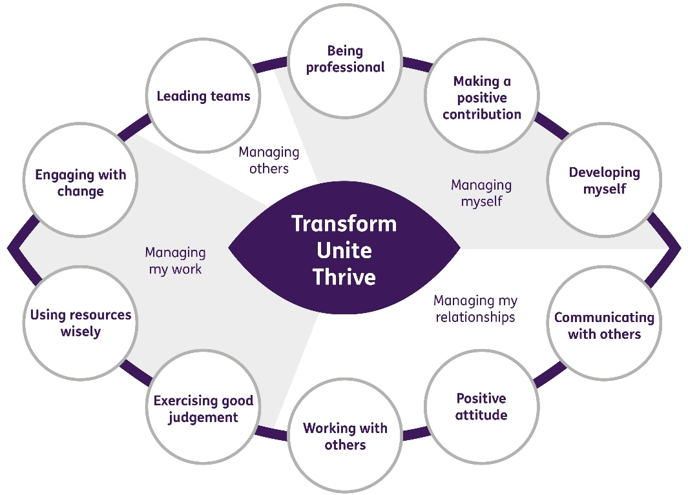

**Our Ways of Working - Managing my Work**

**The main responsibilities and accountabilities of this role are:**

* Contribution to the preparation of monthly management accounts and other reports
* Contribution to the preparation of annual report and accounts for both charities and the Royal Blind Pension Scheme
* Support in the production of annual budgets for approval by service committees and the Board.
* Implementation and maintenance of the financial accounting system
* Co-ordinate the transfer of data from Sage 200 to our new accounting system
* Carry out checks and ensure the new accounting system is accurate including ensuring appropriate testing is carried out
* Production and maintenance of key performance indicators
* Contribution to the administration of asset registers and budgetary control of the capital works programme
* Support the monitoring and reporting on investment activities
* Treasury management
* Authorisation of payments through Corporate Internet Banking and BACS
* Providing appropriate financial information for funding bids and monitoring reports for funders
* Provision of financial information for the Trustees of the pension scheme
* Ensuring that the charities follow procedures for procurement and value for money
* Providing information and advice on all financial activities to key management and staff
* Produce Ad-hoc reports as required by the Board, Chief Executive, Head of Finance, Finance Manager, and other management
* Work in the best interests of the organisation and the people it serves
* Any other duties as required by the Head of Finance

**Our Ways of Working – Managing Myself and Managing my Relationships**

**To do this role, you will:**

* Be a qualified or part qualified Accountant or have sufficient experience in management accounting to be considered part qualified
* Have experience in working with bespoke accounting packages
* Be able to demonstrate experience in budget preparation and monitoring across multiple services
* Have experience in producing annual accounts including for pension funds to FRS 102
* Have demonstrable experience in investment management and reporting
* Be self-reliant and able to work independently with effective time management skills
* Have effective communication skills
* Be able to demonstrate strong planning and organisational skills, attention to detail
* Be able to respond positively to a variety of situations and people to meet changing priorities.

**It would be desirable for this role if you have:**

* Experience in the implementation of new financial systems
* Experience of working in the non-profit sector

**On a day to day basis you will work with different people and teams, these could be:**

* Colleagues
* Other Sight Scotland services
* Senior Staff
* External stakeholders

**Requirements of this role are:**

* You are a member of the PVG scheme (paid for by Sight Scotland)
* You will have a 6 month probation period
* That you participate in all staff training and development and maintain your own professional development
* Ability to build positive professional relationships at all levels
* You will wear the appropriate PPE in accordance with current guidance for the role.
* You will follow Sight Scotland’s guidance, policies and procedures relating to your own health and safety and that of colleagues and service users at all times
* You will uphold the principles of Sight Scotland’s Dignity at Work and Equal Opportunities policies at all times, working in a way which supports an inclusive work environment that is respectful of differences.

**What we can offer you:**

* Generous annual leave entitlement which increases after 4 years’ service
* Generous pension scheme
* Access to learning and development opportunities
* Employee Perks through the Employee Assistance Programme
* Cycle to Work scheme
* And many more, please visit our website for more information

This job profile is not exhaustive. The duties of the post holder may be reviewed from time to time and the employee may be called upon to work in other locations within Sight Scotland.