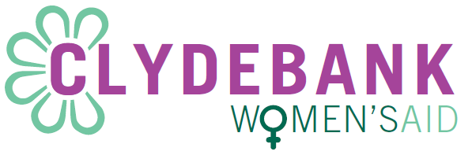
Application Number:
For CWA use only

Fit Person Statement
Family Resource (Outreach) Worker and Collective Manager

To the best of my knowledge I am fit and able to carry out all duties and responsibilities outlined in the job description of the Family Resource (Outreach) Worker and Collective Manager post.

YES

NO

Signed…………………………………….

Date………………………………………

Please check whichever option applies to you and return with application from
This form will be signed on the date of interview

