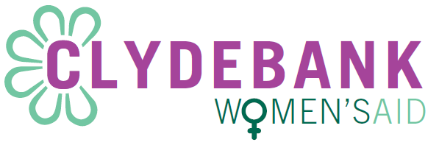

**Application Number:**

For CWA use only

**Qualification Statement**

Family Resource (Outreach) Worker and Collective Manager

The Scottish Social Services Council requires Clydebank Women’s Aid to ensure workers are suitably qualified. If you do not hold a qualification that is acceptable to both the SSSC and Clydebank Women’s Aid you may be required to attain one.

Do you agree to undertake any necessary training?

YES

NO

Signature………………………………..

Date…………………………………….

**Please check whichever option applies to you and return with application form**

This form will be signed on the date of interview